Maths Key Skills Stage 2: Skill Check 12

Name: ___________________________________ Date: _______________ Class/Group: _______________________________

A: Place Value, Add and Subtract |  | B: Multiply, Divide and Fractions |  |  | C: Measure and Geometry
1. What is the missing number?  0 3 6 9 15 | 2:1 | 11. 2 x 9 = |  | 2:11 | 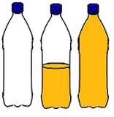  21. Write <, > or = to make the statement correct.  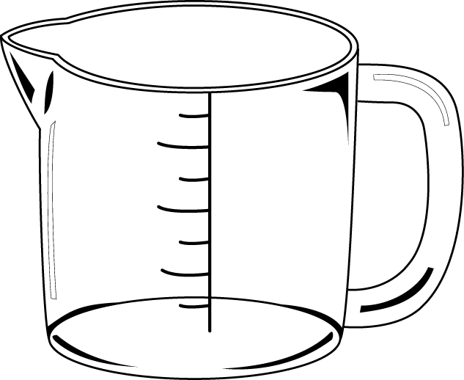  1000 millilitres 1 litre |  | 2:18
2. Circle the 8s that have a value of 80.  82 28 68 81 | 2:2 | 12. Which are the even numbers?  7 14 21 28 |  | 2:11 |  |  | 2:18
3. Draw an arrow to label 16.  15  20 | 2:3 | 13. What symbol is missing?  22 11 = 2 |  | 2:12 | 22. Tick (✓) the shape that has a vertical line of symmetry. |  | 2:23
4. Put these in order, smallest first.  1 12 2 21 | 2:4 | 14. What symbol is missing?  4 x 4 16 |  | 2:12 |  |  | 2:23
5. Write this number in words.  98 | 2:5 | 15. Is this true? Write ‘yes’ or ‘no’.  7 x 4 = 4 x 7 |  | 2:13 | 23. Draw the next shape in this pattern: |  | 2:27
6. There are 23 people on a bus. 9 get off. How many people now? | 2:6 | 16. Bread rolls are sold in packs of 8. If I buy 3 packs, how many rolls do I get? |  | 2:14 |  |  | 2:27
7. Use 12 + 8 = 20 to answer:  + 40 = 100 | 2:7 | 17. 9 apples are shared. How many people are there if each person gets 1? |  | 2:14 | 24. A group of people were asked what their favourite drink was. Complete the tally chart:  25. How many people were asked their favourite drink in total? |  | 2:29  2:30
  Colour | Tally | Total
  Cola
  Lemonade |  | 12
8. 37 + 15 = | 2:8 | 18. What fraction  is shaded? |  | 2:15 |  |  | 2:29  2:30
9. Tick (✓) if true:  8 - 13 = 13 - 8 27 + 9 = 9 + 27 | 2:9 | 19. How many thirds are in 2 whole ones? |  | 2:15 |  |  | 2:29  2:30
10. Use 84 - 26 = 58 to help find:  26 + 58 = | 2:10 | 20. How many quarters do you need to make one half? |  | 2:16 |  |  | 2:29  2:30
Total (A) |  | Total (B) |  |  | Total (C)
Test Total (A+B+C) |  | R (0-9) | Y (10-19) |  |  | G (20-25)

