Dance  Planning a dinosaur stomp | Erupting Volcanoes  Making an erupting volcano model. | Scissor Practise  Dinosaur teeth. | Carnivores and Herbivores  What did dinosaurs eat?
Dinosaur World  Small world play in a dinosaur swamp. | What we will be learning in  Spring 1 Week 5 & 6  Dinosaur |  | Fossil Hunting  Digging for dinosaurs in the sand tray
Dinosaur Art  Using straws to make dinosaur skeleton pictures.  Footprint dinosaurs  Collage volcanoes. | Music  Using percussion to make music for our Dinosaur Roar poem. | Technology  Printing labels for our dinosaur display.  Using the internet to find out about dinosaurs. | Dinosaur fossils  Making dinosaur footprint fossils with playdough.
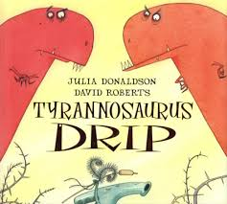 | 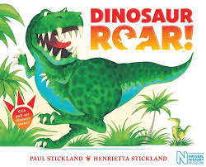 | 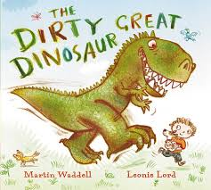 | 