Maths Key Skills Stage 3: Skill Check 15

Name: ___________________________________ Date: _______________ Class/Group: _______________________________

A: Place Value, Add and Subtract |  | B: Multiply, Divide and Fractions |  |  | C: Measure and Geometry
1. What is 100 more than this number? 247 | 3:1 | 11. 16 ÷ 8 = |  | 3:10 | 23. A cake weighs 2 kilograms. It is cut into 4 equal pieces. How many grams does each piece weigh? |  | 3:19
2. What is the 8 worth in this number?  384 | 3:2 | 12. 3 x 4 = |  | 3:10 |  |  | 3:19
3. Write < or > to make this correct:  694 294 | 3:3 | 13. 45 x 4 = |  | 3:11 | 22. What is the  perimeter of this  regular  cm  0  2  4  6  8  10  pentagon? |  | 3:20
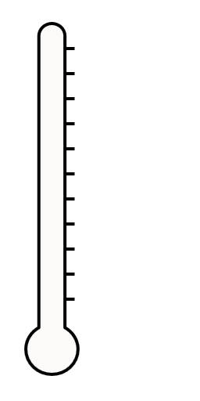  4. Show 12°C on the  20°C  thermometer.  0°C  10°C | 3:4 | 14. There are 3 girls for every 2 boys. If there are 15 girls, how many boys? |  | 3:12 |  |  | 3:20
5. Make the smallest number possible using the digits 4 1 and 3. | 3:5 | 15. What is one tenth of 5?  1  4 |  | 3:13 | 23. Ian turns through    a full turn. How  many degrees has  he turned through? |  | 3:26
6. 310 - 1 = | 3:6 | 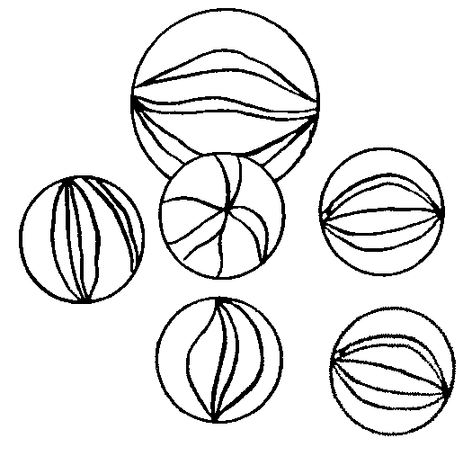  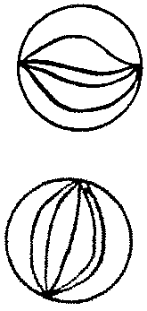  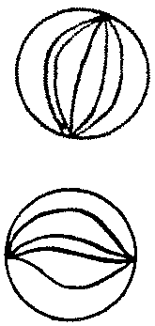  16. Circle  of the marbles.  5  8 |  | 3:14 |  |  | 3:26
7. 792 - 538 = | 3:7 | 17. What is of 32? |  | 3:15 | 24. Draw an angle that is bigger than a right angle. |  | 3:27
8. Circle the best estimate to 452 - 89:  330 340 350 360 | 3:8 | 18.  =  1  3  ?  12 |  | 3:16 |  |  | 3:27
9. A school has 650 tickets to sell for a play. They sell 478. How many left? | 3:9 | 19. Add the  3  8  1  8  +  fractions. |  | 3:17 |   25. Draw a pair of parallel lines. |  | 3:28
10. What is the missing number?  57 + - 23 = 95 | 3:9 | 20. Write the  1  9  1  5  1  7  1  8  largest fraction. |  | 3:18 |  |  | 3:28
Total (A) |  | Total (B) |  |  | Total (C)
Test Total (A+B+C) |  | R (0-9) | Y (10-19) |  |  | G (20-25)

