Maths Key Skills Stage 4: Skill Check 13

Name: ___________________________________ Date: _______________ Class/Group: _______________________________

A: Place Value, Add and Subtract |  | B: Multiply, Divide and Fractions |  |  | C: Measure, Geometry and Statistics
1. What is the missing number?  18 24 36 42 | 4:1 | 11. 7 x 9 = |  | 4:9 | 21. What is the area of this shape?  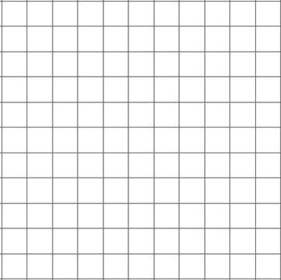  1cm |  | 4:20
2. What is the missing number?  2000 3000 4000 | 4:1 | 12. Circle the sum that is the same as 16 x 7: 4 x 7 x 4 2 x 8 x 6 |  | 4:10 |  |  | 4:20
3. Round this number to the nearest 100: 3,192 | 4:2 | 13. 138 x 9 = |  | 4:11 | 22. Circle the name that describes a 90° angle.  Right Obtuse Acute  angle angle angle |  | 4:24
4. What is 1,000 less than 10,293? | 4:2 | 14. To work out 9 x 58 you could do:  x 9 + 8 x  1  9 |  | 4:12 |  |  | 4:24
5. What is 12 less than 4? | 4:3 | 15. Circle the equivalent fraction to .  3  27  4  18  5  36 |  | 4:13 | 23. To transform shape A onto B:  Translate A  B  units .  A |  | 4:27
6. What is the value of the 2 in this number? 6,283 | 4:4 | 16. Complete  37  100  38  100  39  100  the sequence: |  | 4:14 |  |  | 4:27
7. Write the number 91 in Roman numerals. | 4:5 | 17.  4  3  1  3  + |  | 4:15 | 24. Month of birth of Class 7 pupils.  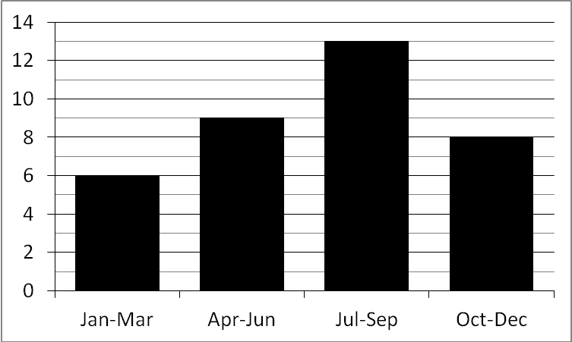  No. of pupils  How many were born in the first half of the year?  25. How many pupils are in Class 7? |  | 4:29  4:30
8. 2,472 - 598 = | 4:6 | 18. Write 0.01 as a fraction. |  | 4:16 |  |  | 4:29  4:30
9. Write the sum to check 3,250 - 975 = 2,275: 3,250 975 2,275 | 4:7 | 19. 11 ÷ 10 = |  | 4:17 |  |  | 4:29  4:30
10. There are 73 people on a bus. 15 get off & 28 get on. How many now? | 4:8 | 20. Label 4.95cm on the ruler section:  4  5  4.5 |  | 4:18 |  |  | 4:29  4:30
Total (A) |  | Total (B) |  |  | Total (C)
Test Total (A+B+C) |  | R (0-9) | Y (10-19) |  |  | G (20-25)

