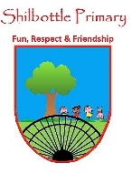
Geography – Year 1 – spring 1 – Around the world
00
Skills
Ask, enquire and question.
Read a map.
Locate continents on a map.
Explore geographical features.
Interpret photographs.
Identify compass points.
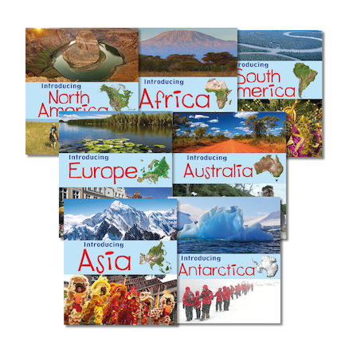
Books

Knowledge
I can name and locate the continents of the world

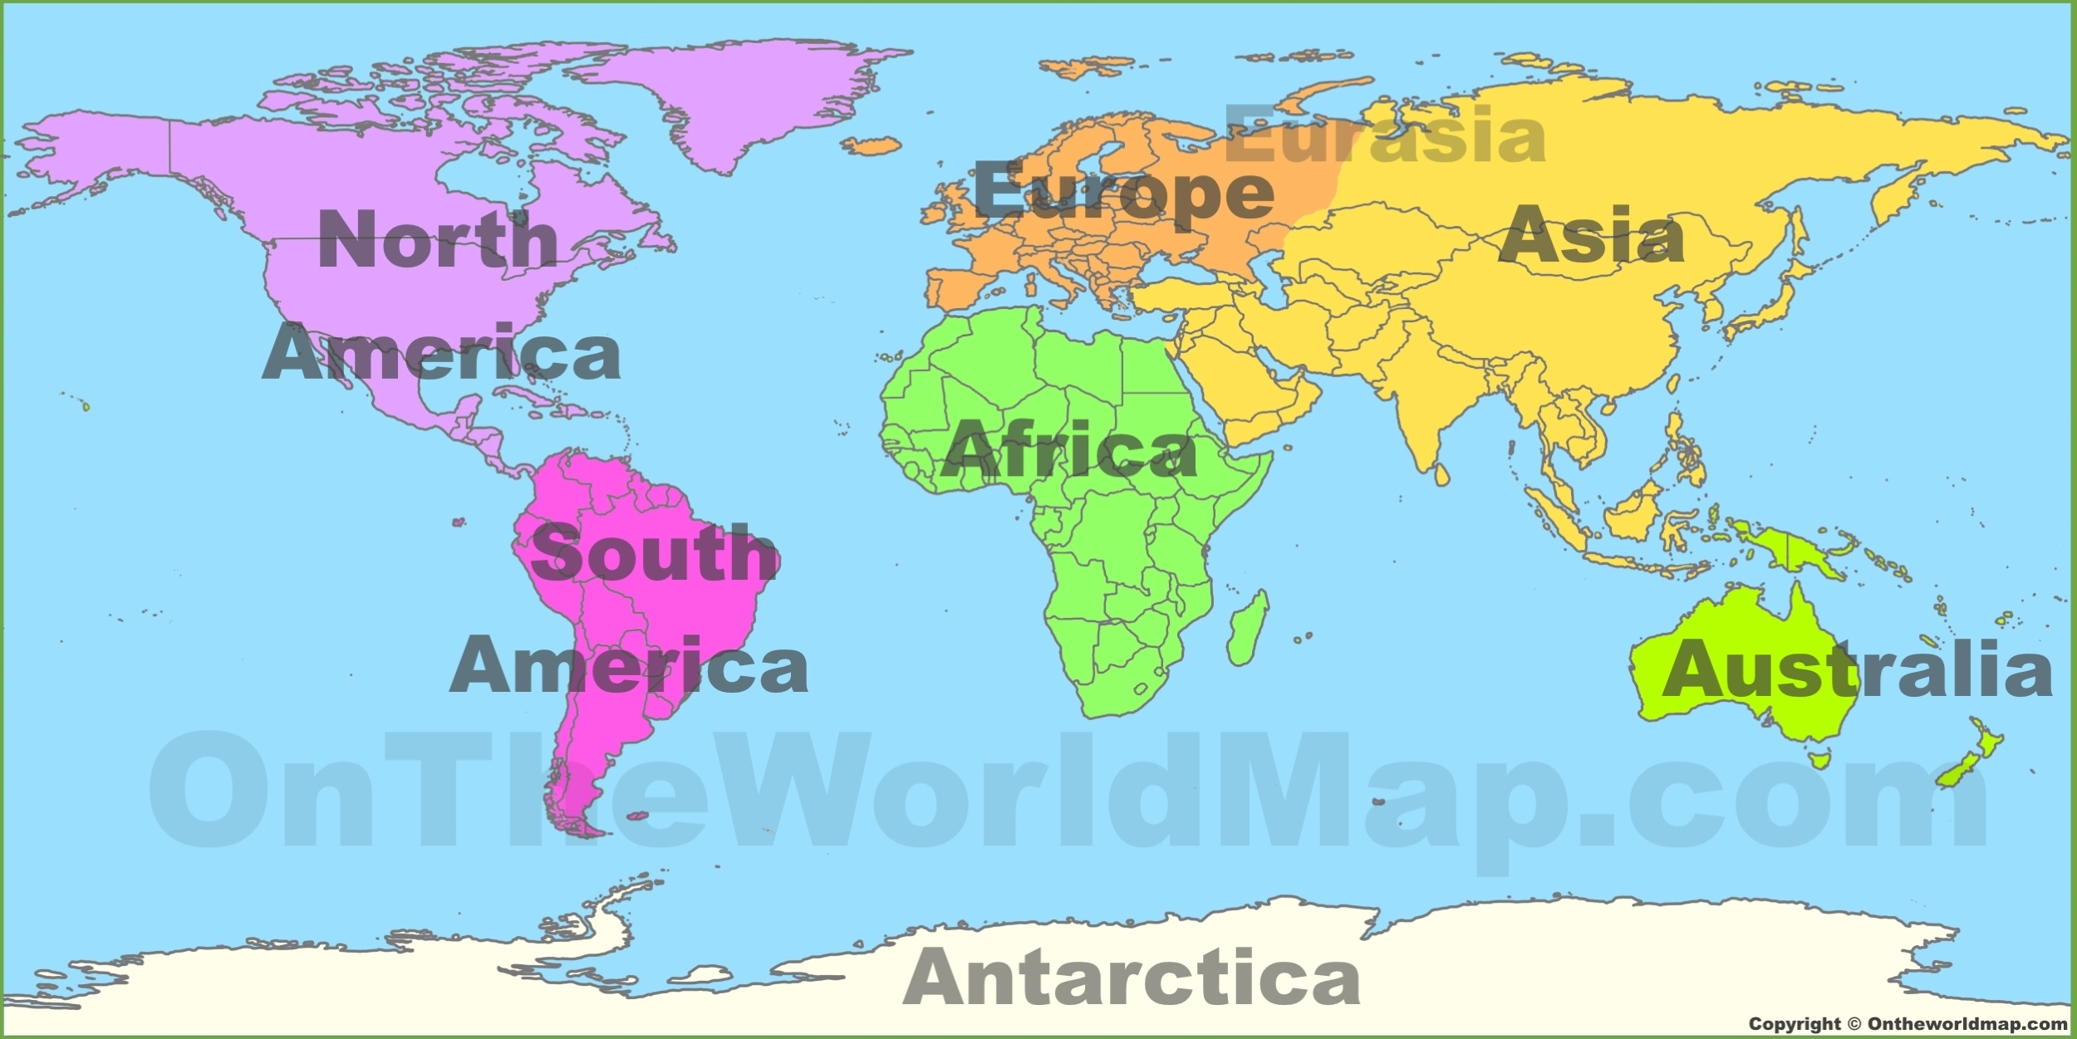

Vocabulary | Meaning
capital | A city or town that is the home to government
city | A large town. London is a city.
continent | A very large area of land that consists of many countries. Europe is a continent.
country | An area of land that is controlled by its own government.
island | A piece of land that is completely surrounded by water
ocean | One of the five very large areas of salt water on the Earth's surface.
savannah | A large, flat area covered with grass, with few trees that is found in hot countries.
sea | A large area of salty water that is part of an ocean

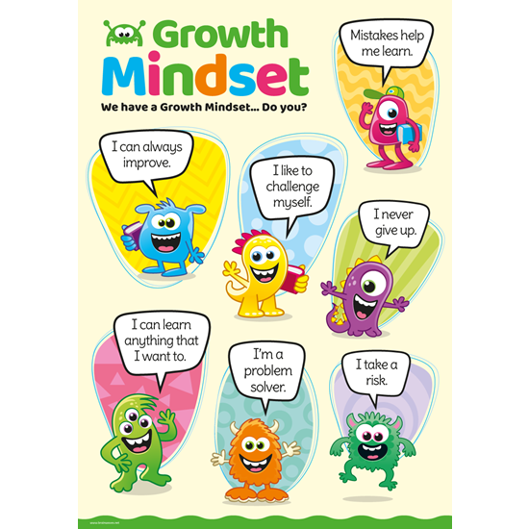
Growth Mindset Strategies

What I will know and be able to do at the end of the topic.
What I should be able to do and know now.
Knowledge
What is a continent? - A continent is a group of countries.
How many continents are there in the world? – There are 7 continents.
Can you name all the continents? – Europe, Asia, Australia, Africa, North America, South America, Antartica.
What continent is France in? France is in Europe.

Skills –
What country do you live in?
Can you name the 4 countries that make up the UK?
What continent do we belong to?
Can you name any other countries in that continent?

Knowledge
The country I live in is called England. I live in Shilbottle, which is a village in England. England is a country in the United Kingdom (England, Scotland, Wales and Northern Ireland).
Skills
Children know about similarities and differences in relation to places, objects, materials and living things.

Children know that different people have different beliefs, attitudes, customs and traditions and why it is important to treat them with respect.

They talk about the features of their own immediate environment and how environments might vary from one another.

What I will be learning

- How to use an atlas to locate the
Continents.
- The names of the continents and where they are in the world.
- Why we have hot and cold countries in the world.
- Comparing the continent I live in to others in the world.

