Making Pancakes on pancake day, choosing our own toppings and singing the pancake song |  | Baking and decorating gingerbread men.  Retelling the story of the gingerbread man. |  | Role play  Italian restaurant  Serving pasta and pizza. |  | Investigating and tasting different types of bread then baking our own.
Writing our own version of Ketchup on your cornflakes. |  | What we will be learning in  Spring 2 Weeks 1-3  Food and Cooking |  |  |  | Thinking about hygiene and learning the hands and apron song.
Writing a shopping list for ingredients, and visiting a shop to buy them. |  | Looking at food groups and thinking about being healthy. |  | Visiting a café for a healthy snack. |  | Making and painting our own salt dough pizzas.
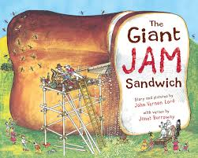 | 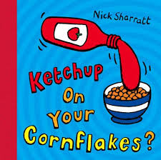 |  | 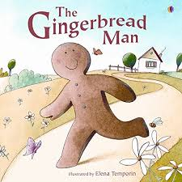 |  | 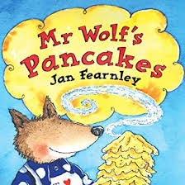 |  | 