Maths Key Skills Stage 1: Skill Check 9

Name: ___________________________________ Date: _______________ Class/Group: _______________________________

A: Number and Place Value |  | B: Fractions and Measure |  |  | C: Measure and Geometry
1. How many counters? | 1:1 | 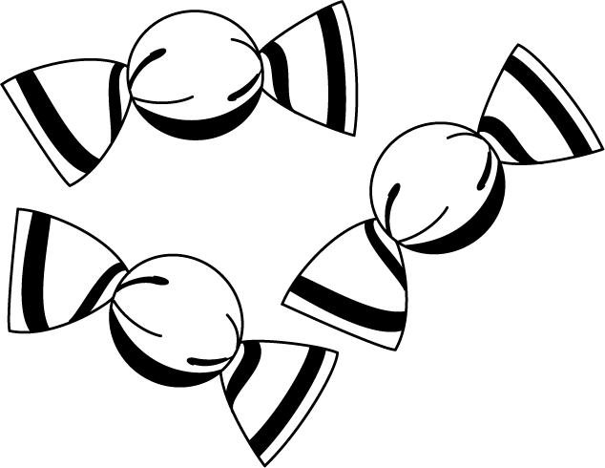  11. What fraction of the sweets is circled? |  | 1:11 | 16. If today is Tuesday, tomorrow is:  a. Monday  b. Wednesday  c. Tuesday |  | 1:16
2. What is the missing number?  10 20 30 50 | 1:2
3. What number is one more than 49? | 1:3 | 12. What fraction of this shape is coloured in? |  | 1:12 | 17. What month is the sixth month of the year?  a. March b. June c. August |  | 1:17
4. Write a number that is more than  12. | 1:4
5. Write this number in numerals:  thirteen | 1:5 |   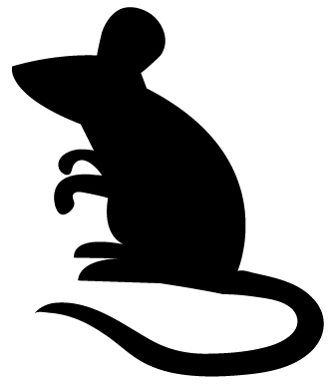  13. Circle the animal that is the slowest? |  | 1:13 | 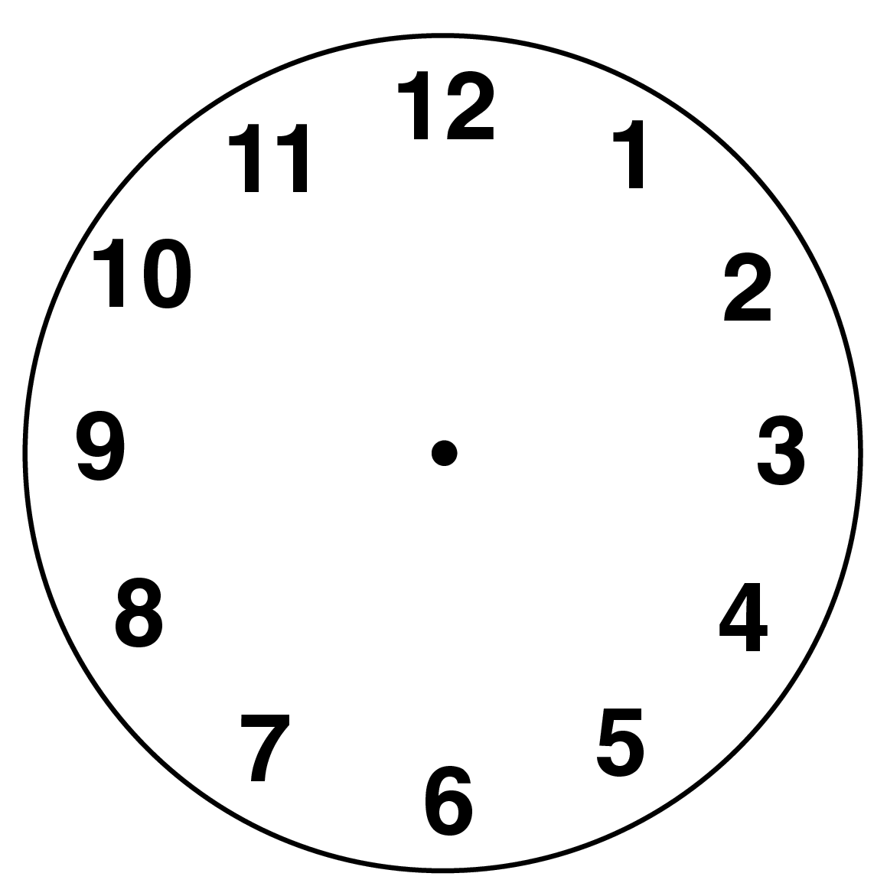  18. Draw the hands  to show:  Half past seven. |  | 1:18
6. What symbol is missing?  14 7 = 7 | 1:6
7. What is the missing number?  6 + = 20 | 1:7 | 14. How much water is in the bowl?  200ml  100ml |  | 1:14 | 19. What is this shape?  a. square  b. triangle  c. rectangle |  | 1:19
8. 13 + 6 = | 1:8
9. Mike has 17 sweets. He eats 6 of them. How many does he have left? | 1:9 | 15. How much altogether?  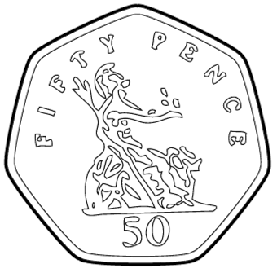  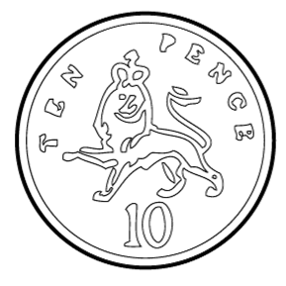 |  | 1:15 | 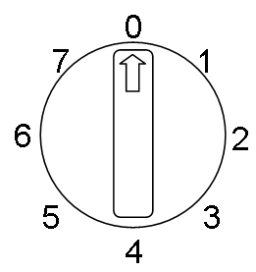  20. What number will the  dial be pointing to  after a three quarter  turn clockwise? |  | 1:20
10. 3 cakes come in a box. If you buy 4 boxes, how many cakes do you have? | 1:10
Total (A) |  | Total (B) |  |  | Total (C)
Test Total (A+B+C) |  | R (0-7) | Y (8-15) |  |  | G (16-20)

