Finding out which animals lay eggs and which animals give birth to babies. |  | Finding out about the Hindu festival of Holi. Monday 9th March. Making art using powder paint. |  | Baking and tasting hot cross buns. |  | Making spring flowers using paint collage and printing.
Listening to the Easter story told by Reverend Helen |  | What we will be learning in  Spring 2 Week 4 - 6  Spring and Easter |  |  |  | Painting spring garden picture, using printing and painting.
Decorating eggs for Easter. |  | Watching eggs hatch in the incubator. |  | Sowing seeds to grow flowers and food. |  | Making a mother’s day surprise!
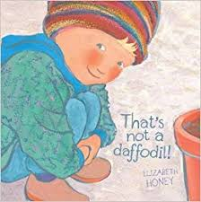 | 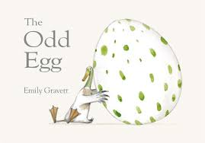 |  | 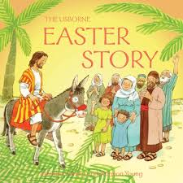 |  | 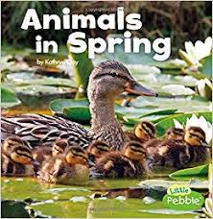 |  | 