Maths Key Skills Stage 2: Skill Check 14

Name: ___________________________________ Date: _______________ Class/Group: _______________________________

A: Place Value, Add and Subtract |  | B: Multiply, Divide and Fractions |  |  | C: Measure and Geometry
1. What is the missing number?  4 14 24 34 44 | 2:1 | 11. 6 x 5 = |  | 2:11 | 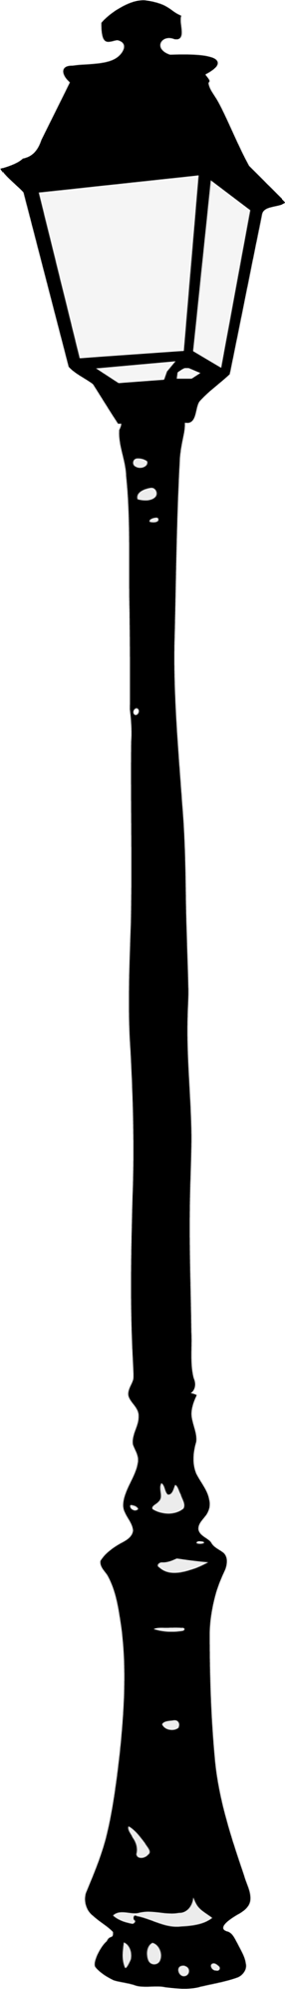  21. Which of these is the tallest?  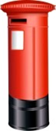  a. a lamppost  b. a bollard  c. a post-box |  | 2:18
2. Circle the 4s that have a value of 40.  104 48 43 54 | 2:2 | 12. Which are the odd numbers?  9 18 27 36 |  | 2:11 |  |  | 2:18
3. What number is labelled?  5  10 | 2:3 | 13. What symbol is missing?  5 x 9 45 |  | 2:12 | 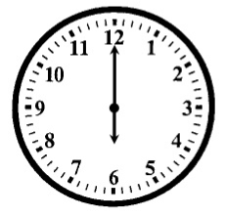  22. How many minutes are there in 1 hour?  a. 12  b. 24  c. 60 |  | 2:21
4. Put these in order, smallest first.  38 3 83 8 | 2:4 | 14. What symbol is missing?  28 4 = 7 |  | 2:12 |  |  | 2:21
5. Write this number in words.  62 | 2:5 | 15. Is this true? Write ‘yes’ or ‘no’.  9 ÷ 3 = 3 ÷ 9 |  | 2:13 | 23. Which of these shapes has 4 sides?  a. triangle  b. circle  c. rectangle |  | 2:23
6. A garden has 12 trees. 4 are cut down. How many trees now? | 2:6 | 16. 7 flowers each have 3 petals. How many petals are there in total? |  | 2:14 |  |  | 2:23
7. Use 11 + 9 = 20 to answer:  44 + = 80 | 2:7 | 17. I have 18 eggs. If they come in boxes of 6, how many boxes do I have? |  | 2:14 | 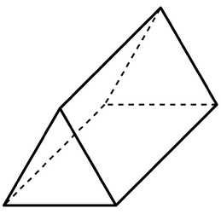  24. Complete the sentence:  A triangular prism has 6  a. vertices  b. edges  c. faces |  | 2:24
8. 3 + 9 + 6 = | 2:8 | 18. What fraction of the  strawberries is circled? |  | 2:15 |  |  | 2:24
9. Tick (✓) if true:  12 + 9 = 9 + 12 35 - 7 = 7 - 35 | 2:9 | 19. Write the fraction three quarters in numerals.  1  4 |  | 2:15 | 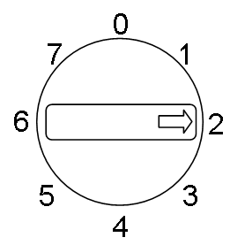  25. This dial is pointing  at 2. What number will  it point to after being  turned clockwise  through 3 right angles? |  | 2:28
10. Use 29 - 12 = 17 to help find:  12 + 17 = | 2:10 | 20. What is of 16 ? |  | 2:16 |  |  | 2:28
Total (A) |  | Total (B) |  |  | Total (C)
Test Total (A+B+C) |  | R (0-9) | Y (10-19) |  |  | G (20-25)

