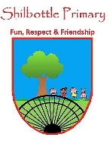
RE – Y5 – Spring 1 – Jewish worship and community
Skills
Children can discuss similarities and differences between Jewish worship and worship in other religions.
Children can identify and talk about their role in communities.
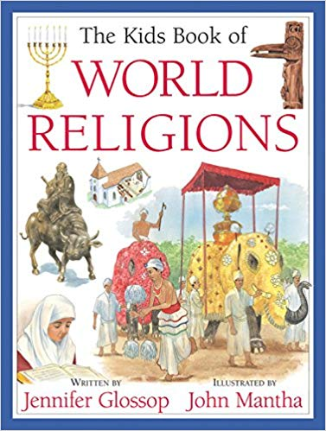
Books

Knowledge
Children can identify some of the key aspects of worship in Judaism.
Children know some of the rituals relating to becoming a member of the Jewish community.
Children know that living in a community gives both responsibility and support.
Children understand the beliefs that can cause people to behave in particular ways.
Children can describe what ‘tzedakah’ is.
Children can identify ways in which religious beliefs affect communities locally and worldwide.
Children can explain why members of the Jewish community value their Jewish identity
Vocabulary | Meaning
Bar Mitzvah | The initiation ceremony of a Jewish boy who has reached the age of 13 and is regarded as ready to observe religious precepts and eligible to take part in public worship.
Bat Mitzvah | A religious initiation ceremony for a Jewish girl aged twelve years and one day, regarded as the age of religious maturity.
prayer shawl | A fringed shawl traditionally worn by Jewish men at prayer.
Torah | (in Judaism) The law of God as revealed to Moses and recorded in the first five books of the Hebrew scriptures (the Pentateuch).
Tzedakah | (among Jewish people) Charitable giving, typically seen as a moral obligation
Shabbat | (among Sephardic Jews and in Israel) The Sabbath
Siddur | A Jewish prayer book containing prayers and other information relevant to the daily liturgy.
Tefillin | cubic black leather boxes with leather straps that Orthodox Jewish men wear on their head and their arm during weekday morning prayer.
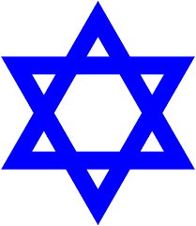
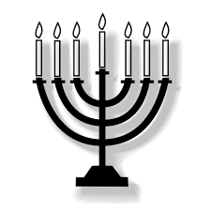

Growth Mindset Strategies
What I will know and be able to do at the end of the topic.
What I should be able to do and know now.

Understand the difference between a FIXED
mindset and a GROWTH mindset.
Be Curious; Be courageous.
Challenge yourself. Ask, ‘What could I do
differently next time?’
Give everything your best effort and
persevere.
Practice; Practice; Practice.

Knowledge
Living in a community gives both responsibility and support because …
Living in a community gives both responsibility and support but …
Living in a community gives both responsibility and support so …

I can identify the Jewish place of worship, holy book and prophets because …
I can identify the Jewish place of worship, holy book and prophets but …
I can identify the Jewish place of worship, holy book and prophets so …

Skills

To compare and contrast the major religions of the world.

To identify the communities that I am part of
Knowledge:
- I can explain what a pilgrimage is.
- Bethlehem is an important religious site
- •Why Mary and Joseph traveled to
Bethlehem
•
Skills:
• Make comparisons between different
peoples’ emotions throughout the
story.
• Retell a story accurately and in detail.
• Use music skills to express religious
ideas.

What I will be learning

To find out about some of the key features of worship in Judaism.
To understand the significance of prayer in Judaism.
To find out the meaning of Jewish rituals in relation to joining the Jewish community.

