RE – Year 3 – Spring 1 – What do we know about Jesus?
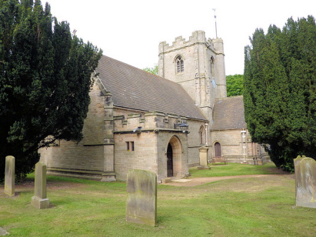
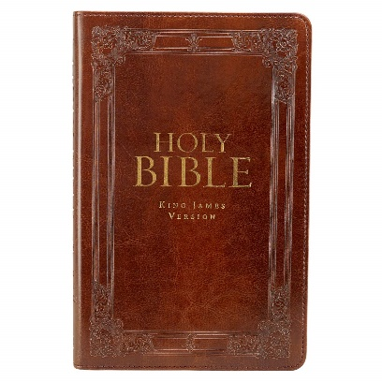
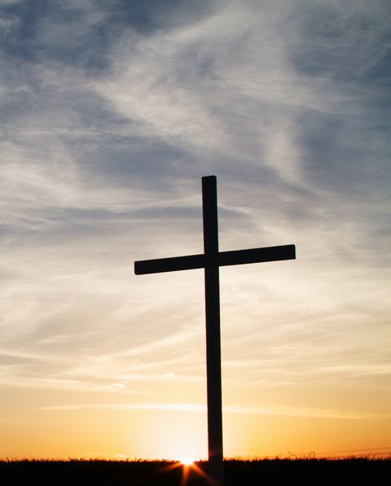
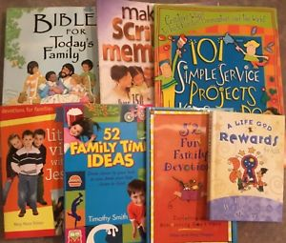
00
Knowledge
Jesus is a teacher and prophet who founded the Christian faith. He is considered by Christians to be the son of God. There are no written descriptions of him and paintings were not done until 150 years after his death. The Bible gives us evidence and clues as to what Jesus may have been like as a person. Different groups of people saw Jesus in many different ways.

Skills
I know that Jesus is a historical figure.
I can talk about my learning.
I am able to understand the importance of a personal image.
I know that representations vary.

Books

Vocabulary | Meaning
believer | to accept as honest or true.
Bible | the main sacred writings of Judaism and Christianity. The writings of Judaism are made up of the Old Testament, while those of Christianity are made up of both the Old and New Testaments.
characteristics | something that makes a person or thing different from others.
Christian | one who believes in the divine nature of Jesus Christ and follows his words and teachings.
evidence | something that gives proof or a reason to believe.
Gospel | any of the four accounts of Jesus Christ's life, death, and teachings in the New Testament books of Matthew, Mark, Luke, and John.
Jesus | the teacher and prophet who founded the Christian faith. He is considered by Christians to be the son of God and the Christ or savior.
metaphor | a phrase that describes something by comparing it to some other thing.
passage | a part of a written or musical work.
portray | to make a picture of in images or words.
representation | the showing or picturing of something in a work of art.
Shroud of Turin | Shroud of Turin, also called Holy Shroud, Italian Santa Sindone, a length of linen that for centuries was purported to be the burial garment of Jesus Christ. It has been preserved since 1578 in the royal chapel of the cathedral of San Giovanni Battista in Turin, Italy.
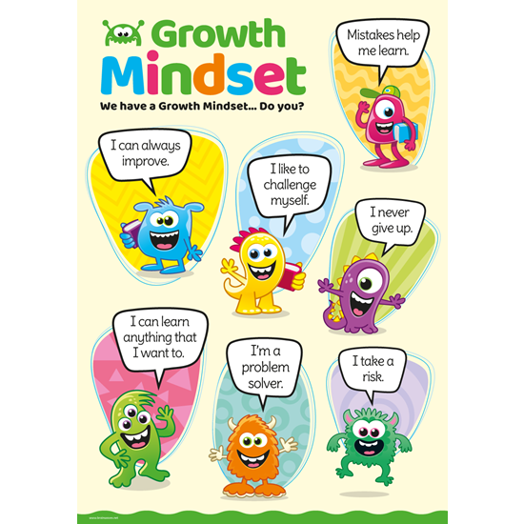
Growth Mindset Strategies

What I will know and be able to do at the end of the topic.
What I should be able to do and know now.
Who was Jesus?

I know that expressions of Jesus’ appearance reflect a variety of contextual characteristics.

We can find out about what Jesus was like and what people thought of him through the Gospels of M_________, M__________, L_______ and J_________.

Ask me what I think Jesus looked like and what type of person I think that he was.

The purported burial garment of Jesus Christ is called the S_________ of T_________.

A Christian is someone who believes in the divine nature of Jesus Christ.

I know that not everyone in Jesus’ time saw him in the same way.
Knowledge
I know that different people believe in different religions and that Christians believe in Jesus.
I know that I can look in non-fiction books for information on different religions.
I know that Jesus is an important historical figure.

Skills
I can compare different religions by looking at their similarities and differences.
I can ask questions about religion.
Name characters from a story.
I can give my own opinion on what I think something looks like.
I can form an opinion on what caharacteristics someone might have based upon their actions towards others.

What I will be learning
That representations of Jesus vary and to explore the reasons for this.
Pictures of Jesus tell us about people’s personal beliefs about him.
To try and find out what Jesus was like as a person from the Gospels.
To explore other people’s view of Jesus from the Bible.
To explore symbolic language used in the Bible.

