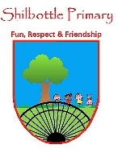
Science - Year 3 – Spring 1 & 2 – Health and Movement
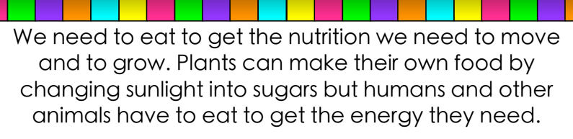
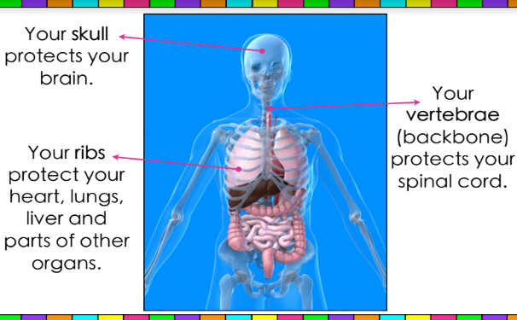
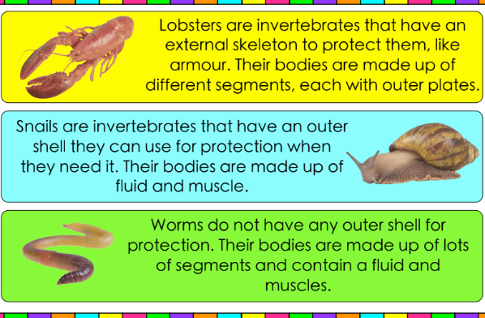
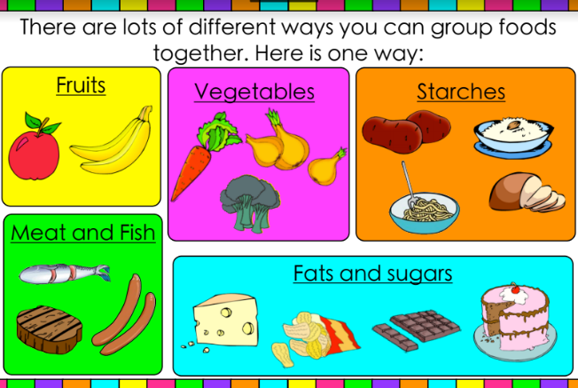
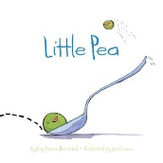
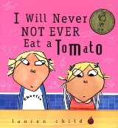
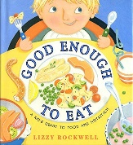
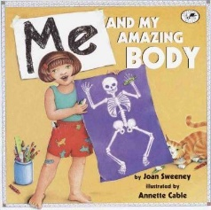
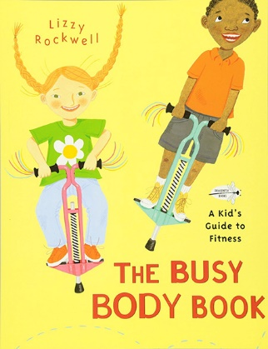
00
Knowledge

Books

Skills
Identify that humans get nutrition from what they eat.
I know that humans need to eat to grow and move.
I know that different animals have different diets.
I understand the differences between invertebrates and vertebrates.
Talk about your learning.
Vocabulary | Meaning
carbohydrates | a compound made of carbon, hydrogen, and oxygen. It is formed by plants, and it is used in the body to easily produce and store energy. Sugars and starches are carbohydrates.
endoskeleton | the internal bony supporting framework characteristic of vertebrates.
exoskeleton | an external supporting structure such as the shell of a crustacean.
fibre | a plant material found in food that is not digested by the body but that plays an important part in good health.
hydrostatic | the scientific study of liquids at rest, especially with regard to pressure and equilibrium.
invertebrate | an animal that does not have a backbone or skeleton inside its body.
minerals | a substance formed in the earth that is not of an animal or a plant. Gold, silver, iron, and salt are minerals.
nutrition | the act or process of eating and using the nutrients in food for living and growing.
protein | a substance that is made up of nitrogen, carbon, oxygen, hydrogen, and possibly other elements. Proteins are found in all living things and are a necessary part of life processes.
skeleton | the inner framework of bones and cartilage in vertebrate animals. Skeletons support the body and protect softer body parts.
vertebrate | an animal that has a skeleton with a backbone inside its body. Mammals, birds, amphibians, reptiles, and fish are large groups of vertebrates.
vitamins | one of a number of natural or human-made substances needed for the health and normal working of the body. Humans get most of their vitamins from food.
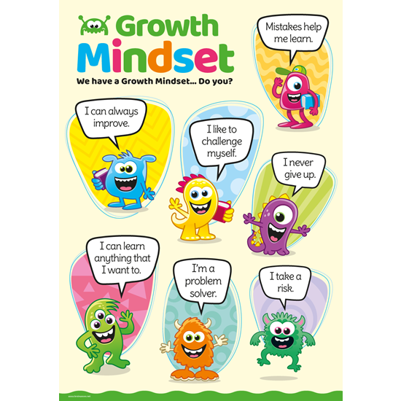
Growth Mindset Strategies

What I will know and be able to do at the end of the topic.
What I should be able to do and know now.

Knowledge
I know that some animals including humans have a skeleton.
I can suggest why some animals including humans have bones.
I know what foods are healthy and which are not.
I understand that animals need to eat to get their nutrition, just like humans.
I know how non-fiction books can help my learning.
Skills
Identify that different foods can give us nutrients to help us grow and move.
I am able to read information from a chart or table.
I can compare, sort and group objects, animals, foods and materials.
I understand that in order to stay healthy, we cannot eat just any food.
Knowledge
I can explain the difference between vertebrates and invertebrates.

I understand that muscles work in pairs to move different parts of the body.

Can you identify what the animals with a skeleton are called?

What do skeletons have in common?

I can recognise whether an animal is a h________, c________ or a o_________.

Skills

What type of chart can I use to display my results?

I can explain my predictions and conclusions using key words or prompts.

Investigate the different types of diets eaten by different animals.

What I will be learning
To identify that humans get the nutrition they need from what they eat.
To identify that a balanced diet is needed in order to stay healthy.
To investigate which foods different animals eat.
To explore human and animal skeletons.
To find out about how the skeleton supports and protects the body and to investigate how invertebrates are supported.

