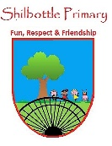

**History – Beamish (Local history)**

**Vocabulary Meaning**

**Skills**

**Books**

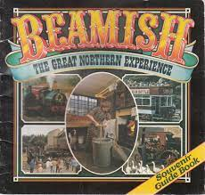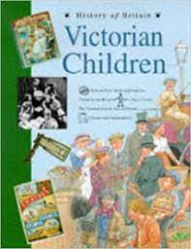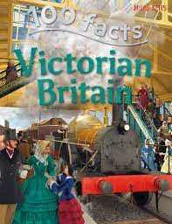

* Use a variety of information sources to find out information.
* Make links between this historical era and others I have studied.
* Research key facts about the Victorian Era.
* Create and ask questions to further develop my understanding of the topic.

A century that began on January 1, 1901 and ended on December 31, 2000.

**20th Century**

An open air museum, representing the Early 20th Century and Victorian periods in Britain.

**Beamish**

Events placed in order of when they occurred. From first to last.

**chronological**

The process of extracting (removing) coal from the ground.

**coal mining**

**Knowledge**

A coal mine and the buildings and equipment associated with it.

**colliery**

A long and distinct (clear) period of history.

**era**

* To learn about what Beamish museum represents and how it links to local history.
* Discover what life was like in the past and make comparisons to life today.
* Investigate coal mining and why it was so important to the North East of England.
* Place events and times on a timeline to show when they happened and how it inks to where we are today and other eras in the past.

The period of British history from the accession of George I in 1714 to the death of George IV in 1830

**Georgians**

A person who worked in a pit and mined for coal.

**miner**

The area on a map of England that is in the North East area of the country.

**North East**

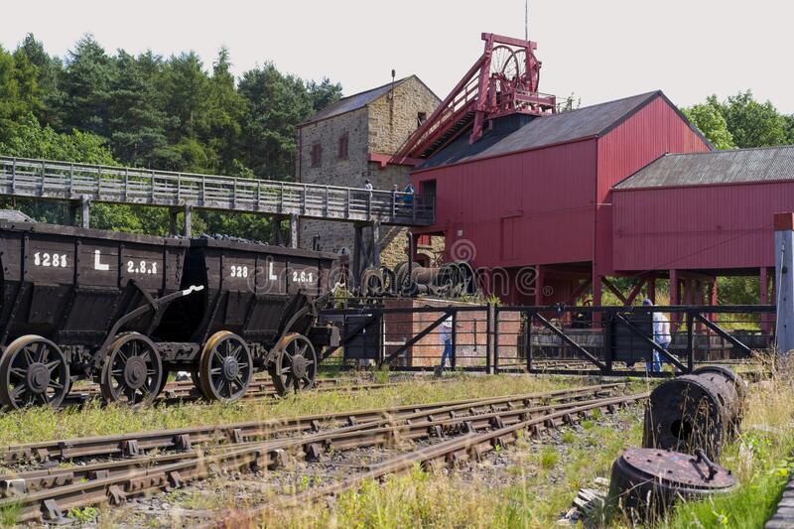

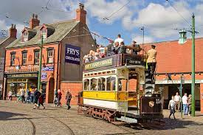

A large interval of time in the past. (Also known as era)

**period**

A large hole in or under the ground where materials are taken (mined) from.

**pit**

People who lived during the Victorian period which was when Queen Victoria reigned.

**Victorians**

**What I should be able to do and know now.**

**What I will know and be able to do at the end of the topic.**

**Key skills in History**

**Knowledge:**

* Can you explain what the museum of Beamish is all about?
* What time periods does Beamish show?
* When did these time periods happen? Can you say which periods can before and after them?
* Why was coal mining such a big part of North East history?
* Describe what life was like for a family in the Victorian era?
* Can you compare (similarities and differences) life in the Victorian period with life today?

**Skills**

* Compare groups of people from the past for their beliefs and cultures.
* Explain why some evidence is reliable and some is not.
* Make interpretations of an event based on the archaeological evidence provided.
* Use an i-pad or computer (internet) to type in suitable research criteria to get answers to questions.
* Use more than one source of evidence to make an informed opinion of an event.
* To know about changes in Britain from the prehistoric times.
* To place events, artefacts and historical figures on a time line using dates.
* To use dates and terms to describe events.
* To use appropriate historical vocabulary to communicate, including: dates, time period, era, change and chronology.
* To use literacy, numeracy and computing skills to a good standard in order to communicate and record information about the past.

**Knowledge:**

* There have been many changes in Britain before I was born.
* People used to live differently in the past.
* People needed coal to light fires in their homes.
* There have been many Kings and Queens in the past.
* Coal mining was a job people used to do in the past.
* Rules and expectations change over time.

**Skills:**

* Make comparisons between different times in the past.
* Examine evidence to make interpretations about what happened.
* Compare life in one era to era in time.
* Compare an aspect of life with the same aspect in another period.
* Research some different view-points of an event.
* Use information sheets, and text books for research.

**What I will be learning**

1. Why is Beamish important to my knowledge of History?
2. What time period in history does Beamish teach me about?
3. How does Beamish link to my local area?
4. When did the time periods that Beamish shows, happen on a timeline?
5. What is coal mining and why was it such a big thing for the North East of England?
6. How is life different or similar today to what life was like in the Victorian period?