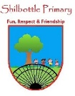

**Geography – Moving out across the world.**

**Books**

**Vocabulary**

**Skills**

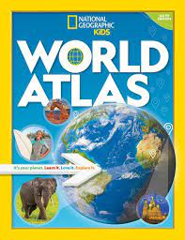

* To be able to label a world map with key countries and capital cities.
* To name and locate on a map some counties across the world.
* To explain how certain countries within the continent of Africa exports their natural resources around the world.

Africa is the world's second-largest continent, after Asia.

**Africa**

Any of the world's main continuous expanses of land (Europe, Asia, Africa, North and South America, Australia, Antarctica).

**continent**

A continent in the western part of the landmass lying between the Atlantic and Pacific Oceans.

**Europe**

The Indian Ocean is the third-largest of the world's oceanic divisions.

**Indian Ocean**

**Knowledge**

The Mediterranean Sea is a sea connected to the Atlantic Ocean.

**Mediterranean Sea**

North America, third largest of the world's continents, lying between the Arctic Circle and the Tropic of Cancer.

**North America**

**By the end of this topic you will learn:**

* Understand similarities between different regions around the world by comparing them with the human and physical geographical features.
* To be able to understand where we are within the world and find and locate us on a world map.
* To be able to name and locate the major continents, countries and capital cities on a world map.

Geography dealing with natural features. (e.g. earthquakes, volcanoes, hills, lakes, rivers, weather.)

**physical geography**

An area or part of a country of the world having definable characteristics but not always fixed boundaries.

**region**

The fourth largest of the world's continents. It is the southern portion of the landmass generally referred to as the New World

**South America**

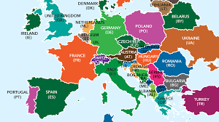

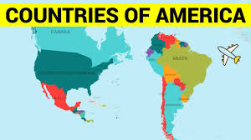

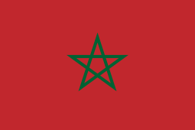

Flag of Morroco

Latitude is the measurement of distance north or south of the Equator.

**The line of latitude**

The Tropic of Cancer is the most northerly circle of latitude on Earth.

**Tropic of Cancer**

Is the southernmost latitude where the Sun can be seen directly overhead.

**Tropic of Capricorn**

**What I should be able to do and know now.**

**What I will know and be able to do at the end of the topic.**

**Key skills in Geography**

**Knowledge:**

* Can you name 5 countries around the world?
* Name the continents of the world?
* Name some countries that are within each continent?
* What is Similar about the UK and another region of the world?
* What is different about another region of the world and the UK?
* Name some physical geography features in countries around the world.

**Skills:**

* Use an Atlas to locate a map relevant to my research on an area.
* Research a country and the key facts about it.
* Compare a region in North or South America with a region in the UK.
* Label a map of the world.
* To describe and understand key aspects of physical geography including; climate zones, rivers, coasts, mountains, earthquakes, volcanoes and tsunamis.
* To use maps, atlases, globes and digital/computer mapping to locate countries and describe features studied
* To use simple symbols and the key when reading maps.

**Knowledge:**

* I know that there are other countries around the world.
* I know that countries are separated by bodies of water.
* I know that the weather is different in some countries compared to England.
* I know that England is within the continent of Europe.
* I can name the 4 countries of the UK and their capital cities.

**Skills:**

* Name some physical geography features.
* Name some human geography features.
* Find countries and geographical features on a map.
* Name some of the seas and oceans.

**What I will be learning**

* To be able to locate the UK on a world map.
* To know what the continents of the world are and name some countries within them.
* To understand how the physical geography is different in other regions of the world.
* To compare other regions of the world through human and physical geography for similarities and differences.
* To name and locate countries and continents around the world.