Maths Key Skills Stage 2: Skill Check 7

Name: ___________________________________ Date: _______________ Class/Group: _______________________________

A: Place Value, Add and Subtract |  | B: Multiply, Divide and Fractions |  |  | C: Measure and Geometry
1. What is the missing number?  0 3 6 12 15 | 2:1 | 11. 2 x 7 = |  | 2:11 | 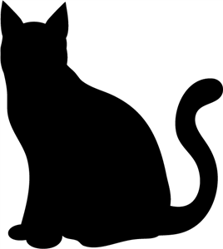  21. Write <, > or = to make the statement correct.  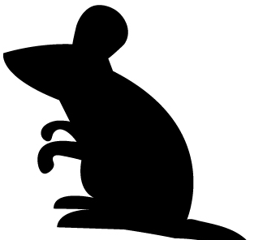  Height of a cat Height of mouse |  | 2:18
2. Circle the 2s that have a value of 2.  12 28 32 21 | 2:2 | 12. Which are the even numbers?  3 6 9 12 |  | 2:11 |  |  | 2:18
3. Draw an arrow to label 19.  15  20 | 2:3 | 13. What symbol is missing?  28 4 = 7 |  | 2:12 | 22. Tick (✓) the shape that has a vertical line of symmetry. |  | 2:23
4. Put these in order, smallest first.  73 3 37 7 | 2:4 | 14. What symbol is missing?  11 x 6 66 |  | 2:12 |  |  | 2:23
5. Write this number in words.  36 | 2:5 | 15. Is this true? Write ‘yes’ or ‘no’.  8 x 3 = 3 x 8 |  | 2:13 | 23. Draw the next shape in this pattern: |  | 2:27
6. There are 16 people on a bus. 9 more get on. How many people now? | 2:6 | 16. Bread rolls are sold in packs of 6. If I buy 4 packs, how many rolls do I get? |  | 2:14 |  |  | 2:27
7. Use 6 + 4 = 10 to answer:  60 + = 100 | 2:7 | 17. 12 apples are shared. How many people are there if each person gets 3? |  | 2:14 | 24. Number of boys & girls in Class 1:  Show 12 girls on the pictogram.  25. How many more boys are there than girls? |  | 2:29  2:30
  Key: ☺ means 2 pupils
  boys | ☺ ☺ ☺ ☺ ☺ ☺ ☺ ☺
  girls
8. 19 + 44 = | 2:8 | 18. What fraction  is shaded? |  | 2:15 |  |  | 2:29  2:30
9. Tick (✓) if true:  4 + 12 = 12 + 4 33 - 6 = 6 - 33 | 2:9 | 19. Circle three quarters  of the strawberries. |  | 2:15 |  |  | 2:29  2:30
10. Use 65 - 28 = 37 to help find:  37 + 28 = | 2:10 | 20. Complete the  2  2  4  =  equivalent fractions. |  | 2:16 |  |  | 2:29  2:30
Total (A) |  | Total (B) |  |  | Total (C)
Test Total (A+B+C) |  | R (0-9) | Y (10-19) |  |  | G (20-25)

