Maths Key Skills Stage 4: Skill Check 5

Name: ___________________________________ Date: _______________ Class/Group: _______________________________

A: Place Value, Add and Subtract |  | B: Multiply, Divide and Fractions |  |  | C: Measure, Geometry and Statistics
1. What is the missing number?  1,000 3,000 4,000 5,000 | 4:1 | 11. 6 x 9 = |  | 4:9 | 21. Tim and Sue both  weighed themselves.  Tim’s weight was 31.5 kg.  Sue’s weight was 3200g.  How many grams heavier was Sue? |  | 4:19
2. What is the missing number?  200 225 250 300 | 4:1 | 12. Complete the sum that is equal to 6 x 7 x 12: x 12 |  | 4:10 |  |  | 4:19
3. Round this number to the nearest 1,000: 2,167 | 4:2 | 13. 236 x 8 = |  | 4:11 | 22. Tick (✓) the shape that has exactly one line of symmetry. |  | 4:25
4. What is 1,000 more than 960? | 4:2 | 14. To work out 39 x 8 you could do:  30 x + x 8 |  | 4:12 |  |  | 4:25
5. If the temperature starts at 3°C, then drops by 9°C, what is it now? | 4:3 | 15.  3  ?  =  15  40 |  | 4:13 | 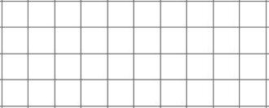  23. Complete this shape:  Mirror line |  | 4:26
6. What is the value of the 8 in this number? 2,789 | 4:4 | 16. What is the missing number?  2.96 2.97 2.98 2.99  11  15  4  15 |  | 4:14 |  |  | 4:26
7. Write the number 13 in Roman numerals. | 4:5 | 17.  3  4  + |  | 4:15 | 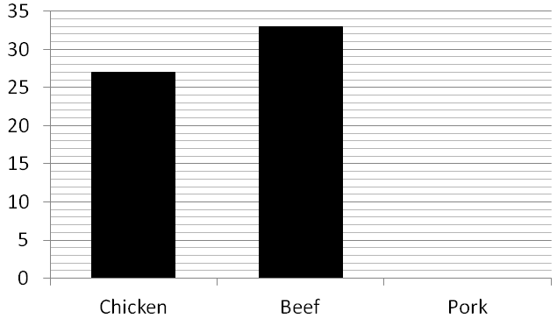  24. Favourite meats of Lower School:  17 pupils said pork. Show this.  25. How many pupils are there in Lower School? |  | 4:29  4:30
8. 8,629 - 5,318 = | 4:6 | 18. Write as a decimal number. |  | 4:16 |  |  | 4:29  4:30
9. Estimate the answer to:  4,012 + 15,982 | 4:7 | 19. 23 ÷ 10 = |  | 4:17 |  |  | 4:29  4:30
10. From 500 tickets, pupils buy 235 & parents buy 188. How many are left? | 4:8 | 20. Using £10, Rob buys a drink for 90p and a wrap for £2.50. How much left? |  | 4:18 |  |  | 4:29  4:30
Total (A) |  | Total (B) |  |  | Total (C)
Test Total (A+B+C) |  | R (0-9) | Y (10-19) |  |  | G (20-25)

