Chinese Food Tasting  Trying new and unfamiliar ingredients from Chinese cooking. |  | Dance  Moving like the animals in the story of the New Year Race. |  | Fine Motor Work  Folding and making Chinese fans and lanterns. |  |  |  | Constructing Banner Books  Finding out why Chinese write down the page.
Music  Making music for the Dragon Dance |  | What we will be learning in  Spring 1 Week 3 & 4  Chinese New Year & Dragons |  |  |  |  |  | Willow Pattern  Using the willow pattern as a base for role play of the New Year Race story.
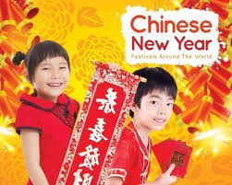 | 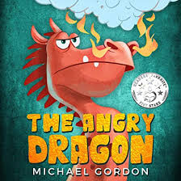 |  |  |  | 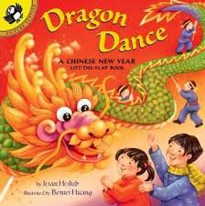 |  | 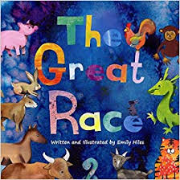
Chinese dragons  Making a concertina dragon for our dragon dance |  |  | Feelings  Thinking about training our Angry Dragon |  |  | Paper dragons  Making a paper fire breathing dragon

