Maths Key Skills Stage 4: Skill Check 12

Name: ___________________________________ Date: _______________ Class/Group: _______________________________

A: Place Value, Add and Subtract |  | B: Multiply, Divide and Fractions |  |  | C: Measure and Geometry
1. What is the missing number?  14 21 35 42 | 4:1 | 11. 11 x 12 = |  | 4:9 | 21. Rebecca went travelling for 5 weeks and 4 days.  How many days was she away for in total? |  | 4:19
2. What is the missing number?  36 42 48 54 | 4:1 | 12. Complete the sum that is equal to 6 x 27: 6 x x 9 |  | 4:10 |  |  | 4:19
3. Round this number to the nearest 10: 3,192 | 4:2 | 13. 59 x 7 = |  | 4:11 | 22. What name is given to this type of angle? |  | 4:24
4. Round this number to the nearest 100: 7,548 | 4:2 | 14. One wooden block is 4cm tall. If 14 blocks are piled up, how tall are they? |  | 4:12 |  |  | 4:24
5. What is the next number in this sequence: 3, 0, -3, | 4:3 | 15.  1  ?  4  20  1  10  = |  | 4:13 | 23. Draw all the lines of symmetry on this square. |  | 4:25
6. Write < or > to make this correct:  1,324 1,605 | 4:4 | 16. Shade of  this shape. |  | 4:14 |  |  | 4:25
7. What number does this Roman Numeral represent? XLV | 4:5 | 17.  19  15  11  15  4  10  - |  | 4:15 | 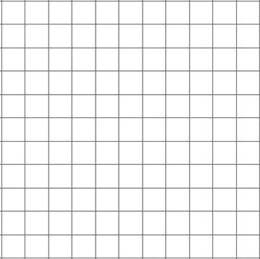  24. Complete this shape:  1 2 3 4 x  y  4  3  2  1  0  Mirror line |  | 4:26
8. 4,763 + 692 = | 4:6 | 18. Write as a decimal number. |  | 4:16 |  |  | 4:26
9. Estimate the answer to:  8,978 - 6,512 | 4:7 | 19. What is the value of the 1 in:  8.15 |  | 4:17 | 25. What are  the co-ordinates  of the point  A  labelled A? |  | 4:27
10. Sarah had £35. She bought a £15 DVD and a £8 CD. How much left? | 4:8 | 20. A log is 8.5 metres long. It is cut in half. How long is each piece? |  | 4:18 |  |  | 4:27
Total (A) |  | Total (B) |  |  | Total (C)
Test Total (A+B+C) |  | R (0-9) | Y (10-19) |  |  | G (20-25)

