Maths Key Skills Stage 2: Skill Check 11

Name: ___________________________________ Date: _______________ Class/Group: _______________________________

A: Place Value, Add and Subtract |  | B: Multiply, Divide and Fractions |  |  | C: Measure and Geometry
1. What is the missing number?  0 2 4 6 8 12 | 2:1 | 11. 60 ÷ 5 = |  | 2:11 | 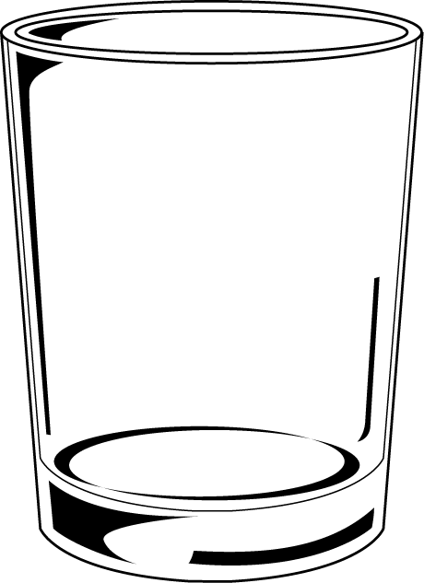  21. Estimate the capacity  of a glass. Write a, b or c.  a. about 3 litres  b. about 30 millilitres  c. about 300 millilitres |  | 2:17
2. What is the value of the 7 in this number? 73 | 2:2 | 12. Which are the odd numbers?  7 14 21 28 |  | 2:11 |  |  | 2:17
3. What number is labelled?  15  20 | 2:3 | 13. What symbol is missing?  3 9 = 27 |  | 2:12 | 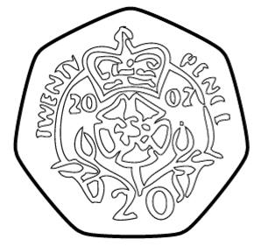  22. How many two pence  (2p) coins are the  same value as a  twenty pence  (20p) coin? |  | 2:19
4. Which numbers are < 12?  12 10 5 15 | 2:4 | 14. What symbol is missing?  21 ÷ 7 3 |  | 2:12 |  |  | 2:19
5. Write this number in numerals.  forty one | 2:5 | 15. Is this true? Write ‘yes’ or ‘no’.  30 ÷ 10 = 10 ÷ 30 |  | 2:13 | 23. Katie has sixty pence (60p).  She spends forty-five pence (45p).  How much money does she have left? |  | 2:20
6. There are 30 children in a class. 16 are girls. How many are boys? | 2:6 | 16. 3 children share 18 sweets.  How many sweets does each child get? |  | 2:14 |  |  | 2:20
7. 20 - 15 = | 2:7 | 17. 8 teams enter a 5-a-side contest. How many players are in the contest? |  | 2:14 | 24. Which is longest? Write a, b, or c.  a. half an hour  b. 40 minutes  c. three quarters of an hour |  | 2:21
8. 82 - 10 = | 2:8 | 18. Write the fraction one third in numerals. |  | 2:15 |  |  | 2:21
9. Is this true? Write ‘yes’ or ‘no’.  25 + 16 = 16 + 25 | 2:9 | 19. One quarter of a cake is eaten. How many quarters are left?  1  2 |  | 2:15 | 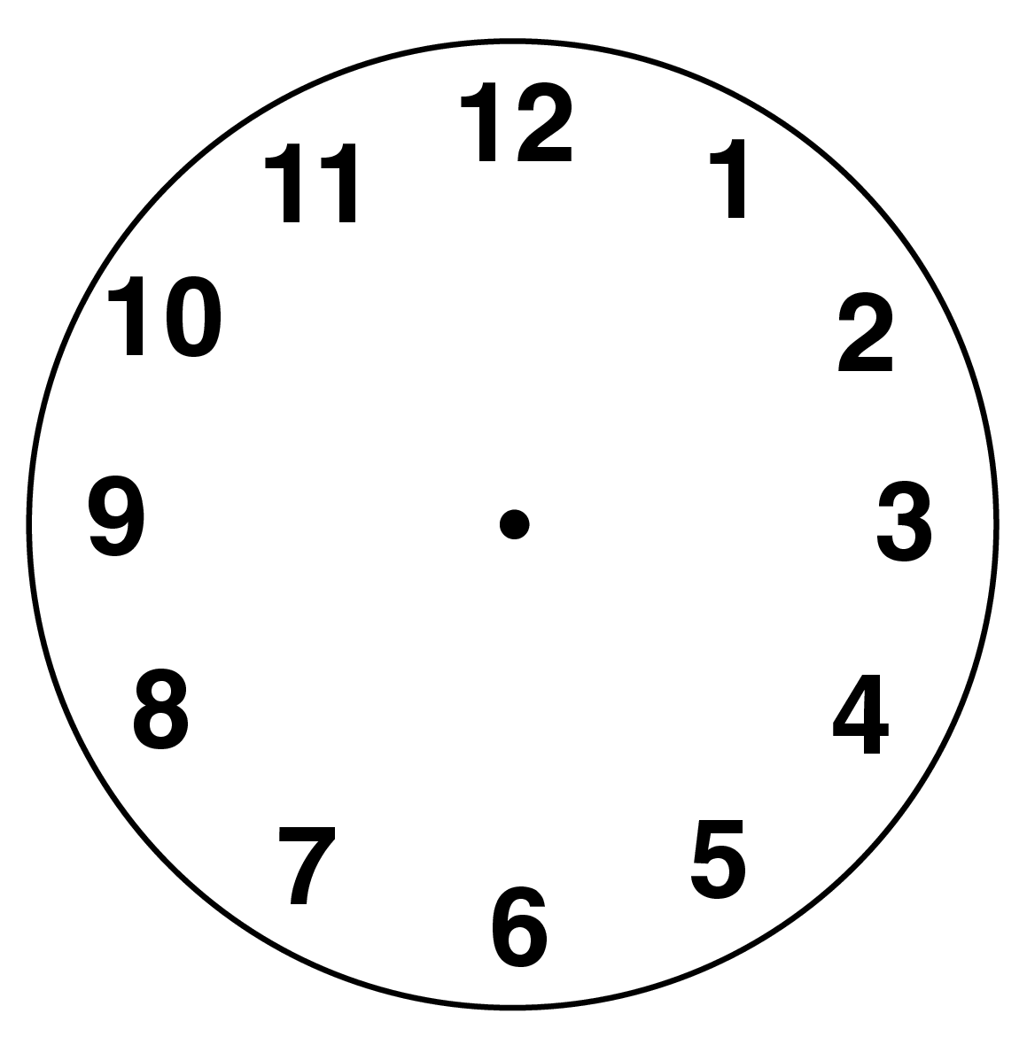  25. Draw the hands  to show  Ten minutes to six. |  | 2:22
10. Use 14 + 58 = 72 to help find:  72 - 58 = | 2:10 | 20. What is of 28 ? |  | 2:16 |  |  | 2:22
Total (A) |  | Total (B) |  |  | Total (C)
Test Total (A+B+C) |  | R (0-9) | Y (10-19) |  |  | G (20-25)

