Skills
Use research to inform the design of innovative, functional and appealing products.
Generate, develop, model and communicate ideas through discussion, sketches and prototypes.
Select from and use a wide range of tools and equipment to perform practical tasks.
Select from and use a wider range of materials and components.
Evaluate their ideas and products against their design criteria.

Knowledge
To consider the purposes of illuminated signs and identify a number of ways in which signs may be illuminated.
To consider ways in which electrical components in a simple circuit can be partially ‘hidden’ inside products to make them more attractive.
To investigate the pros and cons of using different materials in the construction of a decorative light box sign.
To investigate and consider ways in which they can make more permanent circuits to fit and fix inside their finished decorative illuminated light box signs.
To be able to evaluate a finished product.

Design and Technology– Year 6 – Autumn 2 – Christmas Decoration
Vocabulary  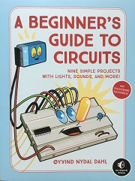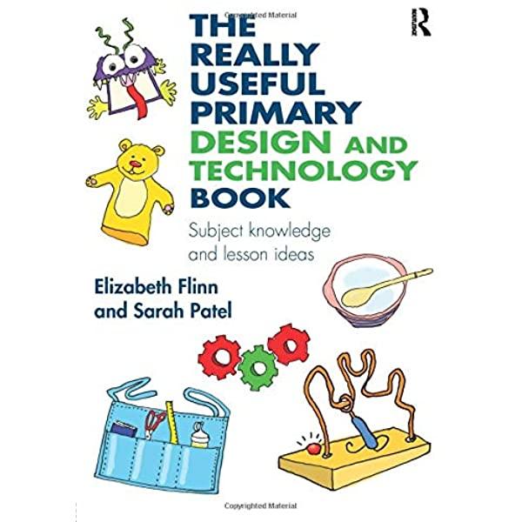  Books | Meaning
circuit | A path for transmitting an electrical current.
component | A part or element of a larger whole.
design | A plan or drawing produced to show an object before it is made.
electrical | Concerned with, operating by, or producing electricity.
evaluate | To assess, judge or calculate the quality of something.
illuminate | Make something visible or bright by shining a light on it; light up.
light box | A box having a side of translucent material and containing an electric light
resistor | A device having resistance to the passage of an electric. current
series circuit | A path along which the whole current flows through each component.
translucent | Allowing light to pass through; semi-transparent.
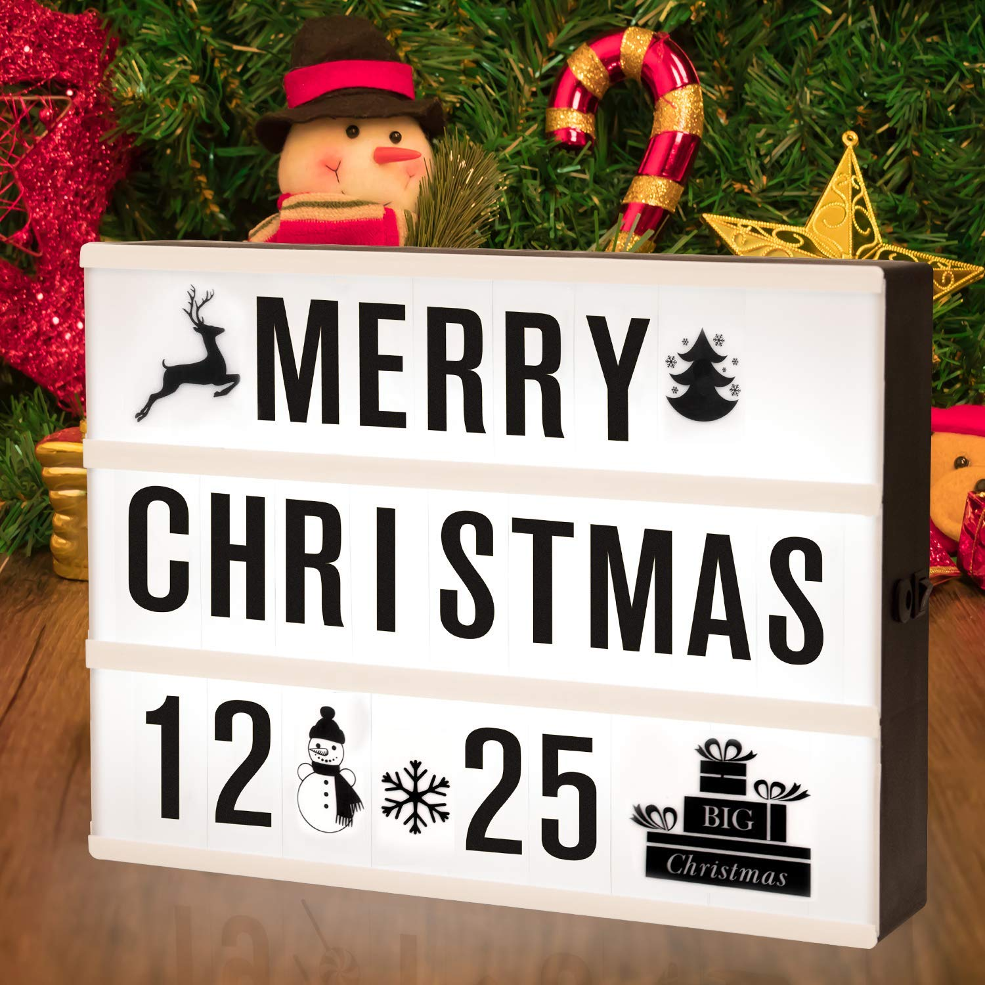

Concept Links

What I will know and be able to do at the end of the topic.
What I should be able to do and know now.

Knowledge
- It is helpful to illuminate signs because …
It is helpful to illuminate signs, but …
It is helpful to illuminate signs, so …

- If too many lights are added to a series circuit, the bulbs will dim because …
If too many lights are added to a series circuit, the bulbs will dim, but …
If too many lights are added to a series circuit, the bulbs will dim, so …

- Translucent materials work best for creating a light box because …
Translucent materials work best for creating a light box, but …
Translucent materials work best for creating a light box, so …
Skills –
- Which components and tools are needed to construct a circuit?

Knowledge
Apply understanding of how to strengthen, stiffen and reinforce more complex structures.
Understand and use electrical systems in their products (for example, series circuits incorporating switches, bulbs, buzzers and motors)
Evaluate ideas and products against their own design criteria.
Skills
Use research and develop criteria to inform the design of innovative, functional, appealing products that are fit for purpose.
Generate, develop, model and communicate ideas through discussion, sketches and prototypes.
Measure and cut precisely.
Choose appropriate tools and materials.

Evaluate Products
Build and
Explore
Design Products

Share ideas with others through design.
Selecting materials and equipment.

What I will be learning

- I am learning to investigate and analyse illuminated signs.
- I am learning to develop ideas for a decorative illuminated sign.
- I am learning to select and use tools, equipment, materials and components to make the enclosure of a decorative illuminated sign.
- I am learning to construct a working circuit with one or more lights, and fit it in a decorative illuminated sign.
- I am learning to evaluate my design and finished product.

