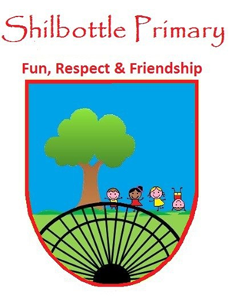
Year 1 Spelling List – Spring 1st
Dear parents/carers,
Below is a copy of the spellings which will be tested this half term. There will be a general spelling rule each week. The final week (18th Feb) will be a combination of all the words. You may also find it useful to take a photo on a smartphone to keep a record of the words which will enable you to support your child’s learning beyond the home. A copy of these words will also be available from the school website should you need to replace them. Many thanks for your continued support.

Week 1  Test date 7th January | Week 2  Test date 14th January | Week 3  Test date 21st January
wrap  wreck  wrong  wrist  write  wriggle  wrestle  wrote  wrinkle  wring  Spelling Rule: “r” spelt wr | finer  braver  closer  wiser  nicer  whiter  timer  wider  larger  ruler  Spelling Rule: adding the suffix “er” – No change to the word or drop an e before adding er | fastest  slowest  softest  loudest  quickest  hardest  largest  widest  rudest  cutest  Spelling Rule: adding the suffix “est” – No change to the word or drop an e before adding est
Week 4  28th January | Week 5  Test date 4th February | Week 6  Test date 11th February
happier  sillier  jollier  funnier  tidier  tastier  prettier  slimier  luckier  spikier  Spelling Rule: adding the suffix “er”- If a word ends in y swap for an i before adding er | funniest  tidiest  happiest  silliest  tastiest  prettiest  slimiest  spikiest  luckiest  floppiest  Spelling Rule: adding the suffix “est”- If a word ends in y swap for an i before adding est | sadder  bigger  slimmer  hotter  fitter  wettest  gladdest  maddest  biggest  saddest  Spelling Rule: adding the suffix “er” and “est”- Doubling the last consonant

