RE – Islamic rites of passage.
00
Knowledge
Most religions mark significant points in their followers’ lives with special ceremonies. Islamic rites of passage focus on key teachings and the demands of living as a good Muslim.
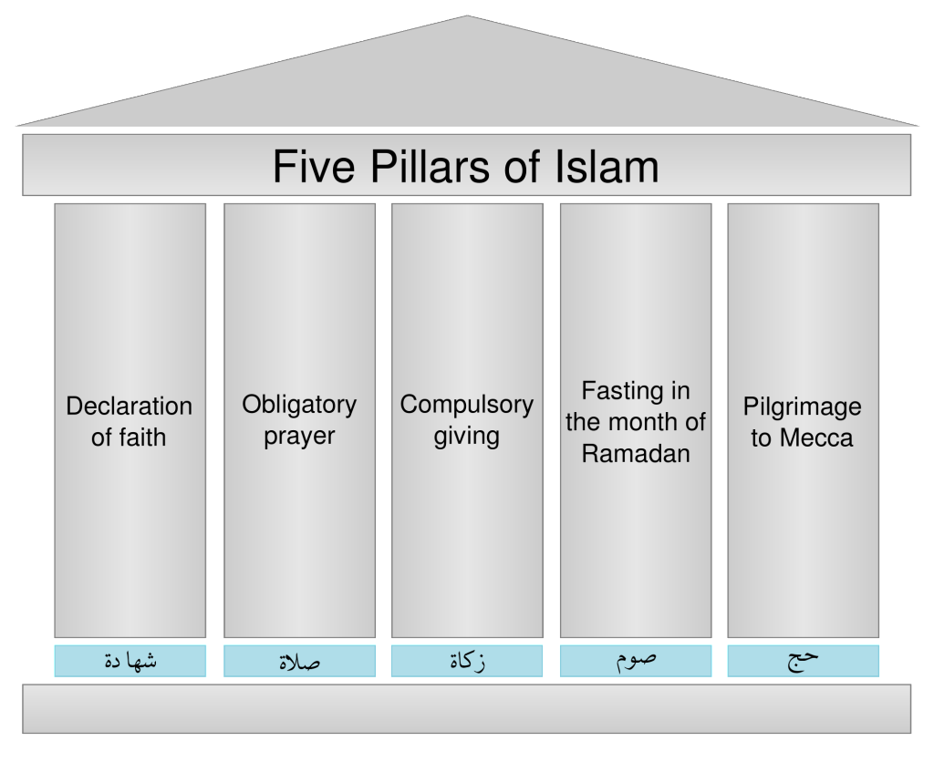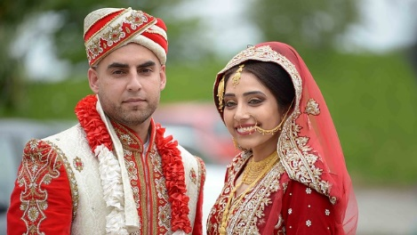

Skills
- I can describe the features of the religion.
- I can discuss comparisons between religions.
- I am able to understand the impact a religion has on the believers’ lives.
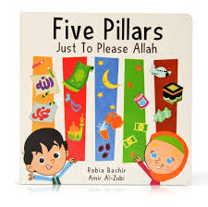
Books

Vocabulary | Meaning
afterlife | The belief that there is a life after death.
ceremony | A religious event celebrating a special event.
five pillars | The five core beliefs and practices of Islam.
Hajj | One of the five pillars of Islam. The greater Muslim pilgrimage to Mecca, which takes place in the last month of the year and which all Muslims are expected to make at least once during their lifetime
Islam | The religion of Muslims. Believing in Muhammad as the prophet of Allah.
Mahr | Money paid by the Groom to the Bride before marriage takes place.
Mendhi | Patterned henna tattoos worn by the bride before her wedding.
Muslim | A person who believes in the Islamic faith.
Nikah | A written contract of marriage.
pilgrimage | A journey to a special place for a religious person.
requirements | Things that are needed to be completed for something to happen.
Walima | A sit down meal which is the second part of an Islamic wedding.

What I should be able to do and know now.
What I will know and be able to do at the end of the topic.

Knowledge
- As you grow up you achieve different things in your life.
- Celebrations are held to celebrate an event or achievement.
- Different religions celebrate special events in different ways.
- Different religions have different ceremonies for different things.
- I know what a symbol is.

Skills
- I can compare different religions by looking at their similarities and differences.
- I can ask questions about religion.
- I can name some features of different religions.

Knowledge

- A person who believes in Islam is called a M_________.
- Muslims believe in the God A_________.
- Can you name the five pillars of Islam?
- Describe what happens at an Islamic marriage ceremony.
- How is an Islamic marriage ceremony similar to a Christian wedding ceremony?
- How is an Islamic wedding ceremony different to a Christian wedding ceremony?

Skills
- To make comparisons between more than one religion.
- Name features and describe the practices of the Islamic religion.
- Ask questions to develop my knowledge and understanding.

- Begin to identify the impact religion has on believers’ lives.
- Recognise and name some features of religious life and practice.
- Describe some of the beliefs and features of a religion, recognising similarities and differences.
- Ask important questions about religion and beliefs.
- Show awareness of other peoples’ views.

What I will be learning
- To understand what Islam is and what the five pillars are.
- To explore Muslim birth ceremonies and naming days.
- To find out about the Islamic marriage ceremony.
- To find out about Muslim funeral ceremonies.
- To understand the importance of the Hajj for a Muslim person.

