Maths Key Skills Stage 4: Skill Check 14

Name: ___________________________________ Date: _______________ Class/Group: _______________________________

A: Place Value, Add and Subtract |  | B: Multiply, Divide and Fractions |  |  | C: Measure and Geometry
1. What is the missing number?  50 75 125 150 | 4:1 | 11. 144 ÷ 12 = |  | 4:9 | 21. Kirsty has 1 kilogram of sugar. She uses 650 grams to make some cakes.  How many grams of sugar are left? |  | 4:21
2. What is the missing number?  54 63 72 81 | 4:1 | 12. Use 7 x 13 x 2 = 182 to answer:  14 x 13 |  | 4:10 |  |  | 4:21
3. What is 1,000 less than 7,345? | 4:2 | 13. 57 x 5 = |  | 4:11 | 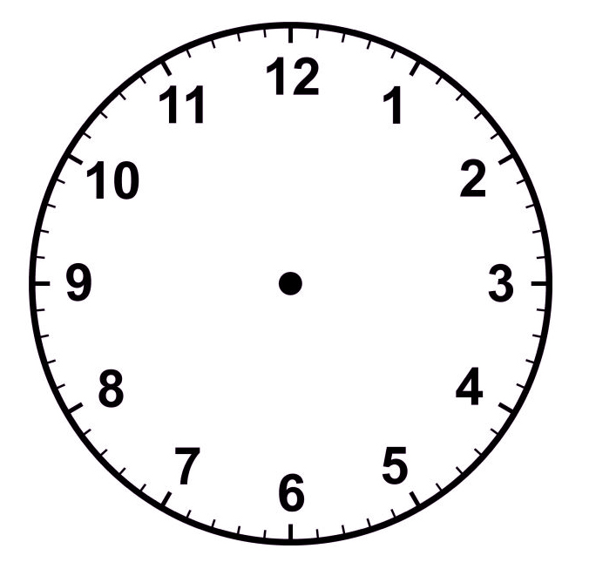  22. Draw the hands  to show:  21:40 |  | 4:22
4. Round this number to the nearest 1,000: 7,548 | 4:2 | 14. Shop A sells 8 pens for £4. Shop B sells 3 pens for £2. Which is cheaper? |  | 4:12 |  |  | 4:22
5. Put these numbers in order, smallest first: -4 0 -2 | 4:3 | 15.  1  5  15  5  1  10  =  = |  | 4:13 | 23. What is the name of this quadrilateral? |  | 4:23
6. Put these in order, smallest first:  4,384 4,843 4,438 | 4:4 | 16. To find of a number, what do you divide it by? |  | 4:14 |  |  | 4:23
7. What number does this Roman Numeral represent? XXXIX | 4:5 | 17.  13  5  3  5  68  100  - |  | 4:15 | 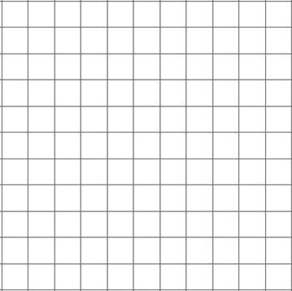  24. Plot the point (1, 1). Label it C.  1 2 3 4 5 x  y  5  4  3  2  1  0  A  B  25. Points A, B and C form 3 corners of a parallelogram. Plot the fourth corner of the shape and label it D. |  | 4:28  4:28
8. 3,916 + 4,207 = | 4:6 | 18. Write as a decimal number. |  | 4:16 |  |  | 4:28  4:28
9. Write the sum to check 283 + 39 = 322: 322 - = | 4:7 | 19. What is the value of the 5 in:  8.15 |  | 4:17 |  |  | 4:28  4:28
10. Pencils weigh 55g. Pens weigh 73g. How heavy are 1 pencil and 2 pens? | 4:8 | 20. Round 9.6 to the nearest whole number. |  | 4:18 |  |  | 4:28  4:28
Total (A) |  | Total (B) |  |  | Total (C)
Test Total (A+B+C) |  | R (0-9) | Y (10-19) |  |  | G (20-25)

