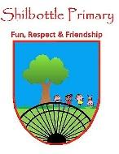

**Art – Landscapes & seascapes**

**Vocabulary Meaning**

**Skills**

**Books**

* To be able to design a piece of artwork in the style of an artist.
* To select materials, appropriate for the task I am completing.
* To use watercolours to create colours appropriate to my artwork style.
* To compare artists work/ styles for what is similar and what is different.

The back of the picture – those parts that are furthest away.

**background**

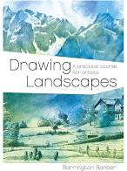 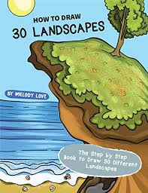

To mix something (paint) together to create new colours.

**blend**

The sweeping movements of the paintbrush.

**brush strokes**

The front of the picture – the things in the front of the picture closest to you.

**foreground**

**Knowledge**

A scene of an area of land.

**landscape**

The view point that the picture is being drawn/ painted from.

**perspective**

**By the end of this topic you will learn:**

* The difference between a landscape and a seascape.
* How to blend watercolours to create appropriate colours for a scene and apply this to your artwork.
* About some artists that are famous for painting landscapes and seascapes.
* How to get perspective in a landscape/ seascape using size and colour of the elements.

A scene of an area of land involving the sea.

**seascape**

A snapshot of all the things in an area – like a photograph.

**scene**

The objects and things that make up a scene.

**scenery**

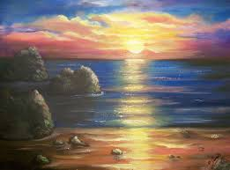

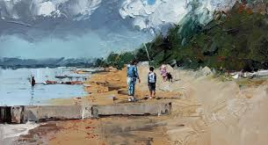

When you use the artistic materials skilfully or in the correct way.

**technique**

The feel or appearance of a surface.

**texture**

A type of paint that requires water to form the liquid paint.

**watercolours**

**What I should be able to do and know now.**

**What I will know and be able to do at the end of the topic.**

**Key skills in Art**

**Knowledge:**

* What is a landscape? What is a seascape?
* Can you name a famous artist who was known for their artwork on landscapes or seascapes?
* For your picture to look 3D you need to use the right p____________.
* In a landscape, the foreground is the __________ and the background is the __________ of the scene.
* Can you explain/ or show how you would make your watercolour paint a darker shade? How would you make the shade of the colour lighter?

**Skills:**

* Copy an artist’s style to create your own landscape/ seascape.
* Choose my colours to bland those for my scene.
* Use perspective in my drawing and painting to create a 3D effect in my artwork.
* Use the correct techniques when using art materials to create my artwork.
* Develop ideas from starting points throughout the curriculum.
* Replicate some of the techniques used by notable artists and designers.
* Create original pieces that are influenced by the study of others.
* Include texture that conveys feelings, expression or movement.
* Use a number of brush techniques using thick and thin brushes to produce shapes, textures, patterns and lines.

**Knowledge:**

* To know that a landscape involves drawing/ painting the land.
* A scene is like a picture.
* Name some famous artists.
* To use watercolours, I must mix the paint with water.
* A smaller brush will give me thinner lines.

**Skills:**

* Use a paint to fill in shapes.
* Mix pain to make new colours.
* Draw shapes and lines using a pencil.
* Draw objects and places to make a scene.

**What I will be learning**

* Learn about famous artists who have created landscapes and seascape artwork.
* Create texture and depth in my artwork to give perspective.
* Create a scene from a certain perspective.
* Use a range of art materials to recreate artists work and use these ideas to create my own pieces.