Maths Key Skills Stage 2: Skill Check 4

Name: ___________________________________ Date: _______________ Class/Group: _______________________________

A: Place Value, Add and Subtract |  | B: Multiply, Divide and Fractions |  |  | C: Measure and Geometry
1. What is the missing number?  12 22 32 42 52 | 2:1 | 11. 9 x 5 = |  | 2:11 | 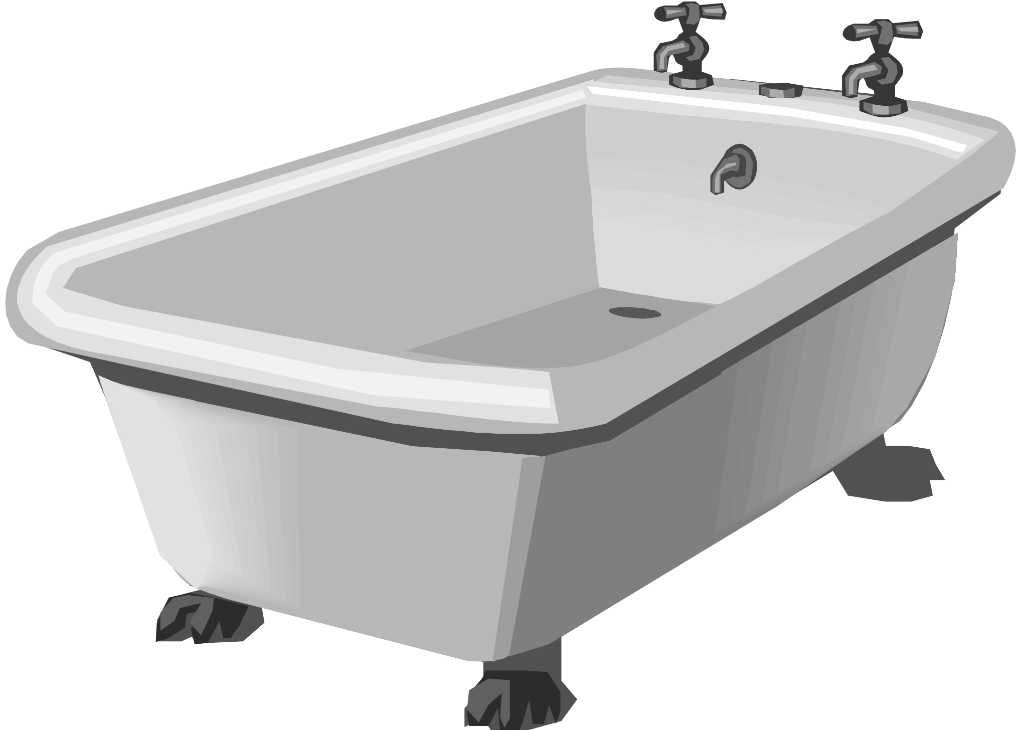    21. Which of these has the greatest capacity?  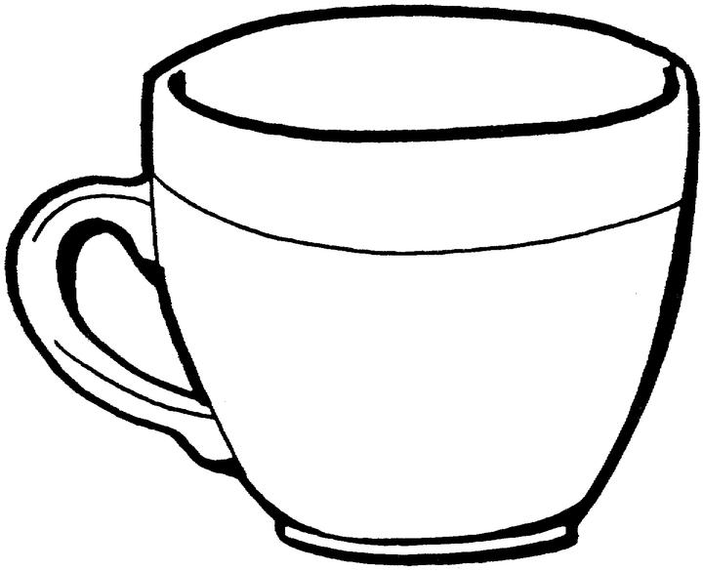  a. a bath  b. a bucket  c. a cup |  | 2:18
2. Circle the 3s that have a value of 3.  13 38 43 31 | 2:2 | 12. Which are the odd numbers?  2 7 16 23 |  | 2:11 |  |  | 2:18
3. What number is labelled?  5  10 | 2:3 | 13. What symbol is missing?  3 x 5 15 |  | 2:12 | 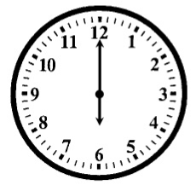  22. How many minutes are there in 1 hour?  a. 12  b. 24  c. 60 |  | 2:21
4. Put these in order, smallest first.  34 4 43 3 | 2:4 | 14. What symbol is missing?  14 7 = 2 |  | 2:12 |  |  | 2:21
5. Write this number in words.  71 | 2:5 | 15. Is this true? Write ‘yes’ or ‘no’.  15 ÷ 3 = 3 ÷ 15 |  | 2:13 | 23. Which of these shapes has 4 sides?  a. triangle  b. circle  c. square |  | 2:23
6. A garden has 15 trees. 9 more are planted. How many trees now? | 2:6 | 16. 4 flowers each have 7 petals. How many petals are there in total? |  | 2:14 |  |  | 2:23
7. Use 11 + 9 = 20 to answer:  55 + = 100 | 2:7 | 17. I have 18 eggs. If they come in boxes of 6, how many boxes do I have? |  | 2:14 | 24. Complete the sentence:  A square based pyramid has 8  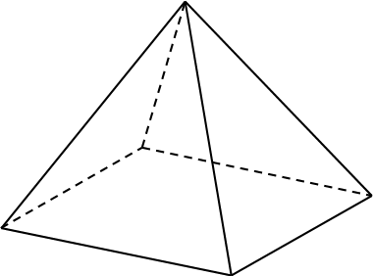  a. vertices  b. edges  c. faces |  | 2:24
8. 9 + 7 + 8 = | 2:8 | 18. What fraction of the  strawberries is circled? |  | 2:15 |  |  | 2:24
9. Tick (✓) if true:  28 - 7 = 7 - 28 38 + 6 = 6 + 38 | 2:9 | 19. Write the fraction two quarters in numerals.  1  4 |  | 2:15 | 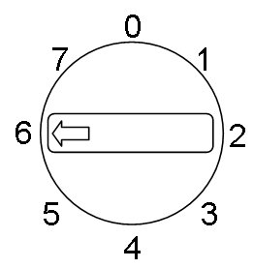  25. This dial is pointing  at 6. What number will  it point to after being  turned clockwise  through 3 right angles? |  | 2:28
10. Use 62 - 17 = 45 to help find:  17 + 45 = | 2:10 | 20. What is of 20 ? |  | 2:16 |  |  | 2:28
Total (A) |  | Total (B) |  |  | Total (C)
Test Total (A+B+C) |  | R (0-9) | Y (10-19) |  |  | G (20-25)

