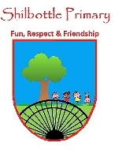

**P.S.H.E. – Being me in my world.**

**Skills**

Face new challenges positively.

Know how to set personal goals.

Empathise with other people.

Listen to other people.

Show respect towards others.

Ask questions to develop my understanding.

Make appropriate behavior choices.

**Knowledge**

In this Puzzle we are learning about being a good citizen. You will look at and plan for the forthcoming year. You will learn about rights and responsibilities of yourself and of other people in the world. You will think about how behaviours have consequences and that you are in charge of your own behaviours and actions. You will look at what democracy is, what it means to have a voice and how you can participate in important events linked personally to you.

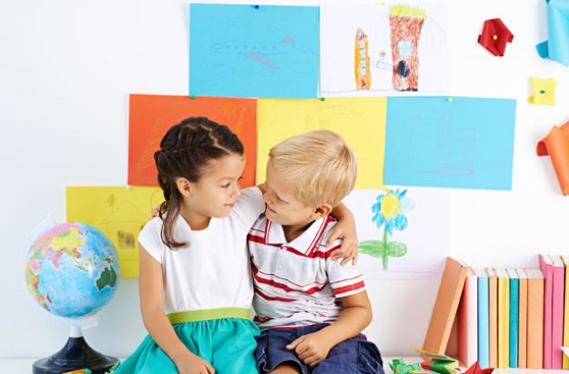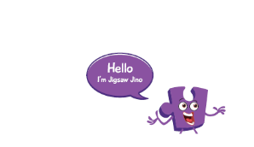

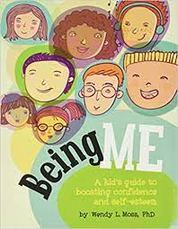 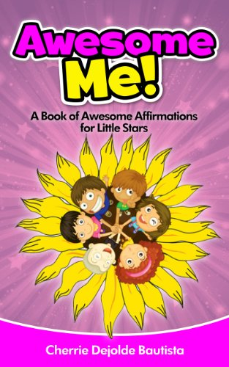 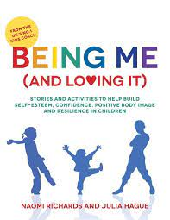

**Books**

|  |  |
| --- | --- |
| Vocabulary | Meaning |
| **achieve** | Successfully reach a desired outcome or result. |
| **appreciation** | Recognition and enjoyment of the good qualities about someone or a situation. |
| **challenge** | To have to put in an effort to gain a desired result. |
| **conflict** | A disagreement or argument. When people do not agree. |
| **consequences** | A result or effect due to an action or behaviour. Often negative and rewards are positive.. |
| **deprive** | To prevent from having or using something. |
| **empathise** | To understand and share the feelings of another person. |
| **goals** | Set by an individual to achieve objectives that will ‘better’ themselves. |
| **opportunities** | A time or set of circumstances that make it possible to do something. |
| **prejudice** | An opinion about another person or group of people based on no reason or experience. |
| **responsibilities** | The opportunity or ability to act independently and take decisions. |
| **rights** | A moral or legal entitlement to have or to do something. |

**What I will know and be able to do at the end of the topic.**

**Key skills in PHSE**

**What I should be able to do and know now.**

**Knowledge**

What are responsibilities?

What are rights? Can you give an example of a right?

Can you give an example where a choice to carry out a behaviour may impact on others in a positive way?

Can you give an example where a choice to carry out a behaviour may impact on others in a negative way?

**Skills**

I can show empathy for others in my responses to their feelings.

I can recognise feelings that are positive and negative.

I can work fairly in a group.

I can explain what other people may be thinking or feeling.

I can respect others’ opinions.



**Knowledge**

I know that as I get older there will be new things to learn and new challenges.

I know that as I get older I will have more responsibilities.

I know that I am allowed to have my own thoughts and feelings.

I know that sometimes a leader has to make a decision.

I know that my choices can impact on others and not just me.

**Skills**

I can sit and listen.

I can give my opinion.

I can explain the reason why someone may feel a particular emotion.

I can take my turn in a conversation or discussion.

I can work with a partner or in a group.

**What I will be learning**

* How to face new challenges positively and how to set personal goals.
* To understand my rights and responsibilities as a citizen of my country and of my school.
* To make choices about my own behaviour and understand how rewards and consequences feel.
* To understand how an individual’s behaviour can impact on a group.
* To understand what democracy is and how having a voice can benefit my school community.