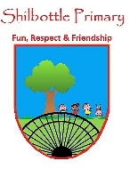
PSHE - Year 1 – spring 1 and 2 – Are we all the same
00
Skills
Develop empathy.
Make links to other areas of learning.
Make choices.

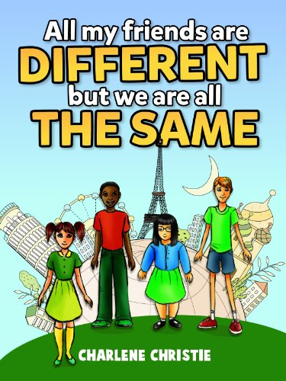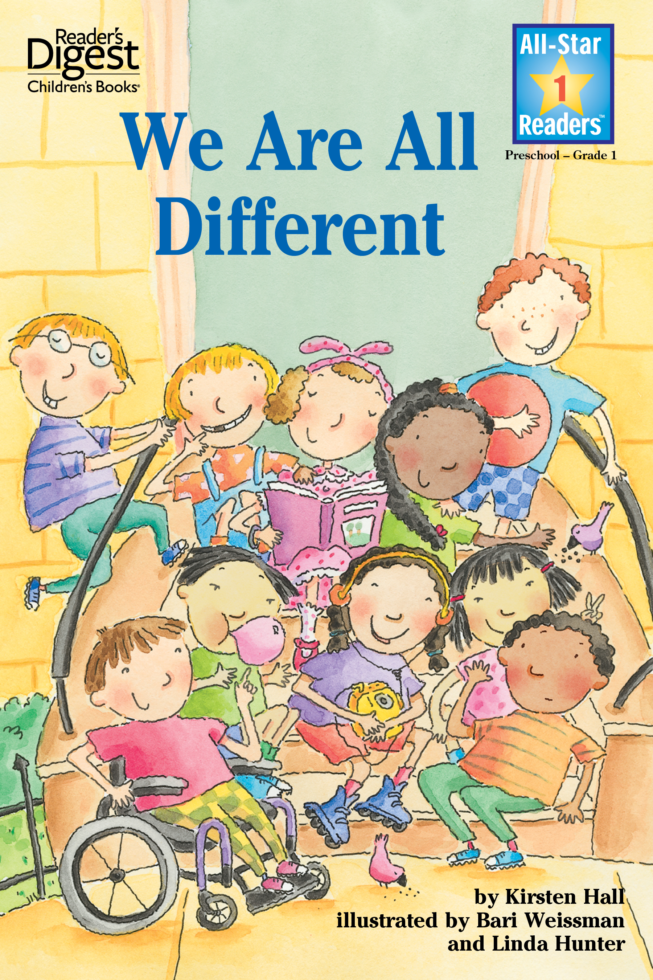
Books

Knowledge
To understand the concept of variation
That belonging to different groups doesn’t make us totally different.
To appreciate the effect their actions can have on others.
To understand that difference is a positive and not something to be mocked or used as
a cause for bullying.
To identify differences between family groups.
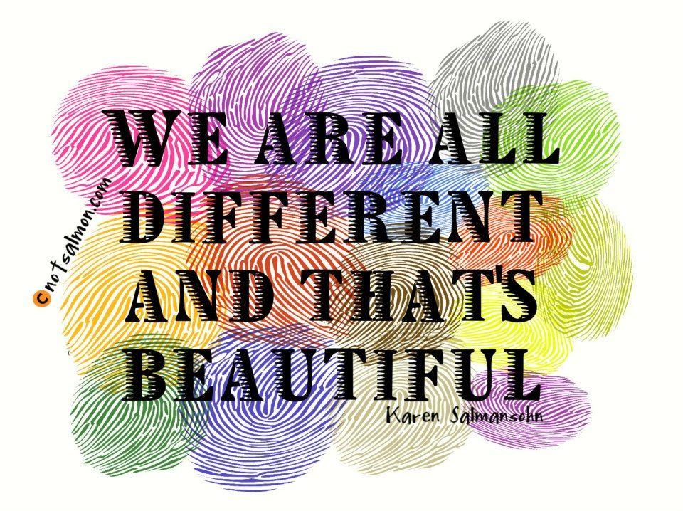
Vocabulary | Meaning
bully | To keep picking on someone because you think you’re better than them.
different | Not the same as each other.
group | A number of people that are classed together.
habit | Something that a person does that is hard to give up.
hobby | An activity done in your spare time for pleasure.
intent | The aim or goal of somebodies actions.
mock | Tease or laugh at someone in a nasty way.
similar | Something that is alike or the same.
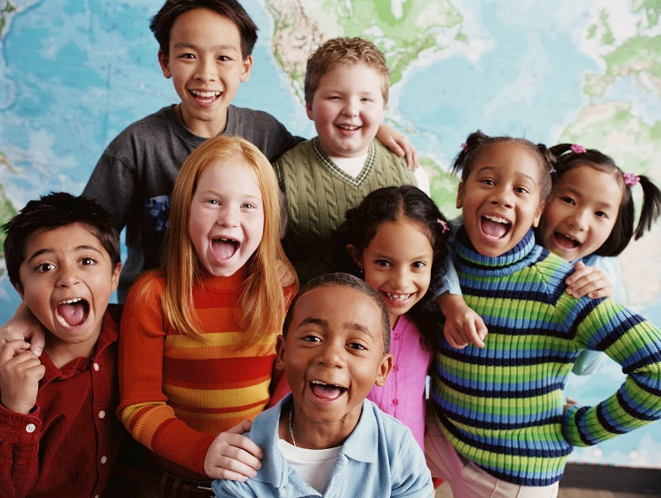

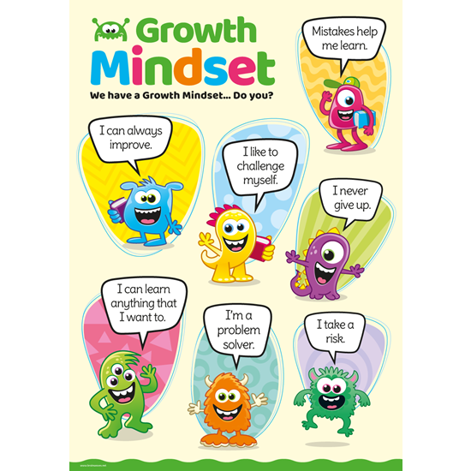
What I will know and be able to do at the end of the topic.
Growth Mindset Strategies

What I should be able to do and know now.
Knowledge
How are people the same and how are we different? Understand that we are all the same even though we may have different eye and hair colour, skin colour, body shape and family.
What groups do you belong to? Understand that they belong to lots of different groups, children in class2 but to lots of bigger groups too. Children in Shilbottle, children in Northumberland, in England, in United Kingdom, in Europe, in the world.
How can our actions affect other people? Understand that our actions can make people sad even if we do not intentionally mean to do so but we can also make people happy too.
Why should we not make fun of people who are different to us? Everyone is different and it is important people are allowed to do things that make them happy and not just do things because everyone enjoys doing them.
Why are all families different? Some children live with both parents some with only one, some with grandparents. Some children have brothers, sisters, aunties.
Knowledge
I know that some children look different to me.

Skills
I can show sensitivity to others’ needs and feelings, and form positive relationships with adults and other children.

I can talk about how I and others show feelings, talk about my own and others’ behaviour and its consequences, and know that some behaviour is unacceptable.

I work as part of a group or class, and understand and follow the rules

I adjust my behaviour to different situations, and take changes of routine in my stride.

What I will be learning

- How to understand the differences and similarities between people.
- To know that they belong to groups and that people in different groups are different and the same.
- I know that my behaviour can hurt a friend’s feelings.
- To appreciate that we are all different.
- That everyone has a family and they are all different.

