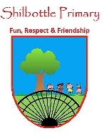
Science – Y5 – Spring 1 – Forces
Skills
Children can plan and carry out an experiment, making sure it is a fair test.
Children can draw conclusions from their own investigations.
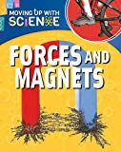
Books

Knowledge
Children know what weight is.
Children can explain why objects fall towards the centre of the Earth.
Children understand the causal link between the mass of an object and the amount of force with which gravity acts on it.
Children can define friction.
Children know that friction can be useful and give some examples.
Children know that air resistance is a force that slows objects moving through the air.

Vocabulary | Meaning
air resistance | A type of friction caused by air pushing against any moving object.
buoyancy | A upward force that a liquid applies to objects.
forces | Pushes and pulls.
friction | A force that acts between two surfaces or objects that are moving, or trying to move across each other.
gravity | A pulling force exerted by the earth (or anything else that has mass).
mass | A measure of how much matter is inside an object.
mechanism | Parts which work together in a machine.
weight  Key People | The measure of the force of gravity on an object.
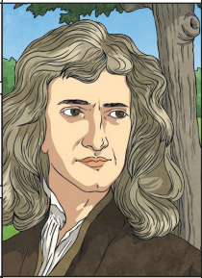

Growth Mindset Strategies
What I will know and be able to do at the end of the topic.
What I should be able to do and know now.

Understand the difference between a FIXED
mindset and a GROWTH mindset.
Be Curious; Be courageous.
Challenge yourself. Ask, ‘What could I do
differently next time?’
Give everything your best effort and
persevere.
Practice; Practice; Practice.

Knowledge

I can explain why an object falls towards the centre of the Earth because …
I can explain why an object falls towards the centre of the Earth but …
I can explain why an object falls towards the centre of the Earth so …

Isaac Newton is one of the greatest scientists that has ever lived because …
Isaac Newton is one of the greatest scientists that has ever lived but …
Isaac Newton is one of the greatest scientists that has ever lived so …

Skills:
Children can plan and carry out an experiment, making sure it is a fair test.
Children can draw conclusions from their own investigations.

Knowledge:
To know that teeth are used to chew food.
To know that once food is swallowed it goes to the stomach.
To know that animals can eat other animals but also plants.
To know that not all animals eat the same diet.
To know that food is used by the body to grow and stay healthy.
To know that organs in the body have different functions to keep us alive.
Skills:
Label a basic diagram using arrows.
Draw a table to collect results for an experiment.
Explain in small steps how a process happens.

What I will be learning
To explain that unsupported objects fall towards the Earth because of the force of gravity acting between the Earth and the falling object.
To identify the effects of friction acting between moving surfaces.
To identify and explain the effects of air resistance.

