Weather Charts  Recording the weather using symbols. | Winter Walks  Looking for signs of winter. | Scissor Practise  Cutting snowflakes and icicles to make a winter display. | Ice Pictures  Making 3D frozen sculptures using objects that float or sink
Frozen Escape  How can we melt ice and free our frozen toys? | What we will be learning in  Spring 1 Week 1 & 2  Winter, Ice and Snow |  | Building Shelters  Using materials we find on our walks and in the class to build shelters for our toy animals
Investigating ice  Finding out whether ice floats or sinks, how it melts, and how water freezes. | Music  Using percussion to make quiet sleepy music for Bear, and icy frosty music. | Technology  Using a laptop to type labels for displays.  Using I-pads to take photographs of signs of Winter. | Arctic Animals  Use small world to create a “snowy” scene for our Arctic animals.
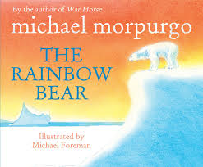 | 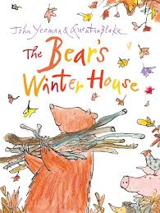 | 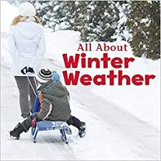 | 