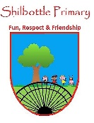

**Geography – Year 6 – autumn 1 – Earth Matters**

**Vocabulary**

**Skills**

**Books**

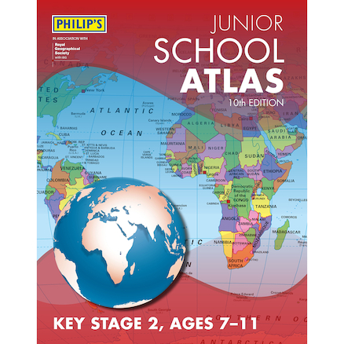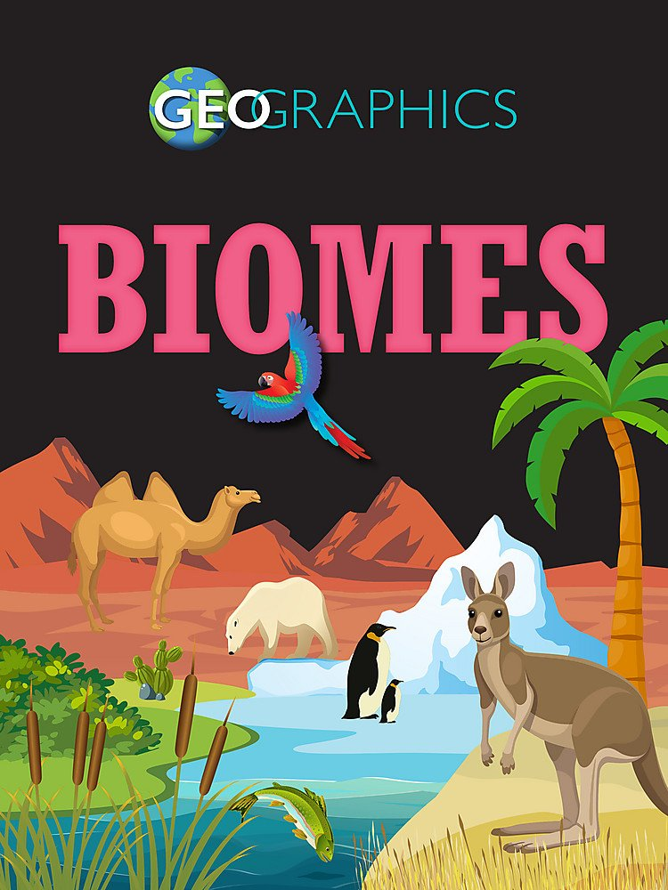 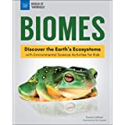 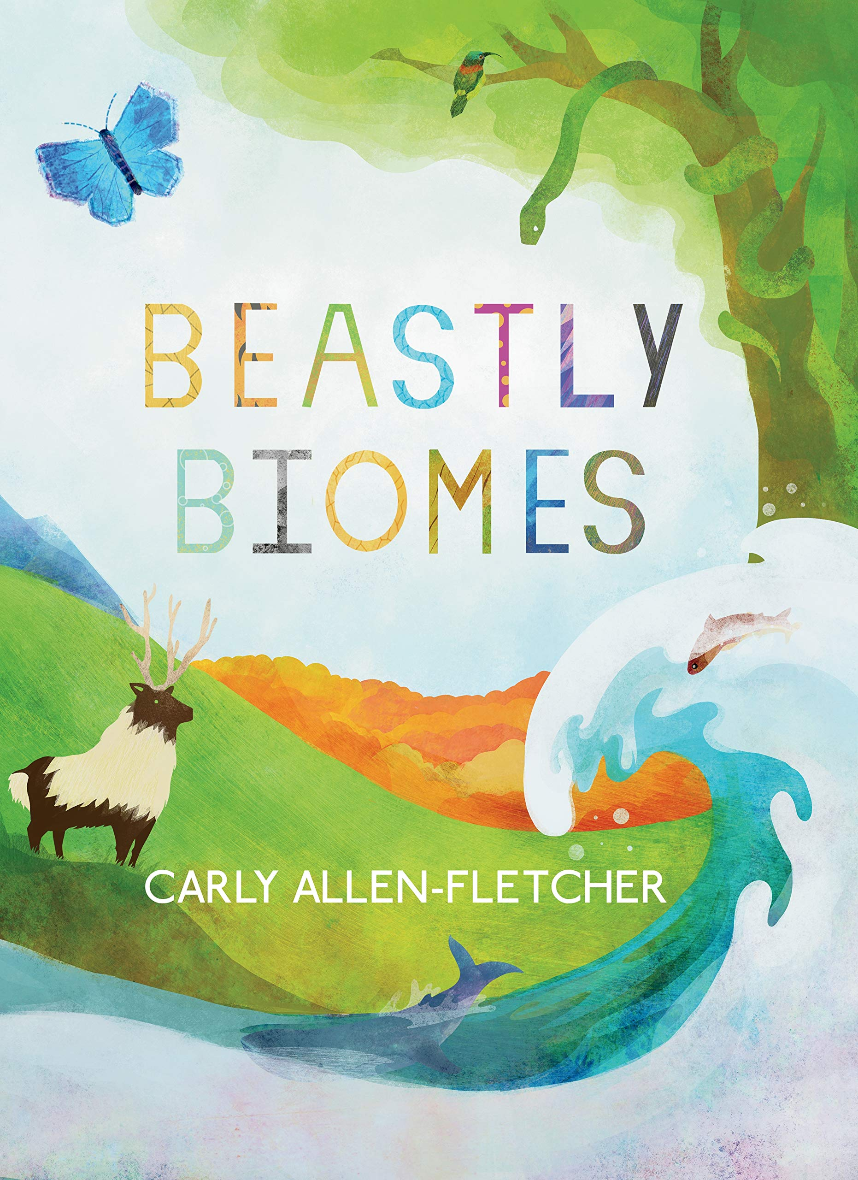

Use and create maps to locate and describe features studied.

Use fieldwork to observe, measure and record the human and physical features in the local area.

Compare different sources of information and decide which is more reliable.

Use photographs to compare ecosystems.

Collect information about the vegetation and wildlife around the local area.

The diverse and complex ecosystem that supports and gives life to all organisms.

**biodiversity**

A collection of ecosystems that have similar weather, rainfall, plants and animals.

**biome**

Average measurements of temperature, wind, humidity and precipitation over time.

**climate**

The long-term changes in global climates.

**climate change**

**Knowledge**

The process by which water vapour turns into liquid.

**condensation**

A community of interacting organisms and their environment.

**ecosystem**

Any individual plant or animal cannot exist by itself. All living things need millions of other living things to survive and they all work in a team. All these living things, together with the sun, soil, water and air is called an ecosystem. A biome is a large collection of ecosystems that have similar weather, rainfall, animals, and plants.

There are seven major biomes in the world: rainforest, savannah, tundra, taiga, desert, temperate, grassland.

The water cycle, also called the hydrolic cycle, occurs all around us within every biome. ... It is through this cycle that our water supply gets replenished and allows for plants and animals to live and thrive. The water cycle has **four main parts, evaporation, condensation, precipitation, and collection**.

Climate change can **alter where species live, how they interact, and the timing of biological events**, which could fundamentally transform current ecosystems and food webs. Climate change can overwhelm the capacity of ecosystems to mitigate extreme events and disturbance, such as wildfires, floods, and drought.

An educational charity that builds relationships between people and the natural world.

**Eden Project**

The surrounding conditions that a living thing organism finds itself in.

**environment**

The process by which a liquid turns into a gas.

**evaporation**

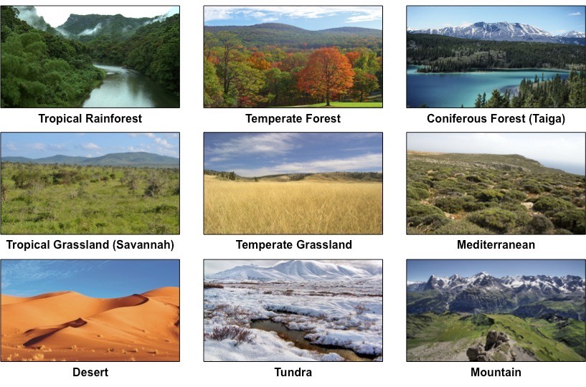

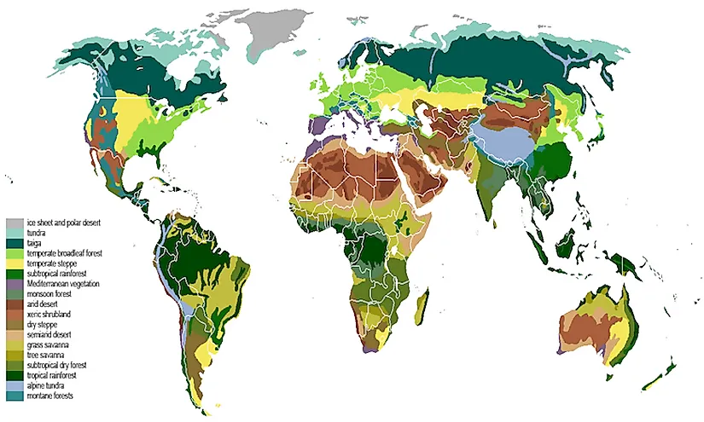

The release of water from the sky, it can be in liquid or solid form.

**precipitation**

The path all water follows as it moves around Earth.

**water cycle**

Plants or plant life in a particular place

**vegetation**

**What I should be able to do and know now.**

**What I will know and be able to do at the end of the topic.**

**Concepts Links**

**Knowledge:**

* Biomes are important geographic areas because …
* Biomes are important geographic areas, but …
* Biomes are important geographic areas, so …
* A biome and an ecosystem are not the same thing because …
* A biome and an ecosystem are not the same thing, but …
* A biome and an ecosystem are not the same thing, so …
* The water cycle is an important part of a biome because …
* The water cycle is an important part of a biome, but …
* The water cycle is an important part of a biome, so …

**Skills**

* Using a digital map can help locate places to 100m because …
* Using a digital map can help locate places to 100m, but …
* Using a digital map can help locate places to 100m, so …
* Being able to measure the humidity of an area is important because …
* Being able to measure the humidity of an area is important, but
* Being able to measure the humidity of an area is important, so

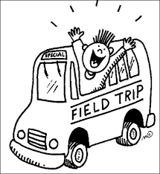 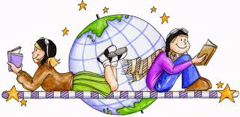 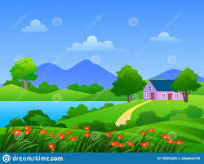

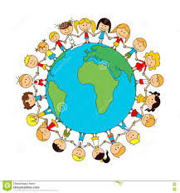 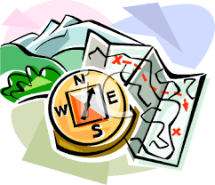

**Knowledge:**

* Know that seven continents of the world.
* Have a basic understanding of the water cycle.
* Know different environments around the world.
* Know the main lines of latitude.
* Know that climate is the general weather conditions of a particular area.
* An understanding of different **climate zones** around the world.
* Have a good knowledge of different countries and their locations around the world.
* Know how to locate places using four-figure grid references.
* The six main compass points.
* How to identify physical features such as hills, mountains, coasts and rivers on a map.

**Skills:**

* Use Ordnance Survey maps, symbols and keys.
* Use four figure grid references to locate areas and features on a map.
* Give directions using the six main compass points.
* Compare and contrast different parts of the world.
* Observe, measure and record human and physical features using a range of methods.
* Compare different sources of information and determine which is the most reliable.
* Record findings using simple geographical language, drawings, labelled diagrams, keys, bar charts and tables.

Physical Features

Location Knowledge

Field Trips

Map Skills

Place Knowledge

**What I will be learning**

1. To understand features of biomes and identify indigenous people.
2. To understand the interdependency of organisms in a biome and the role of the water cycle in a biome.
3. To understand how organisms adapt to life in their biome.
4. To understand the delicate interdependent nature of ecosystems and know about global environmental problems and solutions.
5. To understand the contents of a biome and how living things in the biome are placed together.
6. To understand that the threats faced by the various biomes of the world are serious and urgent.