Maths Key Skills Stage 1: Skill Check 7

Name: ___________________________________ Date: _______________ Class/Group: _______________________________

A: Number and Place Value |  | B: Fractions and Measure |  |  | C: Measure and Geometry
1. What is the missing number?  66 67 68 69 | 1:1 | 11. Draw one line to split the shape into 2 halves. |  | 1:11 | 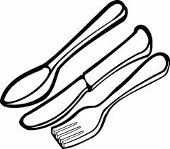  16. I put on pyjamas _______ I get into bed.  a. before  b. after |  | 1:16
2. What is the missing number?  5 10 15 20 | 1:2
3. What number is one less than 50? | 1:3 | 12. Circle a quarter (¼) of the balls.   |  | 1:12 | 17. Is Monday is the 1st day of the week, what day is the 3rd day of the week?  a. Tuesday b. Wednesday c. Friday |  | 1:17
4. Pat has 8 sweets. Sam has 5.  Who has the least? | 1:4
5. Write this number in words:  16 | 1:5 | 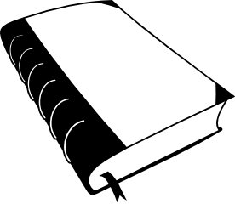  13. Which is heaviest?  A B |  | 1:13 | 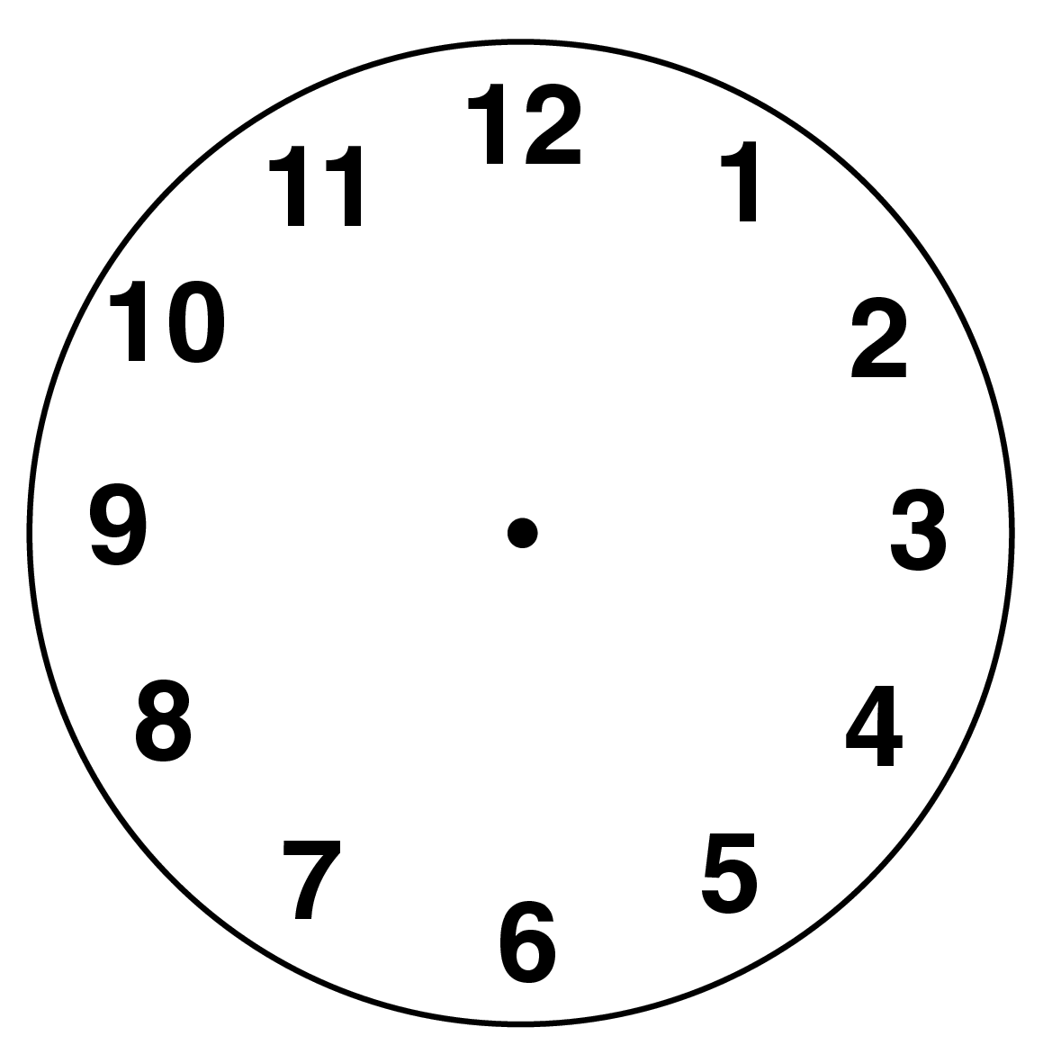  18. Draw the hands  to show:  Half past eight |  | 1:18
6. What symbol is missing?  3 9 = 12 | 1:6
7. What is the missing number?  12 + 8 = | 1:7 | 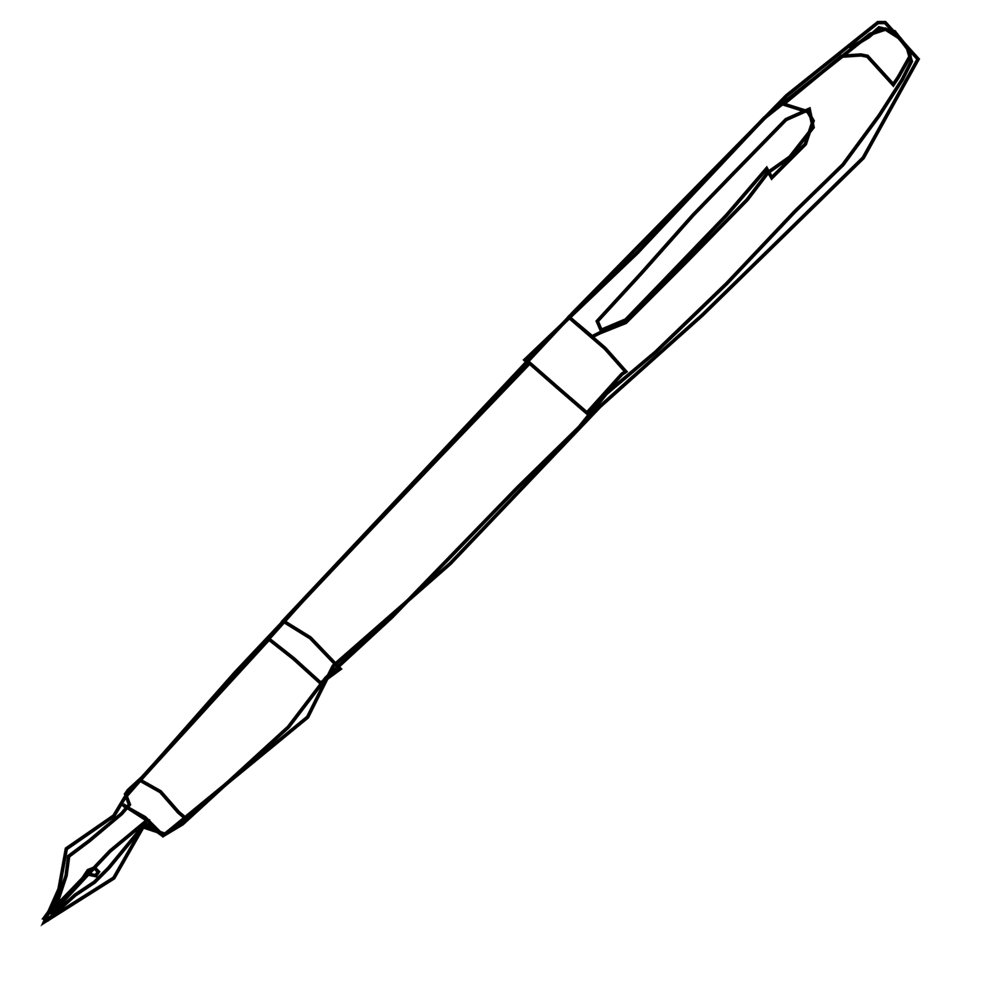  14. How heavy is the pen?  0  5  10  15  20  25  grams |  | 1:14 | 19. What is this shape?  a. square  b. triangle  c. circle |  | 1:19
8. 9 + 17 = | 1:8
9. What is the missing number?  17 = 3 + 6 | 1:9 | 15. How much altogether?  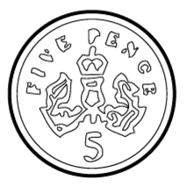  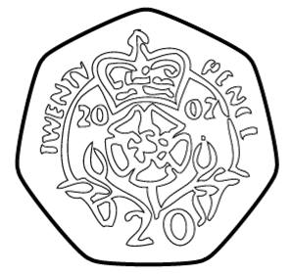 |  | 1:15 | 20. The arrow points:  a. left  b. down  c. right |  | 1:20
10. 4 children each have 4 pens. How many pens do they have altogether? | 1:10
Total (A) |  | Total (B) |  |  | Total (C)
Test Total (A+B+C) |  | R (0-7) | Y (8-15) |  |  | G (16-20)

