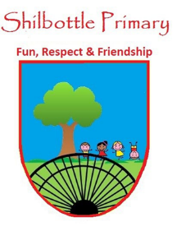
Year 5 Spelling List – autumn 1

Dear parents/carers,
Below is a copy of the spellings which will be tested this half term. There will be a general spelling spellings from the upper key stage 2 statutory list.
These words will no longer be placed into books on a weekly basis and therefore this list should be kept in a safe place. You may also find it useful to take a photo on a smartphone to keep a record of the words which will enable you to support your child’s learning beyond the home. A copy of these words will also be available from the school website should you need to replace them.
Many thanks for your continued support.
Mr Skirving
Week 1 |  |  | Week 2  Test date: 17/9/21 |  | Week 3  Test date: 24/9/21
No spellings. |  |  | Spelling rule  end in –ible  terrible  possible  sensible  visible  legible | Year 5 and 6 statutory spellings  accommodate  accompany  according  achieve  aggressive | Spelling rule  Homophones  cereal  serial  heard  herd  steal  steel | Year 5 and 6 statutory spellings  available  average  awkward  bargain  bruise
Week 4  Test date: 01/10/21 |  |  | Week 5  Test date: 8/10/21 |  | Week 6  Test date: 15/10/21
Spel21ng rule  end in -able  understandable  comfortable  breakable  suitable  enjoyable |  | Year 5 and 6 statutory spellings  competition  conscience  conscious  controversy  convenience | Spelling rule  Homophones  allowed  aloud  guessed  guest  passed | Year 5 and 6 statutory spellings  determined  develop  dictionary  disastrous  embarrass | Spelling rule  silent t words  fasten  glisten  listen  soften  castle | Year 5 and 6 statutory spellings  excellent  existence  explanation  familiar  foreign
Week 7
Test date: 22/10/21
Spelling rule  ibly & ably  endings understandably suitably comfortably miserably | Year 5 and 6  statutory spellings  hindrance  identity  immediately  individual  interfere

