Maths Key Skills Stage 4: Skill Check 8

Name: ___________________________________ Date: _______________ Class/Group: _______________________________

A: Place Value, Add and Subtract |  | B: Multiply, Divide and Fractions |  |  | C: Measure, Geometry and Statistics
1. What is the missing number?  18 24 30 42 | 4:1 | 11. 7 x 11 = |  | 4:9 | 21. What is the area of this shape?  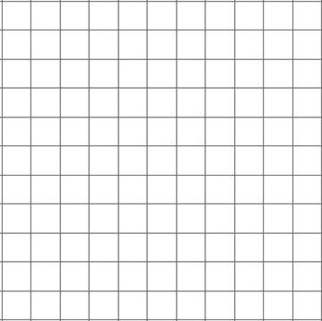  1cm |  | 4:20
2. What is the missing number?  7,000 8,000 9,000 | 4:1 | 12. Circle the sum that is the same as 27 x 12: 3 x 4 x 9 3 x 9 x 12 |  | 4:10 |  |  | 4:20
3. Round this number to the nearest 100: 5,731 | 4:2 | 13. 293 x 7 = |  | 4:11 | 22. Circle the name that describes the smallest angle.  Right Obtuse Acute  angle angle angle |  | 4:24
4. What is 1,000 less than 3,293? | 4:2 | 14. To work out 53 x 8 you could do:  x 8 + 3 x  1  7 |  | 4:12 |  |  | 4:24
5. What is 3 less than 1? | 4:3 | 15. Circle the equivalent fraction to .  3  28  5  35  7  56 |  | 4:13 | 23. To transform shape A onto B:  Translate A  A  B  units to  the . |  | 4:27
6. What is the value of the 2 in this number? 3,296 | 4:4 | 16. Complete  22  100  23  100  24  100  the sequence: |  | 4:14 |  |  | 4:27
7. Write the number 37 in Roman numerals. | 4:5 | 17.  9  5  2  5  + |  | 4:15 | 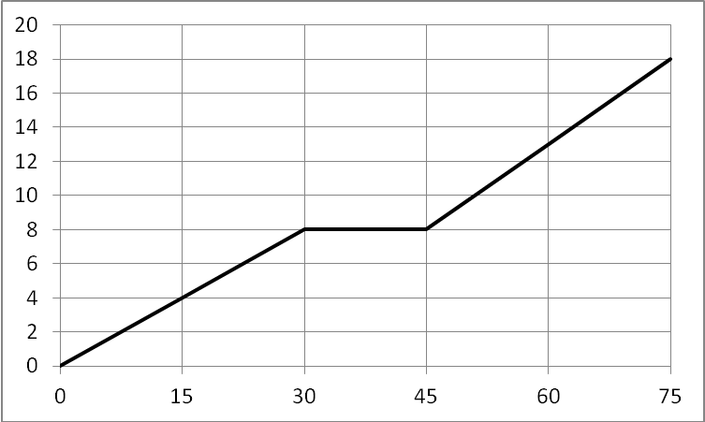  24. Tom rode to his friend’s house.  Distance (km)  Time (minutes)  Using the distance - time graph, how long did Tom rest for?  25. How much further was the 2nd part of Tom’s journey than the first? |  | 4:29  4:30
8. 1,235 + 824 = | 4:6 | 18. Write 0.5 as a fraction. |  | 4:16 |  |  | 4:29  4:30
9. Write the sum to check 1,930 + 383 = 2,313: 2,313 1,930 383 | 4:7 | 19. 8 ÷ 100 = |  | 4:17 |  |  | 4:29  4:30
10.There are 213 people on a train. 28 get on & 49 get off. How many now? | 4:8 | 20. Label 4.25cm on the ruler section:  4  5  4.5 |  | 4:18 |  |  | 4:29  4:30
Total (A) |  | Total (B) |  |  | Total (C)
Test Total (A+B+C) |  | R (0-9) | Y (10-19) |  |  | G (20-25)

