Maths Key Skills Stage 4: Skill Check 4

Name: ___________________________________ Date: _______________ Class/Group: _______________________________

A: Place Value, Add and Subtract |  | B: Multiply, Divide and Fractions |  |  | C: Measure and Geometry
1. What is the missing number?  50 100 125 150 | 4:1 | 11. 72 ÷ 12 = |  | 4:9 | 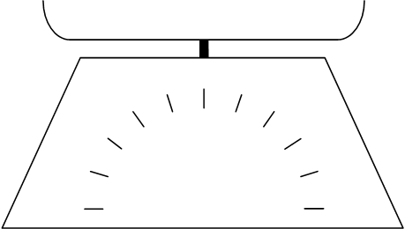    21. Two apples  are weighed.  300  200  How much does  400  100  grams  1 apple weigh?  500  0 |  | 4:21
2. What is the missing number?  54 63 72 90 | 4:1 | 12. Use 2 x 4 x 12 = 96 to answer:  24 x 4 |  | 4:10 |  |  | 4:21
3. What is 1,000 less than 4920? | 4:2 | 13. 83 x 7 = |  | 4:11 | 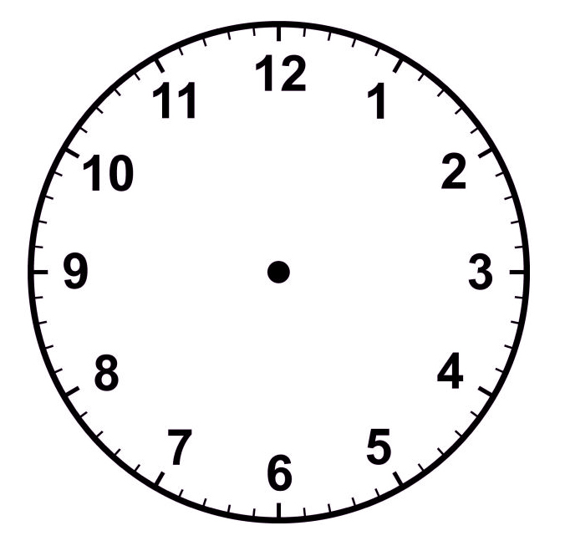  22. Draw the hands  to show:  17:50 |  | 4:22
4. Round this number to the nearest 1,000: 1,543 | 4:2 | 14. Shop A sells 6 pens for £3. Shop B sells 2 pens for 90p. Which is cheaper? |  | 4:12 |  |  | 4:22
5. Put these numbers in order, smallest first: 3 -2 0 | 4:3 | 15.  1  2  4  4  1  10  =  = |  | 4:13 | 23. What is the name of this quadrilateral? |  | 4:23
6. Put these in order, smallest first:  3,293 1,273 2,837 | 4:4 | 16. I have of a cake. How many pieces do I cut it into to make ?  1  100 |  | 4:14 |  |  | 4:23
7. What number does this Roman Numeral represent? XIV | 4:5 | 17.  11  4  9  4  1  100  - |  | 4:15 | 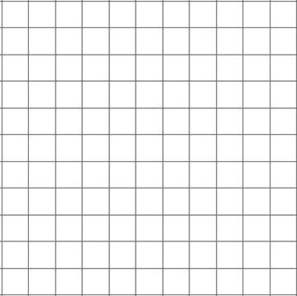  24. Plot the point (3, 0). Label it C.  1 2 3 4 5 x  y  5  4  3  2  1  0  B  A  25. Points A, B and C form 3 corners of a rectangle. Plot the fourth corner of the rectangle and label it D. |  | 4:28  4:28
8. 3,473 + 1,230 = | 4:6 | 18. Write as a decimal number. |  | 4:16 |  |  | 4:28  4:28
9. Write the sum to check 239 - 154 = 85: 85 + = | 4:7 | 19. What is the value of the 2 in:  1.72 |  | 4:17 |  |  | 4:28  4:28
10. A 38cm tall plant grows 16cm a year. How tall will it be after 2 years? | 4:8 | 20. Round 7.8 to the nearest whole number. |  | 4:18 |  |  | 4:28  4:28
Total (A) |  | Total (B) |  |  | Total (C)
Test Total (A+B+C) |  | R (0-9) | Y (10-19) |  |  | G (20-25)

