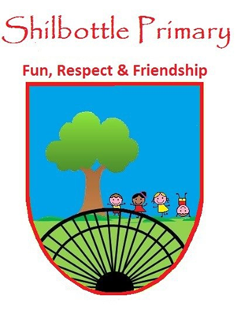
Year 2 Spelling List Autumn 1 2023
Below is a copy of the spellings which will be tested this half term. There is a general spelling rule each week. This list should be kept in a safe place. A copy of the list will also be available from the school website should you need to replace them. Many thanks for your continued support.
Week 2  Test date 15th September | Week 3  Test date 22nd September | Week 4  Test date 29th September
badge  edge  bridge  dodge  fudge  ridge  smudge  judge  wedge  lodge | change  charge  range  orange  hinge  strange  dungeon  sponge  pigeon  fringe | gem  gym  giant  magic  giraffe  energy  digit  engine  religion  gentle
Spelling rule: words where ‘dge’ makes a ‘j’ sound | Spelling rule: words where ‘ge’ makes a ‘j’ sound | Spelling rule: words where ‘g’ makes a ‘j’ sound
Week 5  Test date 6th October | Week 6  Test date 13th October | Week 7  Test date 20th October
race  ice  cell  city  fancy  lace  space  circle  circus  rice | door  floor  poor  because  find  kind  mind  behind  child  children | write  written  wrong  wrap  wren  wreck  wrapped  wriggle  wrestle  wrote
Spelling rule: Words where 'c' makes an /s/ sound before 'e', 'i' and 'y' | Spelling rule: challenge words | Spelling rule: Words where 'wr' makes a /r/ sound at the beginning of words
Week 8
Test date 27th October
table
apple
bottle
little
middle
bubble
cable
uncle
ankle
eagle

Spelling rule: Words ending in 'le'

