Maths Key Skills Stage 3: Skill Check 11

Name: ___________________________________ Date: _______________ Class/Group: _______________________________

A: Place Value, Add and Subtract |  | B: Multiply, Divide and Fractions |  |  | C: Measure and Problem Solving
1. What is the missing number?  0 4 12 16 | 3:1 | 11. 48 ÷ 4 = |  | 3:10 | 23. How long is this toy brick to the nearest millimetre? |  | 3:19
2. What is the 9 worth in this number?  592 | 3:2 | 12. 9 x 8 = |  | 3:10 |  |  | 3:19
3. Write this number in numerals.  seven hundred and nine | 3:3 | 13. Use 7 x 4 = 28 to solve:  21 x 4 = |  | 3:11 | 22. The sides of a regular pentagon are 3cm.  What is the perimeter  of the pentagon? |  | 3:20
4. What number is labelled?  0  40  20 | 3:4 | 14. What is the missing number?  6 x = 45 + 21 |  | 3:12 |  |  | 3:20
5. Make the largest number possible using the digits 5 7 6. | 3:5 | 15. What is the missing number?  1.2 1.1 1.0 0.8  7  10 |  | 3:13 |   23. I had £3. I bought  a comic and got £1 and  60p change. How much  did the comic cost?  Give answer in £ and p. |  | 3:21
6. 247 + 10 = | 3:6 | 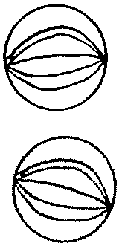  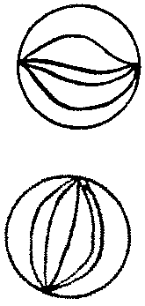  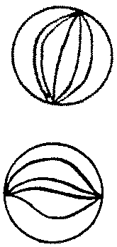  16. Circle  of the marbles.  3  4 |  | 3:14 |  |  | 3:21
7. 382 - 149 = | 3:7 | 17. What is of 16? |  | 3:15 | 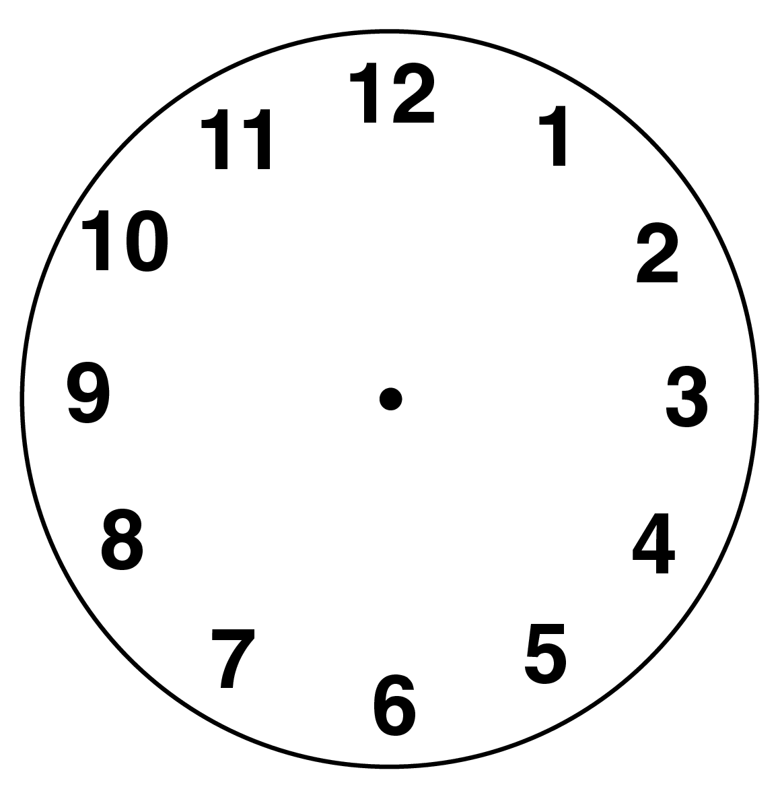  24. Draw the hands  to show  twenty minutes  to eleven. |  | 3:22
8. Circle the best estimate to 39 + 78:  100 110 120 130 | 3:8 | 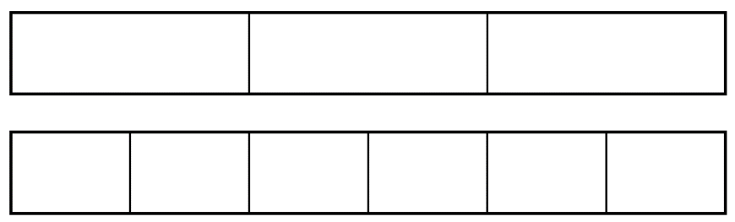  18.  4  6  ?  3  = |  | 3:16 |  |  | 3:22
9. One orange costs thirteen pence. How much will four oranges cost? | 3:9 | 19. Add the  5  7  1  7  +  fractions. |  | 3:17 | 25. How many seconds are in one minute? |  | 3:24
10. What is the missing number?  - 14 = 22 | 3:9 | 20. Write the  1  6  1  3  1  4  1  8  largest fraction. |  | 3:18 |  |  | 3:24
Total (A) |  | Total (B) |  |  | Total (C)
Test Total (A+B+C) |  | R (0-9) | Y (10-19) |  |  | G (20-25)

