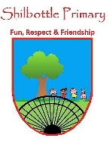
Science - Year 1 – spring 2 - seasons
00
Knowledge
To find out about different seasons and how to describe them.
To find out about the seasons and how they are different.
To find out about how animals are affected by the seasons.
To find out about how humans are affected by the seasons.
To find out about the day length is affected by the seasons.

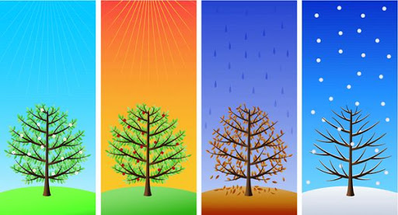
Skills
Ask and enquire.
Sort and classify.
Observe closely using simple equipment.
Perform simple tests.
Identify and classify.
Gather and record data.
Talk about your learning
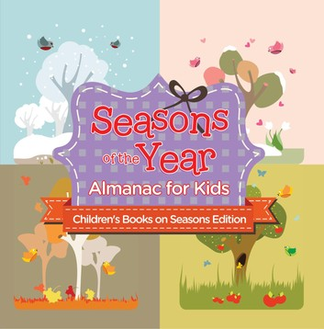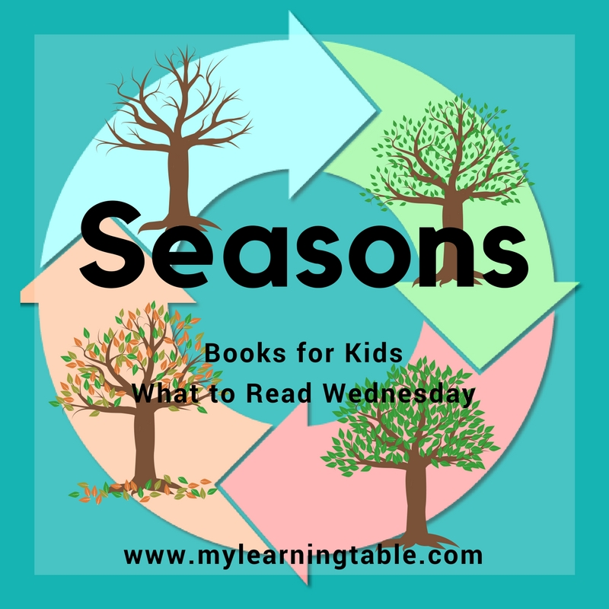
Books

Vocabulary | Meaning
adapt | Get used to new conditions.
Autumn | The months from September to November.
hobby | Something done in your spare time for pleasure.
seasons | Four parts of a year marked by different weather patterns.
spring | If an object is transparent, you can see  through it.
summer | The months from June to August, the warmest season of the year.
winter | The months from December to February, the coldest season of the year.
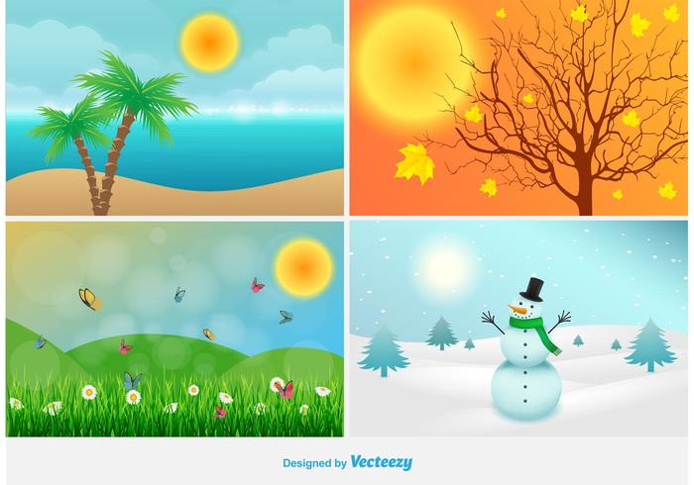
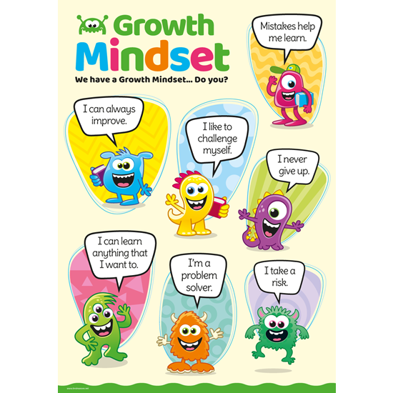
What I will know and be able to do at the end of the topic.
Growth Mindset Strategies

What I should be able to do and know now.
Knowledge
What are the four seasons and what is the weather like in each season? Spring, Summer, Autumn and Winter.
How do the seasons differ from each other? Spring (cold, sunny, showery) Summer (warm, sunny), Autumn (cold, wet) and Winter (cold, wet and snowy).
What clues can we look for to discover what season it is?. Spring - flowers start to grow, Summer – lots of flowers in bloom can be hot and dry, Autumn – leaves turn orange and brown and fall off the trees, Winter – Frosty and icy.
How do the seasons affect animals that live in the wild? – Some animals, such as hedgehogs hibernate in the winter so they sleep through the cold months when finding food
Do humans change how they behave in different seasons? – Their clothes, food and hobbies change.
Which season has the longest days? – Summer
Which season has the shortest days? - Winter
Skills – What materials would be suitable to wear for the different types of weather?
Knowledge
Understand the different types of weather – sun, rain, snow, wind, thunder, lightning.
That we wear different clothes depending on the weather.
Skills
I can listen attentively in a range of situations.

I can answer ‘how’ and ‘why’ questions about my experiences and in response to stories or events.

I can talk about the features of my own immediate environment and how environments might vary from one another.

I know about similarities and differences in relation to places, objects, materials and living things.

I can make observations of animals and plants and explain why some things occur, and talk about changes.

What I will be learning

- How to name the seasons.
- About the different features of each season.
- How the different seasons can affect animal behaviour.
- How the weather affects human activity.
- How the seasons affect what we wear and what we do.
- That different food grows in different seasons.
- Can identify which season has the longest days and the shortest nights.
- The sun rises in the morning and sets in the evening.

