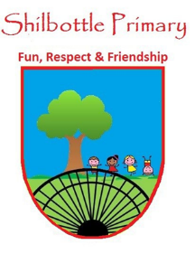
Year 5 Spelling List – Autumn 1
Dear Parents/Carers,
Below is a copy of the spellings which will be tested this half term. The spellings will be a mix of a general spelling rule each week as well as some statutory UKS2 spellings.
Spelling homework should be handed in by Thursday each week. The children are expected to copy out the 10 spelling words and then write a sentence for each word which shows their understanding of the word meanings. Please note - This may not be enough to learn the spellings completely, it is expected that the children will carry out further practice at home of the spellings, in preparation for the spelling test on Friday.

Week 2  Test date: 16/09/2022 | Week 3  Test date: 23/09/2022 | Week 4  Test date: 30/09/2022
Spelling rule  Words with silent letter b  thumb  numb  crumb  debt  comb  tomb  Year 5 and 6 spellings  accommodate  accompany  according  achieve | Spelling rule  Words that contain the letter string ‘ough’  fought  nought  ought  bought  cough  Year 5 and 6 spellings  aggressive  amateur  ancient  apparent  appreciate | Spelling rule  Homophones  cereal  serial  heard  herd  pair  pear  Year 5 and 6 spellings  attached  available  average  awkward
Week 5  Test date: 7/10/2022 | Week 6  Test date: 14/10/2022 | Week 7  Test date: 21/10/2022
Spelling rule  Words ending in - able  understandable  breakable  suitable  enjoyable  adorable  reliable  Year 5 and 6 spellings  bargain  bruise  category  cemetery | Spelling rule  UKS2 Statutory words  suggest  symbol  system  temperature  thorough  twelfth  variety  vegetable  vehicle  yacht | Spelling rule  Words from the term  debt  bought  heard  cough  enjoyable  reliable  temperature  achieve  ancient  vegetable

