RE - Year 1 – spring 2 – What did Jesus teach us
00
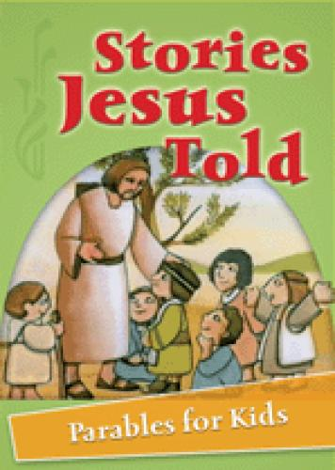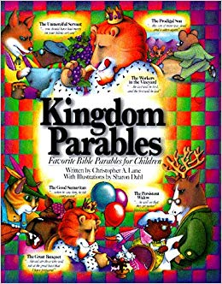
Books

Skills
Ask and enquire.
Recall and remember.
Make links to other areas of learning.
Talk about my learning.
Use vocabulary related to religion.
Knowledge
To find out about the life of Jesus.
To find out about the parable of the lost son.
To find out about the parable of the good Samaritan.
To find out what Jesus taught at the Sermon on the Mount.
To explore what we can learn from the actions of Jesus.

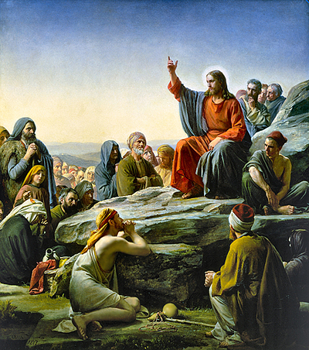
Vocabulary | Meaning
miracle | An extraordinary and welcome thing that cannot be explained.
parable | A story told to teach a lesson.
religion | The belief and worship of a God.
sacred | Something that is linked with God.
special | Made for a particular purpose. Something that means a lot to someone.
Samaritan | A helpful person.
sermon | A talk on a religious subject usually delivered in Church

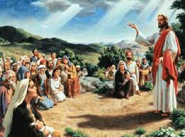

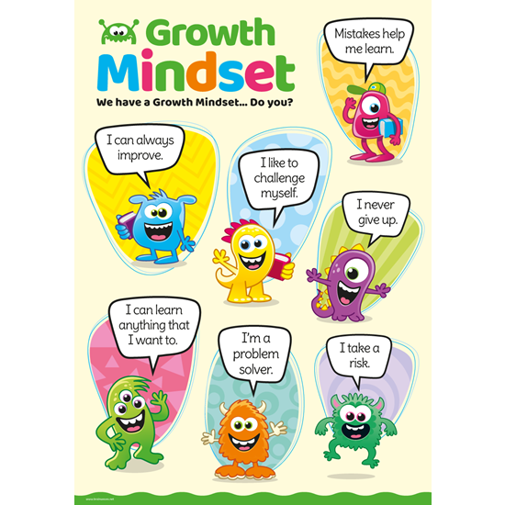
Bib
What I will know and be able to do at the end of the topic.
Growth Mindset Strategies

What I should be able to do and know now.
Knowledge
How long ago did Jesus live? 2000 years ago.
Why did Jesus tell so may stories in his life? – He taught people how God wanted them to live because God has rules he wants people to follow.
What was Jesus trying to tell us through the parable of the lost son? – The story of the lost son shows that Christians believe that God is happy when someone comes back to him because all his children are important and special to him.
What was Jesus trying to tell us through the parable of the good Samaritan? To love everyone as we love ourselves. Treat others as you would expect to be treated.
Why is the sermon on the mount important for Christians? – Jesus gave his followers a special prayer to follow called the Lords Prayer.
Why did Jesus perform miracles? – To heal people.
Skills –
Can you remember any other special stories from the Bible?

Knowledge
I know who God and Jesus are.

Skills
I can answer ‘how’ and ‘why’ questions about my experiences and in response to stories or events.

I can use past form accurately when talking about events that have happened.

I know about similarities and differences between myself and others, and among families, communities and traditions.

What I will be learning

- I can describe the events in the life of Jesus.
- That Jesus often taught through parables.
- A parable is a story that teaches a message.
- I can describe what the Lord’s Prayer is.
- That Jesus was kind and helpful to the people who needed him the most.
- I can think of words to describe Jesus.

