Maths Key Skills Stage 4: Skill Check 11

Name: ___________________________________ Date: _______________ Class/Group: _______________________________

A: Place Value, Add and Subtract |  | B: Multiply, Divide and Fractions |  |  | C: Measure and Geometry
1. What is the missing number?  18 27 45 54 | 4:1 | 11. 36 ÷ 6 = |  | 4:9 | 21. A plant is 73cm tall. How many more centimetres does it have to grow before it is 1 metre tall? |  | 4:19
2. What is the missing number?  49 56 63 70 | 4:1 | 12. Two factors of 48 add up to 16. What are they? |  | 4:10 |  |  | 4:19
3. What is 1,000 more than 1? | 4:2 | 13. 257 x 9 = |  | 4:11 | 22. Calculate the  perimeter of a  square that has a  side length of 4.5cm. 4.5cm |  | 4:20
4. Round this number to the nearest 10: 7,548 | 4:2 | 14. In a class of 25 there are 3 girls for every 2 boys. How many are boys? |  | 4:12 |  |  | 4:20
5. What is 5 – 11? | 4:3 | 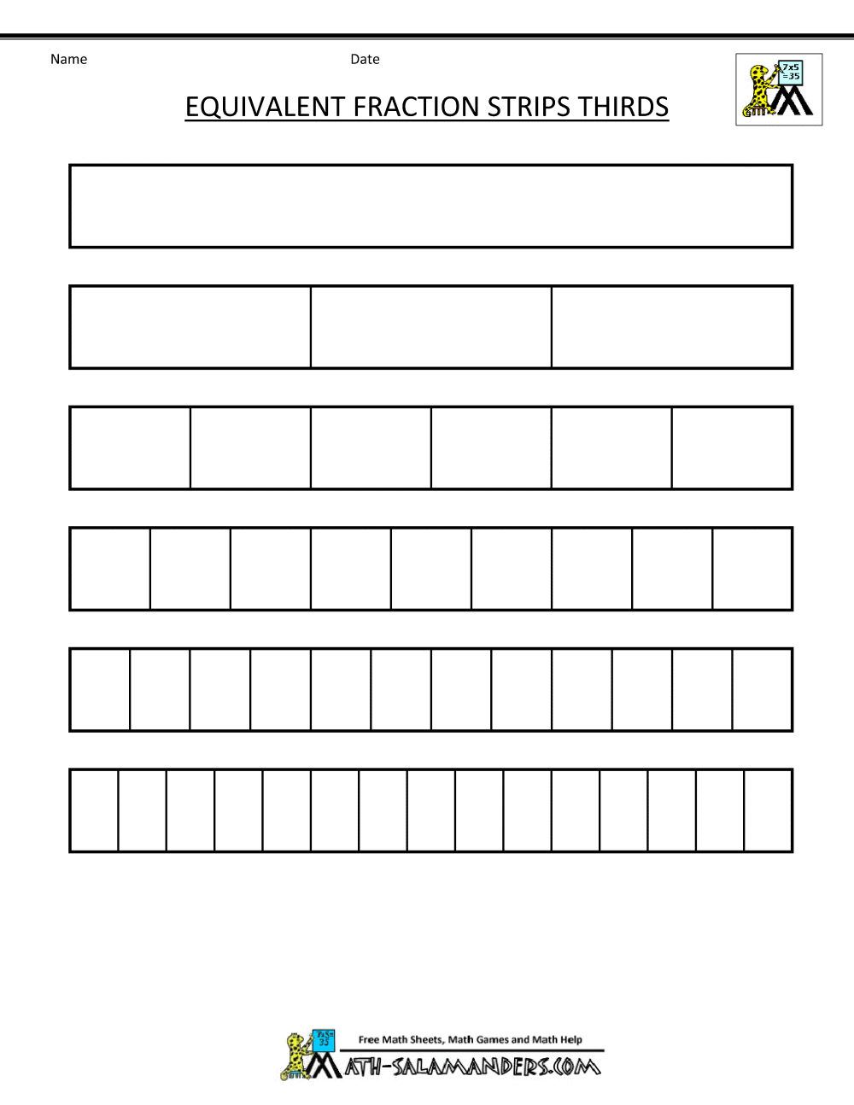  15.  1  3  5  ?  = |  | 4:13 | 23. Here are the heights of three brothers. Who is tallest?  Dave Andy Phillip  1.3m 145cm 1.25m |  | 4:21
6. What is the value of the 6 in this number? 6,283 | 4:4 | 16. What is the missing number?  5.07 5.08 5.09  9  8  2  8 |  | 4:14 |  |  | 4:21
7. Write the number 45 in Roman numerals. | 4:5 | 17.  + |  | 4:15 | 24. How would 11:08pm be shown on a 24 hour digital clock?  : |  | 4:22
8. 2,859 - 1,364 = | 4:6 | 18. Write 0.1 as a fraction. |  | 4:16 |  |  | 4:22
9. Write the sum to check 252 + 125 = 377: 377 - = | 4:7 | 19. 9 ÷ 100 = |  | 4:17 | 25. What is the special  name for this type  of triangle? |  | 4:23
10. I have £5. I spend £2.65 then 97p. How much do I have left? | 4:8 | 20. Round 5.4 to the nearest whole number. |  | 4:18 |  |  | 4:23
Total (A) |  | Total (B) |  |  | Total (C)
Test Total (A+B+C) |  | R (0-9) | Y (10-19) |  |  | G (20-25)

