RE – Y5 – Spring 2 – Buddhist worship and beliefs
Skills
Children can discuss the ways in which Buddhist worship is similar or different to worship in other religions
To understand the difference between right and wrong.
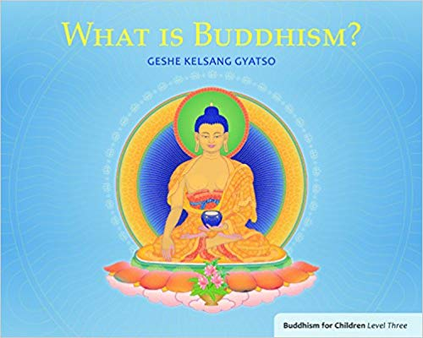
Books

Knowledge
Children can explain how and when Buddhism began.
Children can retell the story of how Prince Siddhartha became Buddha
Children know what the Three Universal Truths are in Buddhism.
Children know what the Five Moral Precepts are
Children can discuss their own opinions about what is right and wrong
Children can explain what their idea of karma is
Vocabulary | Meaning
alms bowl | Money, food, or other donations given to the poor or needy
begging bowl | A bowl held out by a beggar for food or donations
Budhism swastika | The swastika or sauwastika is a geometrical figure and an ancient religious icon in the cultures of Eurasia. It is used as a symbol of divinity and spirituality in Indian religions.
butter lamp | A lamp that is a conspicuous feature of Tibetan Buddhist temples and monasteries throughout the Himalayas.
dharma wheel | The circular shape of the wheel symbolizes the perfection of Buddha's teachings.
mandala | A circular figure representing the universe in Hindu and Buddhist symbolism.
thangka | Is a Tibetan Buddhist painting on cotton, silk appliqué, usually depicting a Buddhist deity, scene, or mandala.
Vesak | |The most important Buddhist festival, taking place at the full moon when the sun is in the zodiacal sign of Taurus, and commemorating the birth, enlightenment, and death of the Buddha.
Key People
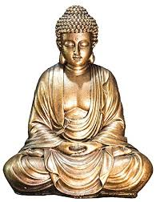

Growth Mindset Strategies
What I will know and be able to do at the end of the topic.
What I should be able to do and know now.

Understand the difference between a FIXED
mindset and a GROWTH mindset.
Be Curious; Be courageous.
Challenge yourself. Ask, ‘What could I do
differently next time?’
Give everything your best effort and
persevere.
Practice; Practice; Practice.

Knowledge

I think universal truths help Buddhist to be good human beings because …
I think universal truths help Buddhist to be good human beings but …
I think universal truths help Buddhist to be good human beings so …
Everyone knows right from wrong because …
Everyone knows right from wrong but …
Everyone knows right from wrong so …

Skills
To compare and contrast the major religions of the world.

To understand right and wrong
Knowledge

Skills

What I will be learning

To find out who Buddha was and why he is important to Buddhists today.
To find out about some of the core beliefs and teachings of Buddhism.
To learn about the Four Noble Truths and the Eightfold Path.
To find out about the Buddhist beliefs of karma and rebirth.

