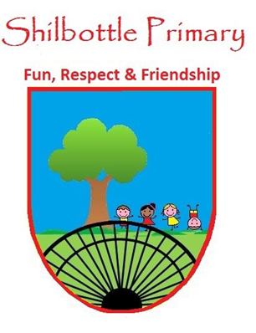
Dear parents/carers,
Below is a copy of the spellings which will be tested this half term. There will be five spellings from the spelling rule being learned and five spellings from the Y5 and 6 statutory spellings. A copy of these words will also be available from the school website should you need to replace them. Many thanks for your continued support.

Week 1  Test Date: 7 January |  | Week 2  Test Date: 14 January |  | Week 3  Test Date: 21 January
Spelling Rule:  1. morning/  mourning  2. compliment/  complement  3. assent/  ascent  4. draft/draught  5. dessert/  desert | Statutory:  1. government  2. guarantee  3. harass  4. hindrance  5. identity | Spelling Rule:  1. expansion  2. comprehension  3. permission  4. possession  5. tension | Statutory:  1. immediate  2. immediately  3. individual  4. interfere  5. interrupt | Spelling Rule:  1. physical  2. secretary  3. privilege  4. soldier  5. yacht | Statutory:  1. language  2. leisure  3. lightning  4. marvellous  5. mischievous
Spelling Rule: Homophones and other words that are often confused; A homophone is a word that has the same pronunciation but different spellings and meanings. |  | Spelling Rule:  The sh sound spelt ‘si’ or ‘ssi’  The sh sound spelt ‘si’ only appears in the middle of words.  Root Words ending in se or d use si when it is part of a suffix.  The sh sound spelt ‘ssi’ only occurs at the beginning of the 2nd, 3rd or 4th syllable of a word.  Root Words ending in mit or ss use ssi when it is part of a suffix. |  | Spelling Rule:  Orange Words; Proceed with Caution …  These are common words that even some adults find tricky to spell. These words make up the Year5/6 statutory spellings.
Week 4  Test Date: 27 January |  | Week 5  Test Date: 4 February |  | Week 6  Test Date: 11 February
Spelling Rule:  1. gnome  2. knee  3. guilt  4. doubt  5. solemn | Statutory:  1. muscle  2. necessary  3. neighbour  4. nuisance  5. occupy | Spelling Rule:  1. available  2. category  3. existence  4. controversy  5. ancient | Statutory:  1. occur  2. opportunity  3. parliament  4. persuade  5. physical | Spelling Rule:  1. piece  2. deceive  3. neighbour  4. niece  5. achieve | Statutory:  1. occur  2. opportunity  3. parliament  4. persuade  5. physical
Spelling Rule:  Silent Letters;  Proceed with Caution …  Letters that cannot be heard when we say a word are called silent letters. We only know they are there when we spell and see a word. |  | Spelling Rule:  Orange Words;  Proceed with Caution …  These are common words that even some adults find tricky to spell. These words make up the Year5/6 statutory spellings. |  | Spelling Rule:The spellings ‘ei’ and ‘ie’  When the sound is ‘e’ write ‘ie’ except after c.  When the sound is other than ‘e’ usually write ‘ei’ except after c.
Week 7: 18th Feb - This week, children will be tested on a mix of words from previous week’s spellings.

All spelling tests will take place on a Friday, unless other school events mean it needs to be changed.

Spelling Rules: Children will learn a spelling rule to help them spell longer words correctly. To ensure children have learned the rule, their spelling rule words will be the root word (a basic word with no prefix or suffix added to it). During the spelling test, children will have to add the given prefix or suffix to the root word ensuring they have followed the rule studied.

Sometimes, the spelling rule will be a focus on Orange Words (Statutory words to be learned by the end of Y5/6). Although, usually, no spelling rule applies to these words, the week’s focus will be on different ways to remember how to spell these words correctly. Some words will be repeated over the year to consolidate the learning of the word.

Statutory Words (Orange Words): These are words that some adults find difficult to spell and they seldom follow a simple spelling rule. These are, generally, words that just have to be learned and remembered. However, there are different strategies that may help with the learning of these words. I have given a few examples below.

If you have any questions then please get in touch.
Thank you
MrP

Helping your child.

One method of helping your child learn their spelling is
‘Look, cover, write, check’
Children look at a word and sound it out, cover it, practice writing it and then check it.
If you wish to challenge your child even further you could ask them to say a sentence using the word or even write a sentence and then try to improve it.

Other ways to help learn spellings:
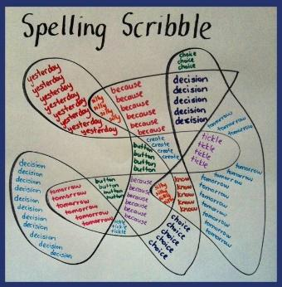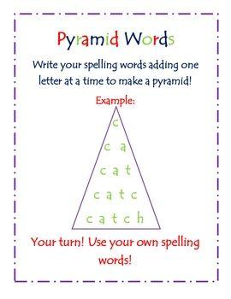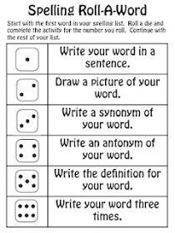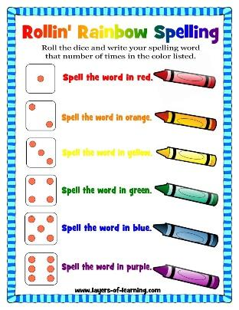

Memory Strategies:
Syllables: Listen to how many syllables there are and break the word into smaller chunks to remember. September = Sep – tem – ber (clap them out if it helps)
Root words: Find the root word of the longer word. Smiling = smile + ing
Analogy: Use words that you already know to help spelling. Would, Should, Could
Mnemonic: Make up a sentence to help remember the word:
Caught = Can An Ugly Goat Have Teeth

SPELLING HOMEWORK: All weekly spelling words are on LITERACY PLANET for children to practice as part of their homework.

