

**Science - Year 6 - autumn 1 – Evolution and Inheritance**

**Books**

**Skills**

**Meaning**

**Vocabulary**

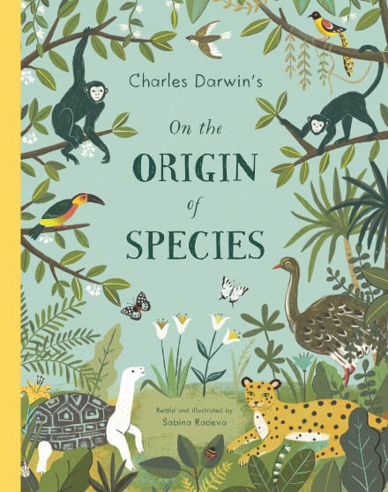

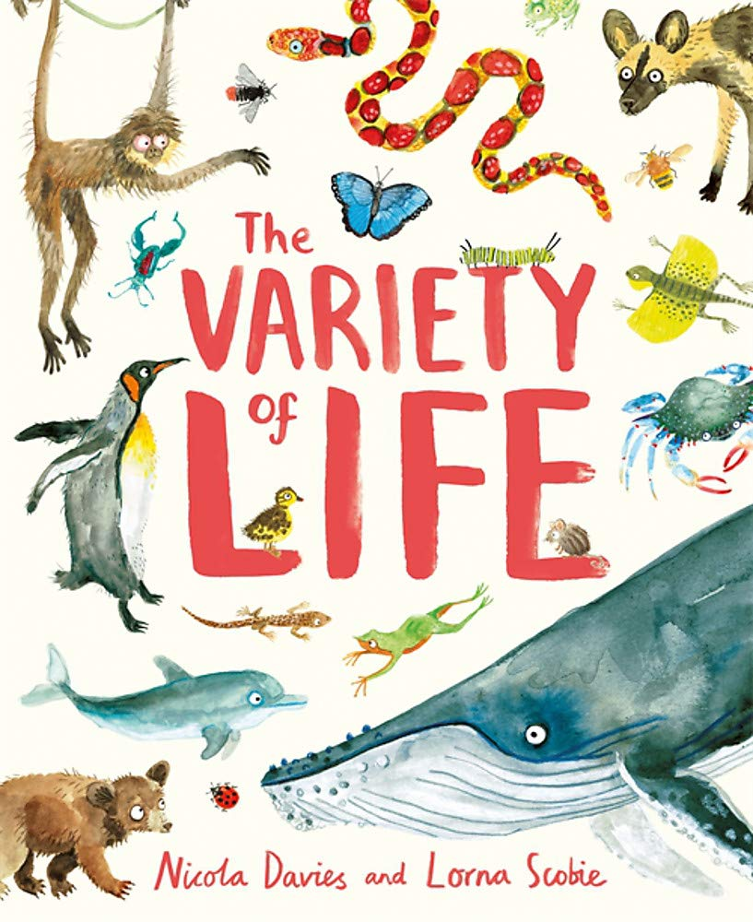

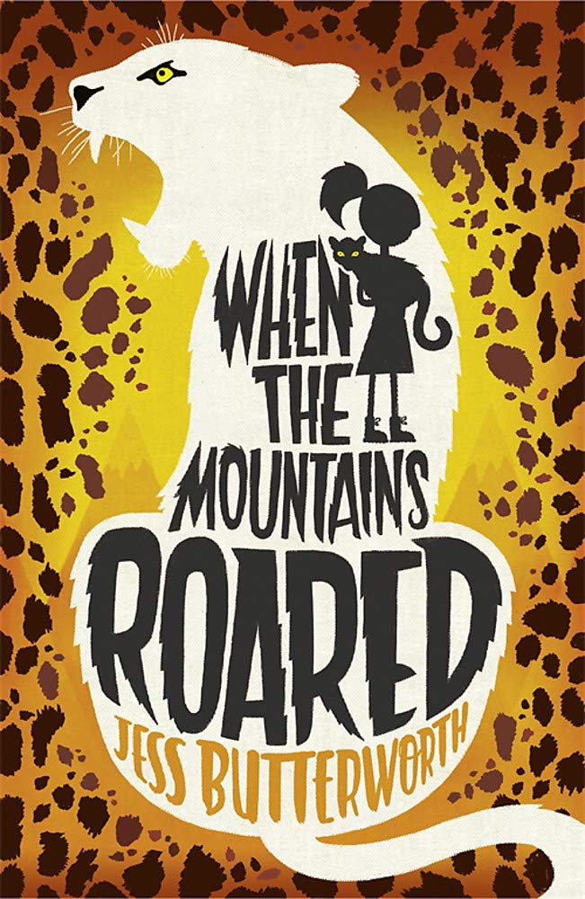

🞄Record data and results of increasing complexity using scientific diagrams and labels and classification keys..

🞄Reporting and presenting findings from enquiries, including conclusions, causal relationships and explanations of results, in oral and written forms such as displays and other presentations..

🞄Identifying scientific evidence that has been used to support or refute ideas or arguments.

🞄Use test results to make predictions to set up further comparative tests.

The process of change by which an organism or species becomes better suited to its environment.

**adaptation**

**Carl Linnaeus**

A Swedish scientist whose work on the classification of animals continues to be of huge significance today.

A feature or quality belonging to a person, place or thing and serving to identify them.

**characteristics**

An English naturalist, geologist and biologist, best known for his contributions to the science of evolution.

**Charles Darwin**

**Knowledge**

🞄**Evolution** is a process of change that takes place over many generations, during which **species** of animals, plants, or insects slowly change some of their physical **characteristics**. This is because offspring are not identical to their parents**.**

🞄It occurs when there is competition to survive. This called **natural selection**.

🞄Difference within a species (for example between parents and offspring) can be caused by **inheritance** and **mutations**.

🞄**Mutations** in **characteristics** are not **inherited** from their parents and appear as new **characteristics**.

🞄Evidence of **evolution** comes from fossils – when these are compared to living creatures from today, palaeontologists can compare similarities and differences.

🞄**Adaptation** is when animals and plants have **evolved** so that they have **adapted** to survive in their **environments.** For example, polar bears have a thick layer of blubber under their fur to survive the cold, harsh **environment** of the Artic.

🞄Some **environments** provide challenges, yet some animals and plants have **adapted** to survive there.

The arrangements of animals and plants in taxonomic groups according to the observed similarities.

**classification**

The surroundings or conditions in which a person, animal or plant lives or operates.

**environment**

The theory that all the kinds of living things that exist today developed from earlier types.

**evolution**

The name for the passing of traits, or characteristics from parents to offspring.

**inheritance**

The process by which a species changes over time in response to changes in the environment, or competition, in order to survive.

**natural selection**

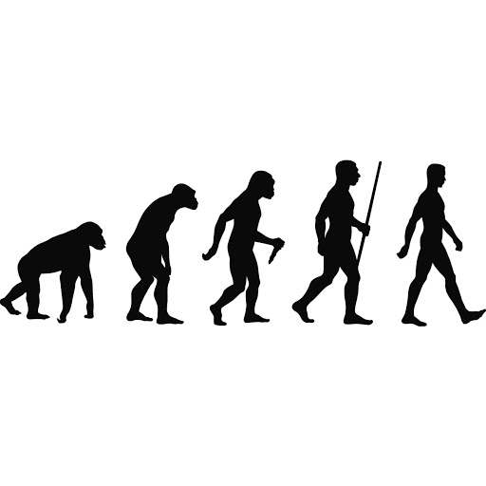

A group of similar organisms that can breed with one another to produce fertile offspring.

**species**

**variation**

The differences between individuals within a species. This can be caused by inherited or environmental factors.

**Concept Links**

**What I should be able to do and know now.**

**What I will know and be able to do at the end of the topic.**

**Knowledge:**

Disadvantageous characteristics are less likely to be inherited because …

Disadvantageous characteristics are less likely to be inherited, but …

Disadvantageous characteristics are less likely to be inherited, so …

Spider monkeys have adapted long, strong arms and legs with long toes and fingers because …

Spider monkeys have adapted long, strong arms and legs with long toes and fingers, but

Spider monkeys have adapted long, strong arms and legs with long toes and fingers, so …

The variations that occur from one generation to the next are not always random because …

The variations that occur from one generation to the next are not always random, but …

t The variations that occur from one generation to the next are not always random, so …

**Skills:**

Using tables, drawings and other means to note observations and measurements is important because …

Using tables, drawings and other means to note observations and measurements is important, but …

Using tables, drawings and other means to note observations and measurements is important, so …

 

Gathering and recording Identifying and classifying

 

Making comparisons Using scientific evidence

**Knowledge:**

🞄Which things are living and which are not.

🞄Identifying animals (e.g. amphibians, reptiles, birds, fish, mammals, invertebrates) and plants using classification keys.

🞄Animals that are carnivores, herbivores and omnivores.

🞄Animals have offspring which grow into adults.

🞄The basic needs of animals for survival (water, food, air).

🞄Some animals have skeletons for support, protection and movement.

Some animals have skeletons for support, protection and movement.

🞄Food chains, food webs and the role of predator and prey.

🞄Features of habitats and the animals and plants that exist there..

🞄Examples of different biomes.

🞄The features of some rocks and the role they play in the formation of fossils.

**Skills:**

🞄Ask relevant questions and use different types of scientific enquiries to answer them.

🞄Set up simple practical enquiries, comparative and fair tests.

🞄Make systematic and careful observations and, where appropriate, take accurate measurements using standard units, using a range of equipment, including thermometers and data loggers.

🞄Gather, record, classify and present data in a variety of ways to help answer questions.

🞄Record findings using simple scientific language, drawings, labelled diagrams, keys, bar charts and tables.

🞄Identify differences, similarities or changes related to simple scientific ideas and processes.

**What I will be learning**

🞄To recognise that living things produce offspring of the same kind, but offspring may vary.

🞄To identify how animals and plants are adapted to suit their environment in different ways.

🞄To understand that adaptation of plants and animals to suit their environment may lead to evolution.

🞄To find out about how the work of scientists has helped develop our understanding of the process of evolution.

🞄To recognise that living things have changed over time and that a number of factors can affect a species’ evolution.

🞄To understand how humans have evolved over time and how human behaviour can affect change in species over time.