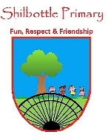
Art – Year 6 – Spring 1 – Painter’s Family
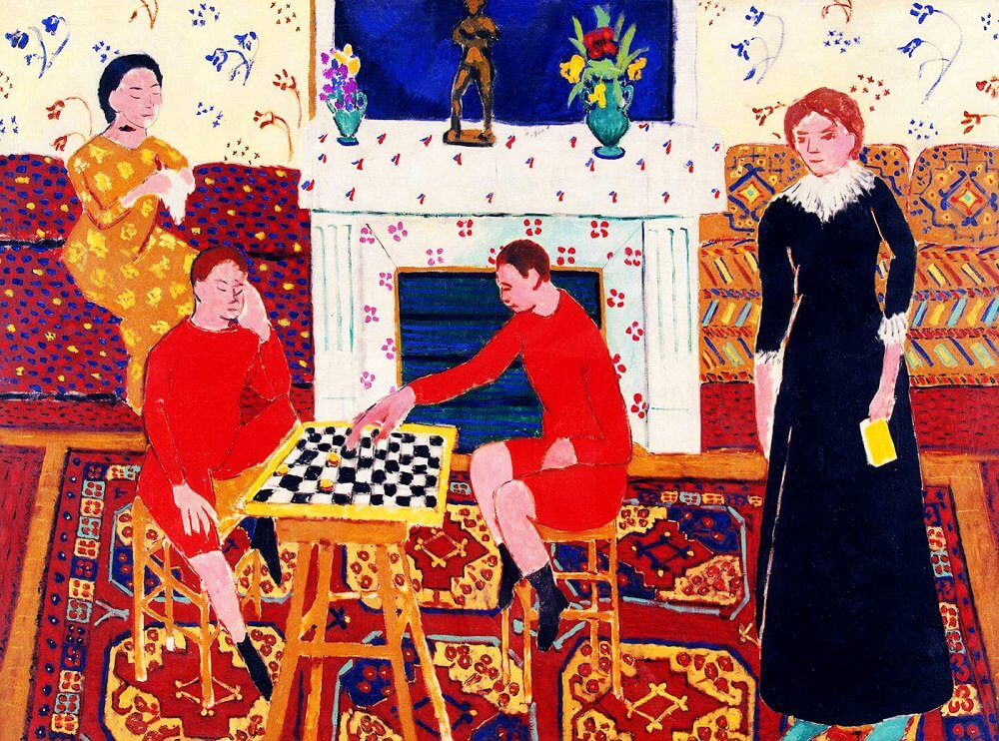
Vocabulary | Meaning
block printing | The process of printing patterns by means of an engraved block.
collage | A piece of art made by sticking various different materials such as photographs and pieces of paper or fabric on to a backing.
Fauvism | A style of painting with vivid expressionistic and non-naturalistic use of colour that flourished in Paris from 1905.
Henri Matisse | A French visual artist, known for both his use of colour and his fluid and original draughtsmanship.
mark-making | The different lines, dots, marks, patterns, and textures we create in an artwork.
Painter’s Family | Created by Henri Matisse in 1911 using the oil on canvas method and depicts the freedom within his family.
patterns | One of the principles of art and are motifs (consisting of shapes, lines, and forms) that are repeated in arrangements, sequences, and groupings.
textiles | A type of cloth or woven fabric.
texture | The tactile quality of the surface of a work of art.
tone | The relative lightness or darkness of a colour.
William Morris | A British textile designer, poet, artist, novelist, architectural conservationist, printer, translator and socialist activist associated with the British Arts and Crafts Movement.
Knowledge
Henri Matisse was a French artist, born in the late 19th century. He was well known for his bold use of colour and distinctive, fluid painting technique. Although he was also a printmaker and sculptor, he’s primarily known as a painter and is widely thought of, along with Pablo Picasso, as one of the artists who helped to develop, and really revolutionise, the visual arts throughout the first half of the 20th century.
In the first few years of his career, his innovative style earned him notoriety as one of the Fauves (“wild beasts”) – a group of early 20th century modern artists who left the realism of Impressionism behind to focus on expression and intensity of colour. However, it’s believed that many of his finest works were created in the decade or so following, as he developed his own unique style that emphasised flattened forms and decorative pattern.
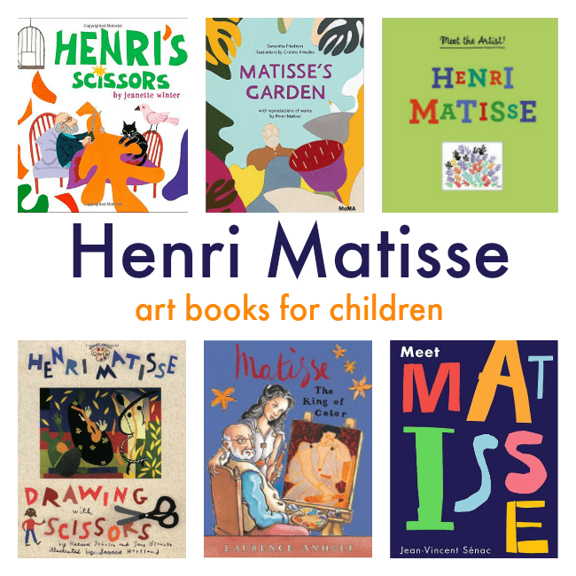
Books

Skills
Use sketch books to review and revisit ideas.
Improve mastery of art and design techniques, including drawing, painting and sculpture.

What I will know and be able to do at the end of the topic.
Concept Links

What I should be able to do and know now.
Knowledge
Fauvism was an important art movement because …
Fauvism was an important art movement, but …
Fauvism was an important art movement, so …

Painter’s Family shows the freedom within the artists’ family because …
Painter’s Family shows the freedom within the artist’ family, but …
Painter’s Family shows the freedom within the artists’ family, so …

Pattern in art is often based on natural patterns in art because …
Pattern in art is often based on natural patterns in art, but …
Pattern in art is often based on natural patterns in art, so …

Skills
Using a sketchbook to revise and improve ideas is important because …
Using a sketchbook to revise and improve ideas is important, but …
Using a sketchbook to revise and improve ideas is important, so …

Knowledge
I can explain what I can see in different sections of a picture.
I understand how to identify similarities and differences in art.
I am able to talk about my art work.
I am able to choose the right equipment and tidy up my equipment during my art work.
Skills
I know how to draw with a range of equipment.
I can show my observational skills by drawing what I can see.
Be able to identify key features in a picture.

Famous artists, designers, architects and craft-makers
Drawing, painting and sculpture.
Creating a sketchbook

Using art and design techniques
Using materials
What I will be learning

- I am learning to comment on artworks using artistic language.
- I am learning to research famous artists.
- I am learning to describe a famous painting.
- I am learning to enhance the mood of paintings by using opposite colours.
- I am learning pencil techniques to create different staples of mark-making.
- I am learning to identify art patterns in modern wallpaper.
- I am learning to use block-printing techniques to create modern wallpaper.
