Maths Key Skills Stage 1: Skill Check 13

Name: ___________________________________ Date: _______________ Class/Group: _______________________________

A: Number and Place Value |  | B: Fractions and Measure |  |  | C: Measure and Geometry
1. What is the missing number?  78 79 80 81 | 1:1 | 11. What fraction is coloured? |  | 1:11 | 16. I go put on my swimming costume __________ I go swimming.  a. before  b. after |  | 1:16
2. What is the missing number?  5 15 20 25 | 1:2
3. What number is one less than 1? | 1:3 | 12. A cake is cut into quarters. How many pieces are there? |  | 1:12 | 17. If Wednesday is the 3rd day of the week, what day is the 1st day of the week?  a. Monday b. Friday c. Sunday |  | 1:17
4. Pat has 13 sweets. Sam has 11.  Who has the most? | 1:4
5. Write this number in words:  12 | 1:5 | 13. Which cup has more than ‘Y’?  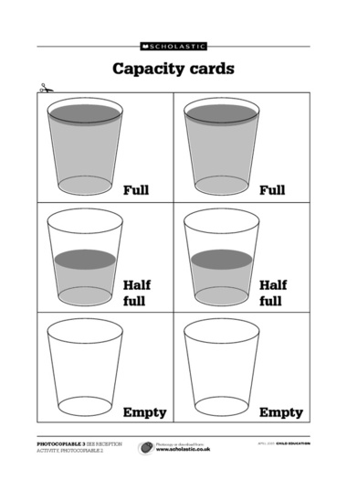  Y A B |  | 1:13 | 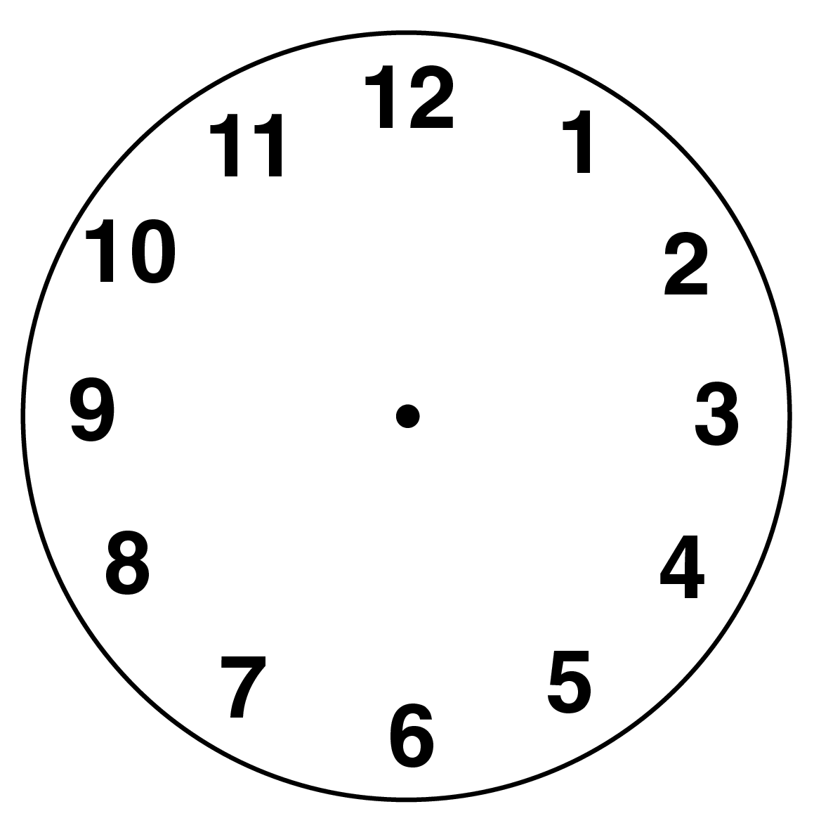  18. Draw the hands  to show:  2 o’clock |  | 1:18
6. What symbol is missing?  9 8 = 1 | 1:6
7. What is the missing number?  9 + = 20 | 1:7 | 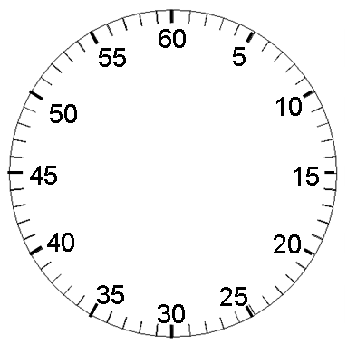  14. A girl times how  long it takes her to tie  her shoelaces. How  long does it take? |  | 1:14 |   19. Complete this triangle. |  | 1:19
8. 13 - 4 = | 1:8
9. What is the missing number?  16 = 3 - 8 | 1:9 | 15. How much altogether?  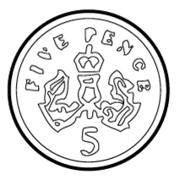  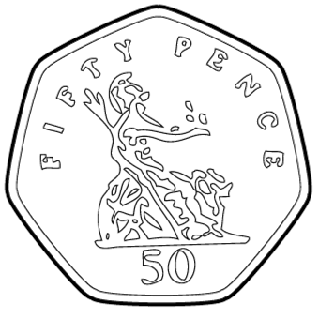  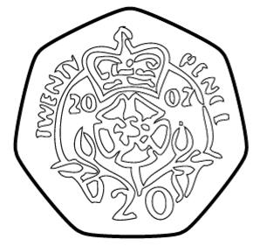 |  | 1:15 | 20. The arrow points:  a. left  b. up  c. right |  | 1:20
10. There are 6 sweets in a bag. How many sweets do I get in 3 bags? | 1:10
Total (A) |  | Total (B) |  |  | Total (C)
Test Total (A+B+C) |  | R (0-7) | Y (8-15) |  |  | G (16-20)

