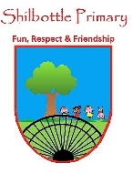
P.S.H.E. – Year 3 – Spring 1 – When things go wrong.
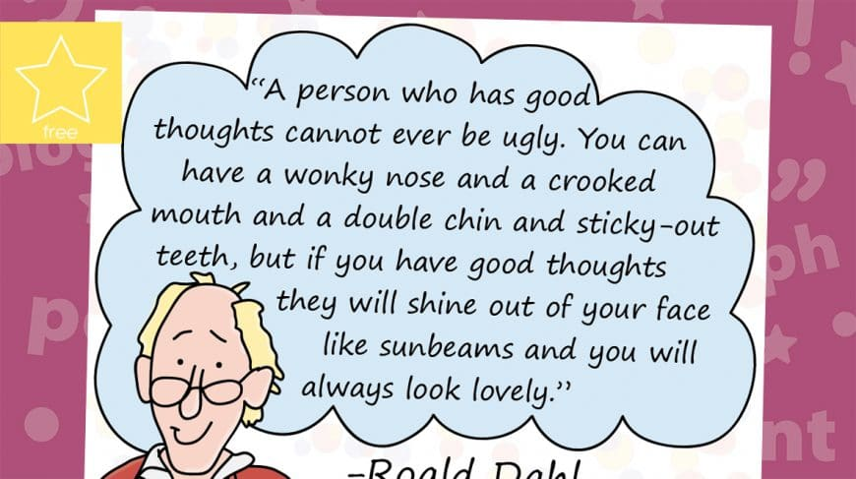
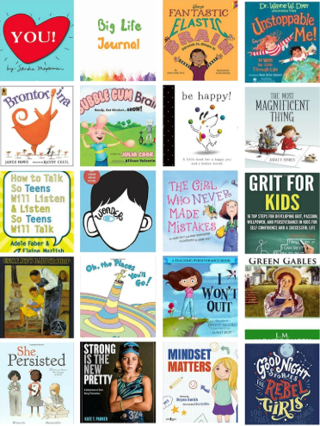
Skills
To be able to celebrate their own and others’ skills, strengths and attributes.
To demonstrate a range of strategies for dealing with put-downs.
To be able to recognise what is special about themselves.
Talk about and explain your learning.

Books

Knowledge

D

Children’s literature to support the topic
How to catch a star – Oliver Jeffers Wonder Goal – Michael Forman
Dr Seuss – Oh the places you’ll go The wrong start – Marchette Chute
Vocabulary | Meaning
catastrophising | a form of negative thinking where a person thinks the worst about a situation.
challenged | an invitation to enter into a contest of skill.
challenges | an interesting or difficult problem or task.
difficult | hard to do or understand.
goal | a result or end that a person wants and works for; aim or purpose.
negative | not helpful or constructive/saying or meaning no.
overcome | to win against or defeat; to get over or past.
positive | approving or optimistic/bringing something good, or giving some kind of advantage/saying or meaning yes.
put-down | an unfair criticism or negative remark about a person.
put-up | to think about your own qualities and what you’re good at.
set-backs | something that happens that slows, stops, or reverses progress that is being made.
strengths | the power to hold off wear, damage, or injury.

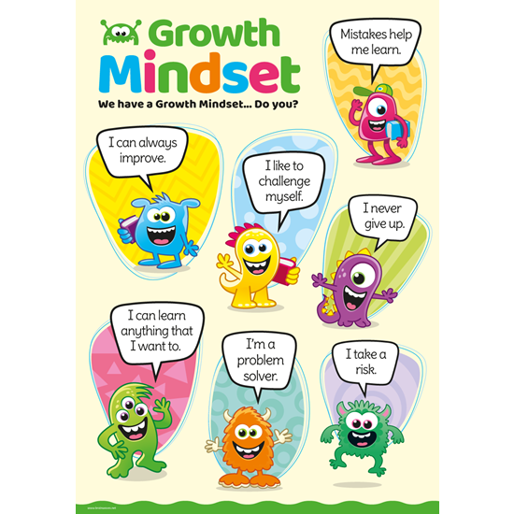
What I will know and be able to do at the end of the topic.
Growth Mindset Strategies

What I should be able to do and know now.

I know how to listen to other peoples’ points of view.

I can explain how it feels to be challenged, try something new or difficult.

Can you describe a situation where you were able to overcome a challenge?

What is meant by a put-down and a put-up and also how this can affect people.

I am special because_________________, (things for me to remember when I am given a put-down).

Helpful thinking includes t__________, r_______, c___________ and asking for h_____.

I can recognise that everyone has set-backs at times, and that these cannot always be controlled.

Knowledge
I know how to recognise things that I am good at and things that are good about me.
To know that it is wrong to tease or bully someone.
What is right and wrong.
How their actions or words may make others feel.
I am able to recognise feelings when faced with a challenge, such as excitement, worry, fear or happiness.
Skills
Recognise what is fair / unfair in their actions.
Recognise what is right / wrong in their actions.
I can create a storyboard to help focus my ideas.
Understand tolerance.
I know that it is positive to ask for help.
I can reflect on how I feel.

What I will be learning

I know about celebrating achievements and setting personal goals.
I am able to deal with put-downs positively.
I know some positive ways to deal with set-backs.
I can plan the steps required to achieve a goal or challenge.

