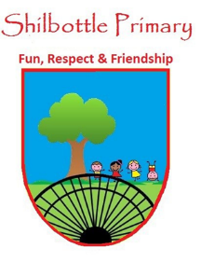
Year 5 Spelling List – Spring 2
Dear Parents/Carers,
Below is a copy of the spellings which will be tested this half term. The spellings will be a mix of a general spelling rule each week as well as some statutory UKS2 spellings.
Spelling homework should be handed in by Thursday each week. The children are expected to copy out the 10 spelling words and then write a sentence for each word which shows their understanding of the word meanings. Please note - This may not be enough to learn the spellings completely, it is expected that the children will carry out further practice at home of the spellings, in preparation for the spelling test on Friday.

Week 1  Test date: 3/03/2023 | Week 2  Test date: 10/03/2023 | Week 3  Test date: 17/03/2023
Spelling rule  Words ending in -iblr  legible  terrible  sensible  visible  reversible  edible  Year 5 and 6 spellings  mischievous  muscle  necessary  neighbour | Spelling rule  Homophones  stationery  stationary  father  farther  steal  steel  Year 5 and 6 spellings  nuisance  occupy  occur  opportunity | Spelling rule  Words ending in -able  reliable  enviable  miserable  predictable  noticeable  adaptable  Year 5 and 6 spellings  parliament  persuade  physical  prejudice
Week 4  Test date: 24/03/2023 | Week 5  Test date: 31/03/2023
Spelling rule  Words with silent letter t  hustle  bustle  jostle  whistle  thistle  wrestle  Year 5 and 6 spellings  Privilege  Profession  Programme  pronunciation | Spelling rule  Words from the term  predictable  visible  stationary  whistle  adaptable  farther  muscle  occupy  privilege  persuade

