Maths Key Skills Stage 2: Skill Check 10

Name: ___________________________________ Date: _______________ Class/Group: _______________________________

A: Place Value, Add and Subtract |  | B: Multiply, Divide and Fractions |  |  | C: Measure and Geometry
1. What is the missing number?  64 54 44 34 24 | 2:1 | 11. 100 ÷ 10 = |  | 2:11 | 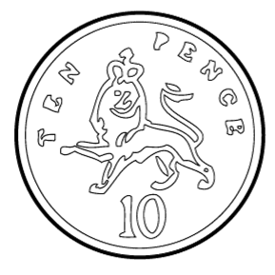  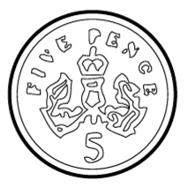  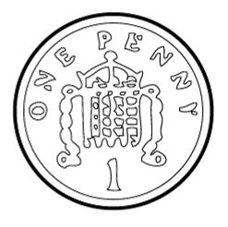  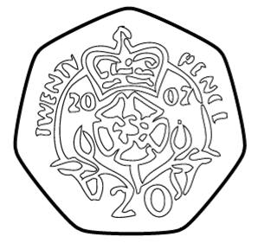  21. Tim has fifty pence (50p). Tick the coins that have the same value. |  | 2:19
2. What is the value of the 9 in this number? 89 | 2:2 | 12. Which are the even numbers?  7 14 21 28 |  | 2:11 |  |  | 2:19
3. Draw an arrow to label 9.  5  10 | 2:3 | 13. What symbol is missing?  36 = 4 9 |  | 2:12 | 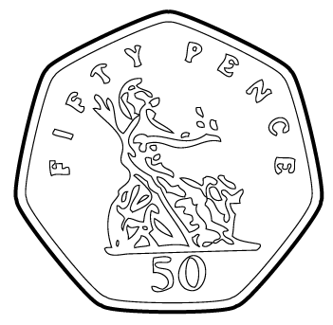  22. Sam has ninety pence  (90p). He buys a can of  pop for fifty pence  (50p). How much  change does Sam get? |  | 2:20
4. Use <, > or = to make this correct:  3 x 2 2 + 4 | 2:4 | 14. What symbol is missing?  8 = 48 6 |  | 2:12 |  |  | 2:20
5. Write this number in numerals.  seventy two | 2:5 | 15. Tick (✓) if true:  5 x 9 = 9 x 5 12 ÷ 3 = 3 ÷ 12 |  | 2:13 | 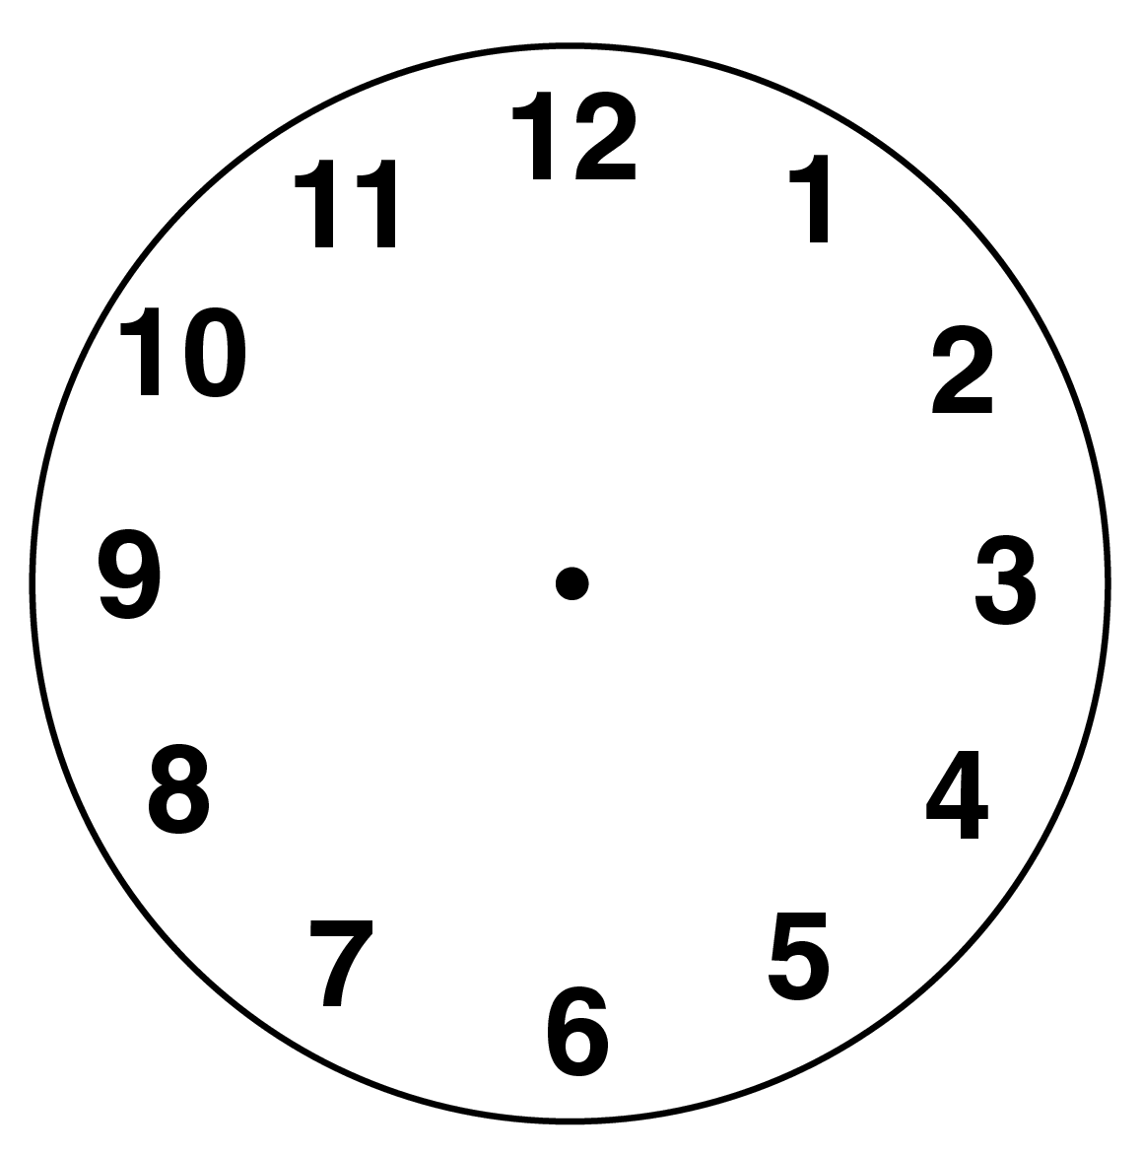  23. What time does  this clock show? |  | 2:22
6. There are 34 people on a train. 22 get off. How many people now? | 2:6 | 16. 7 boys share 21 chocolates. How many chocolates does each boy get? |  | 2:14 |  |  | 2:22
7. 20 - = 8 | 2:7 | 17. 3 bags each contain 8 apples. How many apples are there in total? |  | 2:14 | 24. 8 pupils were asked if they liked certain snacks:  Which snack was most popular?  25. How many more pupils liked crisps than liked nuts? |  | 2:29  2:30
  Key: ✓ = Yes, ✗ = No
  crisps | ✓ ✓ ✗ ✓ ✓ ✗ ✓ ✓
  nuts | ✓ ✗ ✗ ✓ ✓ ✗ ✓ ✗
  popcorn | ✓ ✓ ✓ ✓ ✓ ✓ ✓ ✓
8. 48 - 10 = | 2:8 | 18. What fraction  is shaded? |  | 2:15 |  |  | 2:29  2:30
9. Is this true? Write ‘yes’ or ‘no’.  52 + 9 = 9 + 52 | 2:9 | 19. How many halves are in 1 whole? |  | 2:15 |  |  | 2:29  2:30
10. Use 61 = 29 + 32 to help find:  61 - 29 = | 2:10 | 20. Complete the  1  2  4  =  equivalent fractions. |  | 2:16 |  |  | 2:29  2:30
Total (A) |  | Total (B) |  |  | Total (C)
Test Total (A+B+C) |  | R (0-9) | Y (10-19) |  |  | G (20-25)

