

**History – autumn 2 – Guy Fawkes**

00

**Skills**

Develop an awareness of the past.

Place events in chronological order.

Ask and answer questions.

Use vocabulary related to the passing of time.

Know some of the ways we find out about the past.

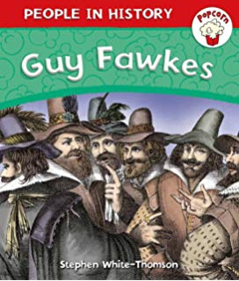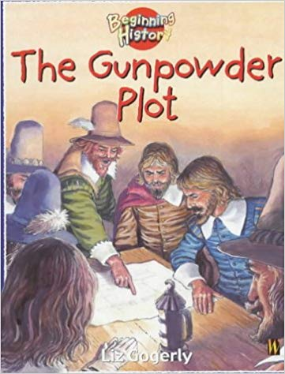

**Books**

**Knowledge**

Understand what a bonfire is and why we light them?

To know who King James I was.

To know who Guy Fawkes was.

I know what happened in the gunpowder plot.

I can explain why fireworks are lit on bonfire night.

**Guy Fawkes King James I The Houses of Parliament**



|  |  |
| --- | --- |
| Vocabulary | Meaning |
| bonfire | A fire outdoors to burn rubbish  or celebrate an event |
| capital city | Where the government gather to  create laws |
| Catholics | Members of the Catholic church. |
| dummy | A model of a person, often used  to display clothes. |
| executed | To kill someone as a punishment  for a serious crime. |
| explosives | A substance or device that can  cause an explosion |
| government | The group of people who  are responsible for running it. |
| gunpowder | An explosive substance used to  make fireworks or explosions. |
| Houses of  parliament | The buildings where the British  government does its work |
| monarch | A King or Queen |
| plot | A secret plan to do something  that is wrong. |
| Protestants | Christians who are not Catholic. |

**Growth Mindset Strategies**

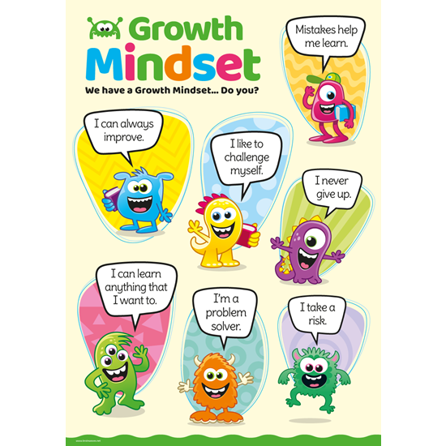

**What I will know and be able to do at the end of the topic.**

**What I should be able to do and know now.**

**Knowledge**

**What is a bonfire and when do we light them?** – Bonfires are lit on 5th November every year and a dummy of Guy Fawkes is often burned on the bonfire.

**Who was King James I?** - Under the rule of James I, Catholics were treated unfairly. The plotters were all Catholic and wanted King James removed from the throne.

**Who was Guy Fawkes and what did he plan to do?**- He plotted to use explosives to destroy the Houses of Parliament and King James I.

**What happened in the Gunpowder plot?** - A letter was sent to Lord Monteagle, who was due to go to the Houses of Parliament, warning him of the plot. He told the king, who sent guards to search the cellars. They found Guy Fawkes and gunpowder.

**Why do we light fireworks on Bonfire night?** **.** Bonfires and fireworks remind us of the explosion that could have destroyed the Houses of Parliament and killed King James.

**Skills -** Develop an awareness of the past and begin to understand where the Gunpowder plot fits in a chronological framework.

**Knowledge**

I can talk about past and present events in my life and in the lives of family members.

**Skills**

I can answer ‘how’ and ‘why’ questions about my experiences and in response to stories or events.

I can use past, present and future forms accurately when talking about events that have happened or are to happen in the future.



**What I will be learning**

|  |
| --- |
| 1. About the life of Guy Fawkes. |

1. How he plotted to use explosives to destroy the Houses of Parliament and King James I.
2. 5th November 1605 – Planned day of the plot.
3. The plot was unsuccessful and Guy Fawkes was executed.
4. We celebrate this event on Bonfire Night