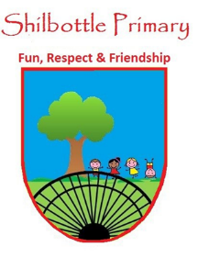
Year 5 Spelling List – autumn 2
Dear parents/carers,
Below is a copy of the spellings which will be tested this half term. There will be a general spelling rule each week as well as statutory UKS2 spellings. These words will no longer be placed into books on a weekly basis and therefore this list should be kept in a safe place. You may also find it useful to take a photo on a smartphone to keep a record of the words which will enable you to support your child’s learning beyond the home. A copy of
these words will also be available from the school website should you need to replace them.
Many thanks for your continued support.

Week 1  Test date: 05/11/21 |  | Week 2  Test date: 12/11/21 |  | Week 3  Test date: 19/11/21
Spelling rule  ent endings  frequent  patient  ancient  innocent  dependent | Year 5 and 6  statutory spellings  mischievous  muscle  necessary  neighbour  nuisance | Spelling rule  ending in -ence  patience  silence  violence  obedience  innocence | Year 5 and 6 statutory spellings  physical  prejudice  privilege  profession  programme | Spelling rule  ending in -ence  hence  pence  fence  offence  licence | Year 5 and 6 statutory spellings  restaurant  rhyme  rhythm  sacrifice  secretary
Week 4  Test date: 26/11/21 |  | Week 5  Test date: 03/12/21 |  | Week 6  Test date: 10/12/21
Spelling rule  ee sound spelt ei  receive  deceive  ceiling  receipt  conceit | Year 5 and 6 statutory spellings  sufficient  suggest  symbol  system  temperature | Spelling rule  ie and ei words: rulebreakers  ancient  efficient  sufficient  conscience  protein | Year 5 and 6 statutory spellings  yacht  accommodate  accompany  according  achieve | Spelling rule  Words ending in –ant –ance and -ancy  assistant  elegance  defiant  relevance  distance | Year 5 and 6 statutory spellings  attached  available  average  awkward  bargain
Week 7
Test date: 17/12/21
The spelling test will be made up from the previous 6 weeks of spelling learning.

